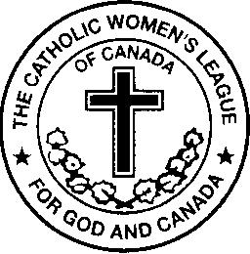

The Catholic Women’s League of Canada
ALBERTA MACKENZIE PROVINCIAL COUNCIL
Annually Presents the

Father Walter Krewski Membership Award
for the Most New Members in the year 2019

This form is to be completed by each Parish Council President.

The purpose of this award is to give recognition to the council that had the greatest number of new members in the previous year. (Please note: New members are only those who have never held a CWL membership before.)

Name of Council _________________________________________________________

President’s Name ________________________________________________________

Address _________________________________________________________________

Postal Code __________________ Telephone number _____________________

Email __________________________________________________________________

Number of New Members ____________________

Please complete this application form and submit the information by email or by regular mail.
The deadline for submission of this information is February 29th, 2020.

If you have any questions, please feel free to call or email.

Mary Hunt
CWL Alberta Mackenzie Provincial President-Elect
Organization Chair
c/o www.cwl.ab.ca
Email: abmkprovpreselect@gmail.com
Please email me for my postal mailing address and/or telephone number.

