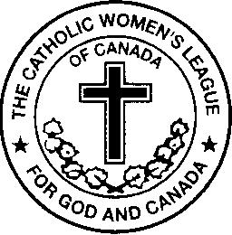

The Catholic Women’s League of Canada
ALBERTA MACKENZIE PROVINCIAL COUNCIL
Criteria for the Father Walter Krewski Membership Awards

Each year, since 2007, the Father Walter Krewski Award has been given to three councils in the Alberta Mackenzie area for increases in membership during the previous year. The awards will be presented each year at the Provincial convention.

- The first award will go to the council that has the greatest number of new members in the previous year. (Please note: ‘New Members’ are only those who have never held a C.W.L. membership before). Information is to be submitted by each Parish Council President

2. The second award will go to the council that has the greatest increase in membership in the previous year. Information is to be submitted by each Diocesan Treasurer or President-Elect

3. The third award will go to the council that has the greatest percentage increase in membership in the previous year. Information is to be submitted by each Diocesan Treasurer or President-Elect

The purpose of these awards is to encourage all councils to promote the ‘League’ in their parishes and to recruit new members.

- The second award will benefit those councils that not only strive for new members, but also work to have all members renew each year.
- The third award will benefit small councils who do not have a large membership, but also do not have a large parish population from which to recruit members.

All Parish C.W.L. Councils in Alberta Mackenzie are eligible for these awards. However, the council must have been active in the year prior to the award year (e.g. the awards given at the 2016 Convention will be for the year 2015, therefore the recipient councils must have been active in 2014).

Please Note:
- From the information provided by you, the Provincial Council will ascertain who will receive each award and will notify these councils by April 15th. In other words, you must apply for the awards in order to be considered.
- The receiving councils will be awarded a certificate of appreciation. A religious picture or statue for each category will be held by the receiving councils until February 28th of the following year at which time it must be returned to the Provincial President-elect.
- A revised application form will be forwarded to each council and to each Diocesan Treasurer and Organization Chair each year.

- Applications must be received by the Provincial President-Elect by February 28th of each year. In order to be considered, an application must be made.

