St. Alphonsus Parish
Living Rosary Celebration

Date: Sunday, May 15, 2022
Where: St. Alphonsus Church
Time: After the 11:00 am Mass
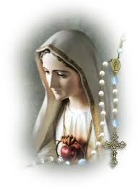
May is traditionally dedicated in a special way to honouring and seeking the intercession of Mary as the Mother of God and Mother of the Church.

The St. Alphonsus CWL invites you and your families to join us at this special Living Rosary Celebration to encourage and spread the Devotion of the Rosary in our parishes and homes.

“For this is the month during which Christians, in their churches and their homes, offer the Virgin Mother more fervent and loving acts of homage and veneration; and it is the month in which a greater abundance of God’s merciful gifts comes down to us from our Mother’s throne”

Please plan to join us for this beautiful celebration.
There will be Fellowship in the Hall after the Living Rosary.

