The Survivors’ Flag
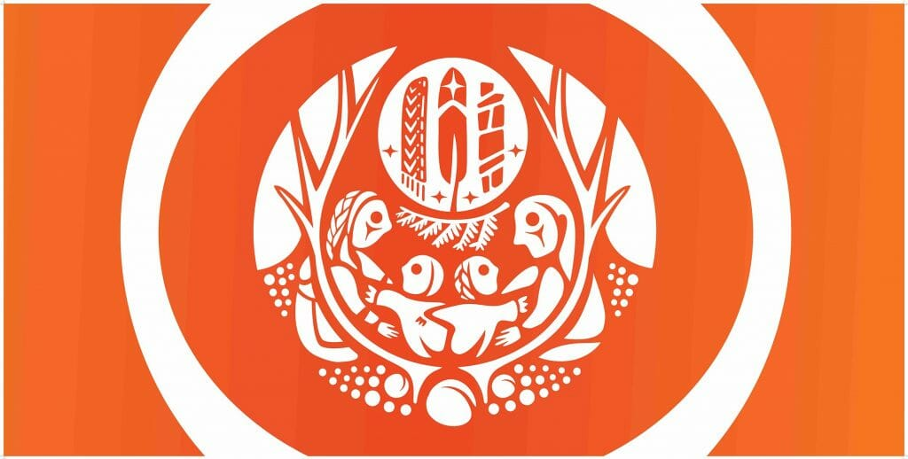

The Survivors’ Flag is an expression of remembrance, meant to honour residential school Survivors and all the lives and communities impacted by the residential school system in Canada. Each element depicted on the flag was carefully selected by Survivors from across Canada, who were consulted in the flag’s creation.

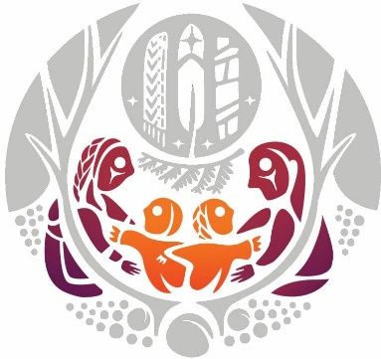
The Family
Some saw the adults as our ancestors watching over us; others saw these as parents signifying whole families ripped apart…
Read More…

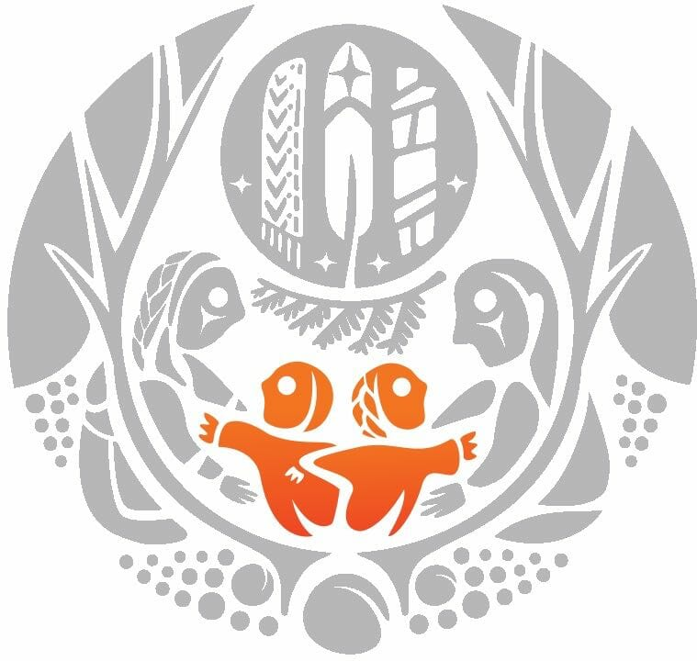
The Children
More than one child is depicted in the design as often whole sibling groups were taken from their parents, younger…
Read More…

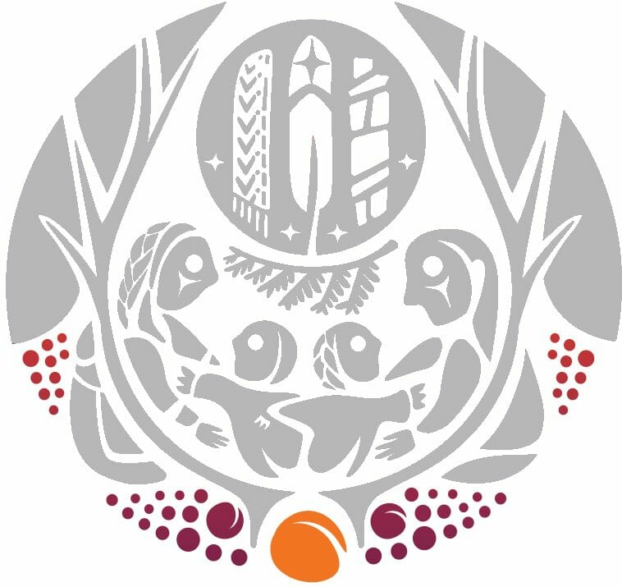
The Seeds Below Ground
Represent the spirits of the children who never returned home. Although they have always been present, they are now seen…

Read More…

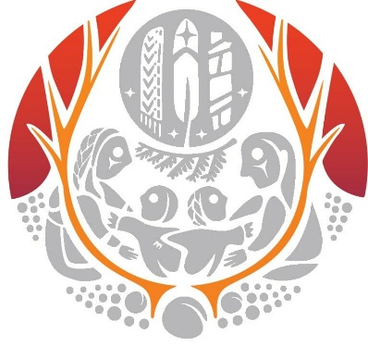
Tree of Peace
Haudenosaunee symbol of how nations were united and brought to peace, which in turn, provides protection, comfort and renewal.
Read More…

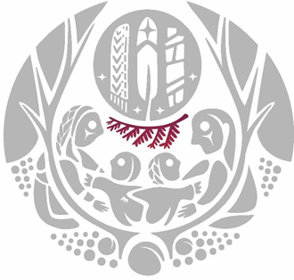
Cedar Branch
Sacred medicine that represents protection and healing, but also what is used by some Indigenous cultures when one enters the…
Read More…

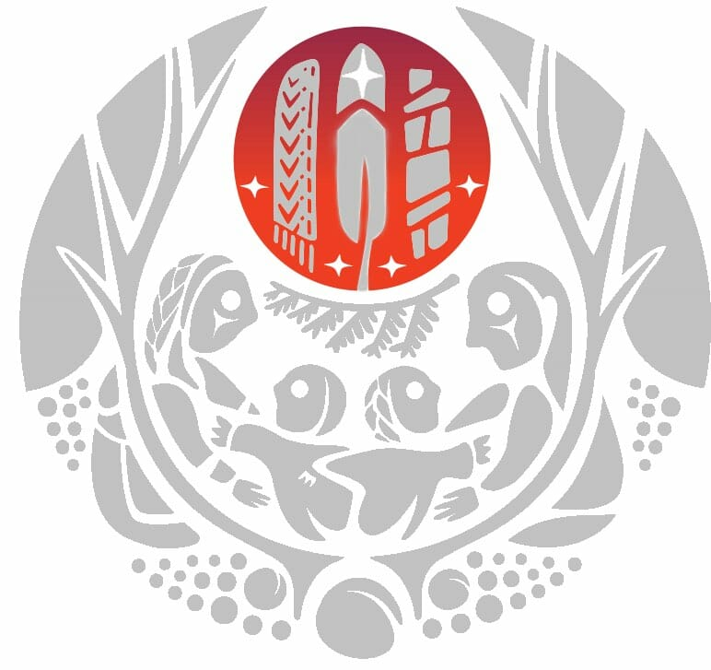
Cosmic Symbolism
Represents Sun, Moon, Stars and Planets. The Sun represents the divine protection that ensure those who survived came home. The…
Read More…

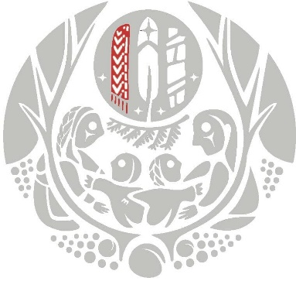
The Métis Sash
The Sash is a prominent ceremonial regalia worn with pride. Certain colours of thread represent lives that were lost, while…
Read More…

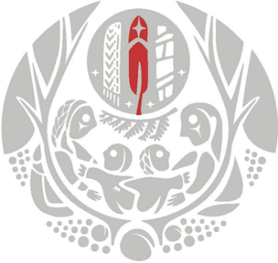
The Eagle Feather
The Eagle Feather represents that the Creator’s spirit is among us. It is depicting pointing upwards which mirrors how it is…
Read More…

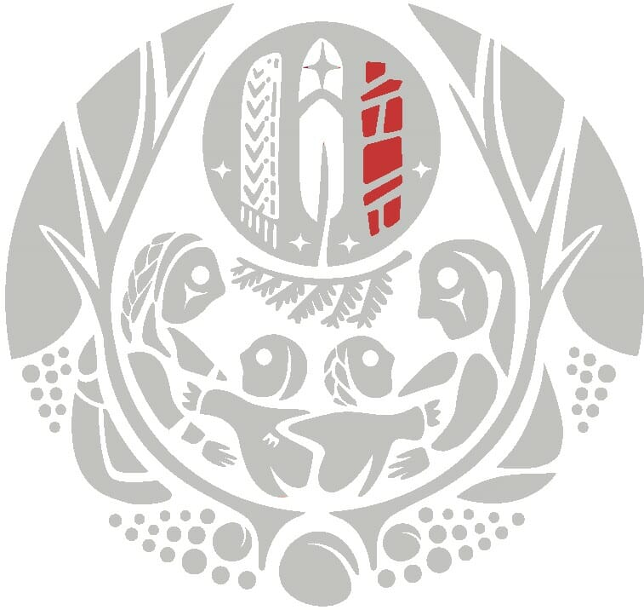
The Inukshuk
Inuksuit are used as navigational guides for Inuit people and link to tradition.
Read More…

