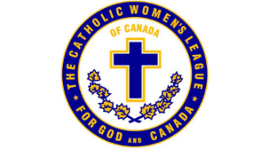

St. Theresa’s CWL Cookbooks are now on sale!
Our cookbook is dedicated to the 40th anniversary of St. Theresa’s Parish.
Over 130 favourite recipes are now ready for you to try.
Cost: $20 each
Please order with the following link:

https://forms.gle/vH1xGCfJRQPVyh3Y7

Once payment is received, you will be contacted for delivery/pickup arrangements.
Thank you for supporting St. Theresa’s CWL Cookbook fundraiser!

