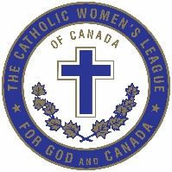

The Catholic Women’s League of Canada
Edmonton Diocesan Council
Spiritual Development Communique April, 2020
Ladies, let us be united in prayer and solidarity as we accept the good and the bad that God offers us each day. Unquestionably, we are drawn through fear and uncertainty, to the crisis which surrounds us and affects not only humanity, but all of God’s Creation. In the wise words of Chief Seattle spoken in 1887: “All things are connected. Whatever befalls the earth, befalls the children of the Earth.” As League sisters, I invite and encourage you individually and as councils, to reach out and connect with your members who are most alone and isolated at this time. One never knows the impact a short phone call or Facetime encounter can have on the mental and emotional state of someone in need of feeling that someone cares.
I invite you to begin a daily reflection on the graces that God is presenting to each and all of us. Some of you will want to keep a written record of the graces that you feel gifted with either personally, for your family, your faith community and/or the global community. Some examples might be things like, because your children are unable to attend school and you’re not able to travel, you have extra time to spend together. Because people are unable to drive and fly, the level of carbon dioxide and air pollution have fallen. Because we are unable to participate in our eucharistic liturgies in person, we have entered the desert in which so many of our sisters and brother dwell as the norm, where they may only attend mass once or twice a year. Reach out to them in solidarity and prayer. You get the idea. You may find it helpful to reacquaint yourself with the “Footprints in the Sand” poem to reinforce the reality that God is surely with us now.
I am attaching with this email an exquisite prayer which I received from one of the members of the Implementation Committee who thinks that it came from Pope Francis. I am also attaching the “CWL Prayer for Renewal” and ask that you consider praying this every day as the work of the Implementation Committee continues as all of our work is done digitally, be it conference calls or through emails.
“This too shall pass, love endures. “I believe the meaning of the Resurrection of Jesus is summed up in the climactic line from the Song of Songs, “love is stronger than death” (8:6). If the blank white banner that the Risen Christ usually holds in Christian art should say anything, it should say: “Love will win!” Love is all that remains. Love and life are finally the same thing, and we know that for ourselves once we have walked through death.
Love has you. Love is you. Love alone, and your deep need for love, recognizes love everywhere else. Remember that you already are what you are seeking. Any fear “that your lack of fidelity could cancel God’s fidelity, is absurd” (Romans 3:3), says Paul. Love has finally overcome fear, and your house is being rebuilt on a new and solid foundation. This foundation was always there, but it takes us a long time to find it. “It is love alone that lasts” (1 Corinthians 13:13). All you have loved in your life and been loved by are eternal and true.” Richard Rohr March 27, 2020
I close with a quote from an amazing woman, Julian of Norwich: “All shall be well, and all shall be well and all manner of thing shall be well.”
Sr. Susan Scott CAF
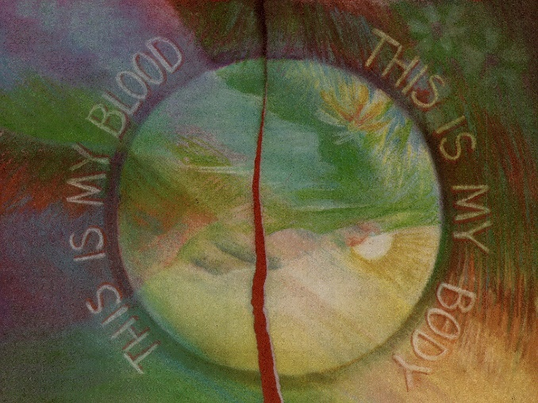
Diocesan Spiritual Development Chair

