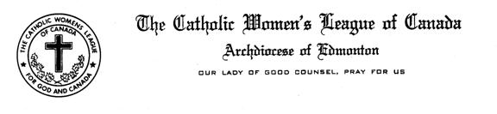
SECRETARY
COMMUNIQUE
FALL 2016
Mary Pat O’Neill
27 Sorrel Crescent, St. Albert, AB T8N 0K4
e-mail: edmontoncwl.secretary@gmail.com
‘
Madam President, Sisters in the League

A special warm welcome to all Secretaries, whether you are starting your term or in your second year, I do look forward to working with you and with our CWL Councils. I welcome your comments, questions, suggestions and ideas as they pertain to our role as Secretary. We learn from one and another, support one another and encourage one another.

The main mission you undertake as secretary is to listen to the proceedings during the meeting; and to record accurately what you have heard so as to prepare the minutes - correctly, concisely and completely. I strongly urge you to appoint a member to assist you in taking notes at meetings; so that you don’t miss any important information. Thus said, as a secretary, you must remember to provide and file a hard copy of minutes as they clearly tell the story and maintain a clear picture of your Council’s activities. Minutes are intended to tell exactly what happened at meetings – not what was said. An accurate paper trail tells the story of your Council. Therefore, you must focus on maintaining the files in the most efficient and up-to-date manner. Years into the future as members look at the archives, the minutes will tell the story and these future members will know what actions and deeds were completed

Furthermore, keep in mind when sending e-mail messages that those reading your e-mail do not hear your voice, see your body language and feel your need. The use of gentle and kind words is important to convey what may sometimes be an urgent message. Harsh and abrupt words have no place in e-mail messages. With regards to maintaining Council rosters, please keep in mind that in accordance with the provincial privacy policy this information is for league use only, and is not to be shared.

I encourage all of you to obtain a copy of the Handbook for Secretaries, which can be downloaded from the national website. Other resource materials that you might find helpful include the Constitution and By-laws, the National Manual of Policy and Procedure and Robert’s Rules of Order.

Respectively submitted,

Mary Pat O’Neill
Secretary, CWL Edmonton Diocese

“Start by doing what’s necessary, then do what’s possible; and suddenly you are doing the impossible.”
St. Francis of Assisi

