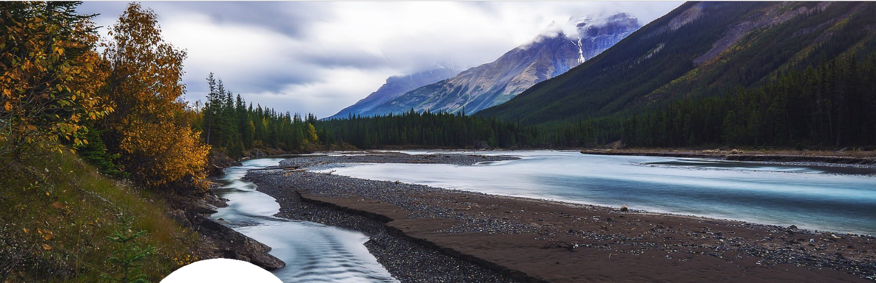
SEASON OF CREATION
PRAYER GUIDE
SPIRITUAL ACTIVITY

PRAYER GUIDE
SUNDAY CELEBRATIONS
FEAST OF ST. FRANCIS OF ASSISI
This spiritual tool offers useful materials to local Season of Creation organizing committees wishing to inspire their faith community members to join together in prayer for the well- being of the Creation God entrusts in our care.

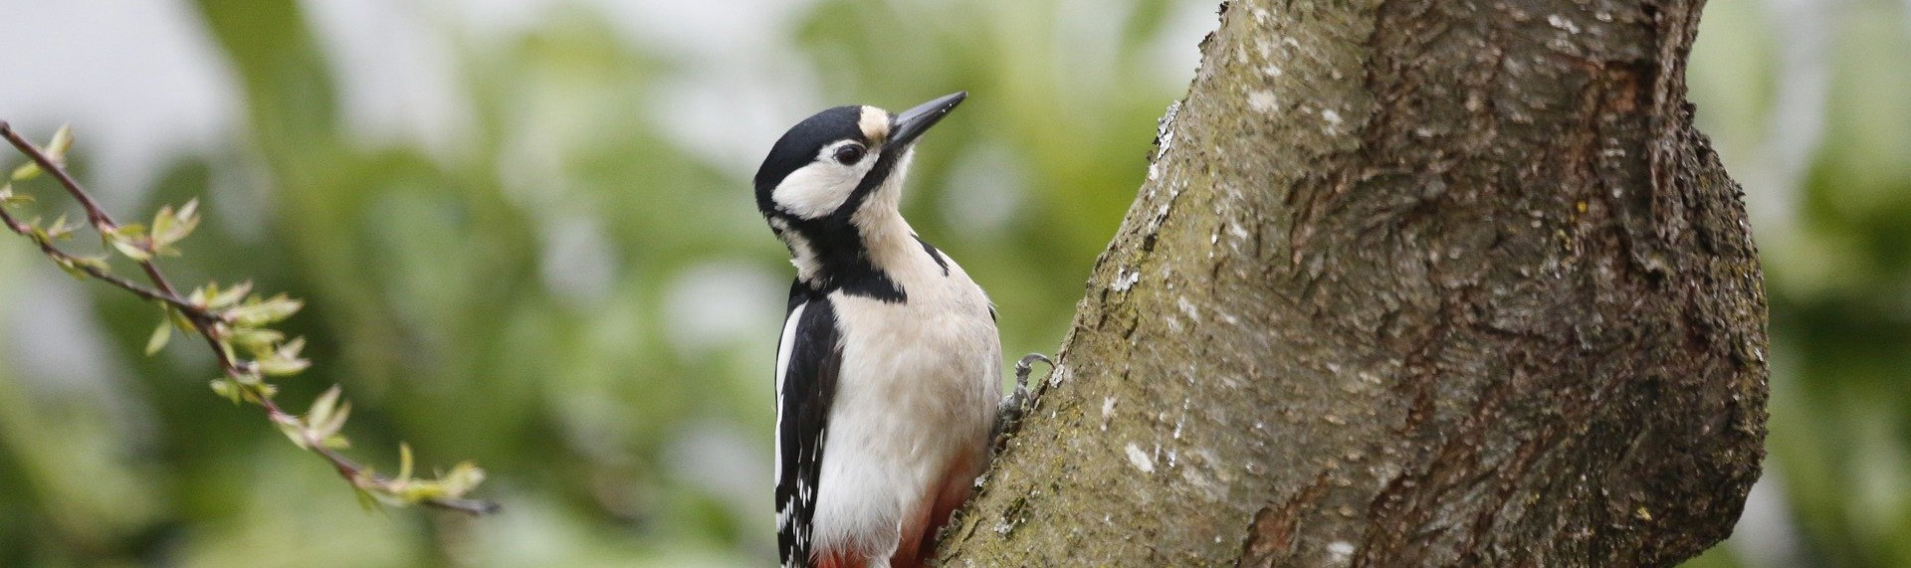
HIS COMPASSION IS OVER ALL HE HAS MADE

“The Lord is good to all and, his compassion is over all that he has made.’’ (Ps 145:9)

SUNDAY CELEBRATIONS
SEPTEMBER 1ST WORLD DAY OF PRAYER FOR THE CARE OF CREATION
Prayer for the Season of Creation 2021
Bless the Earth
God is infinite good, and God’s spirit of love and life permeates everyone and everything on this marvelous planet that we call home. Today, let us bless the planet Earth. We give thanks for the beauty that is everywhere on Earth and for the diversity of people, plants, and animals that make our home a wonder-filled place to live.
Earth provides all we need for healthy, prosperous living We increase this abundance by affirming harmony, peace and
goodwill for all Earth’s inhabitants. Let us promote a healthy world!
Conditions can’t help but improve as the loving spirit of God moves through each of us to bless Earth and all it contains.
(Adapted from the Daily Word Message)

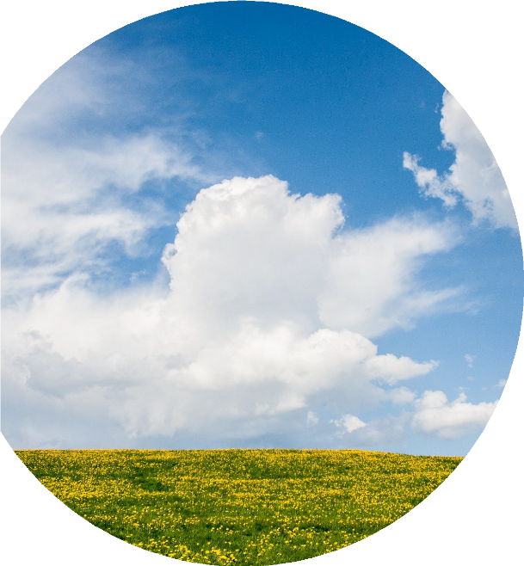

“Today, let us bless the planet Earth.
We give thanks for the beauty that is everywhere on Earth and for the diversity of people, plants, and animals that make our home a wonder-filled place to live.”
Brief History
On 1 September 1989, His Holiness Dimitrios I, Patriarch of Constantinople, decreed the first day of September as a day of special reverence and prayer for the Safeguarding of Creation. The Orthodox Church continues to celebrate this important day, the start of the liturgical year, with the reading of Chapter 1 of Genesis.

Since 2008, The World Council of Churches has encouraged all Christian denominations to observe and celebrate this day. In 2015, Pope Francis announced that the Catholic Church would also mark September 1st as the World Day of Prayer for the Care of Creation. It provides an occasion for Christians from various churches around the world to gather together in prayer for the well-being of the earth, our common home.
Quote
’This is the season for letting our prayer be inspired anew by closeness to nature …
to reflect on our lifestyles … for undertaking prophetic actions … directing the planet
towards life, not death.’’ Pope Francis https://www.youtube.com/watch? v=tbK5l8OcjJg&list=PLdu7tsNYIRxn- prAR60t3HeKwGCP3h1yK&index=2

Action
Recognize and assume our Christian responsibility to care for and respect the rightful place occupied by each element of Creation in our common home.
His All-Holiness, Ecumenical Patriarch Bartholomew of Constantinople calls upon all faithful to ‘’realize that the protection of the natural environment is the spiritual responsibility of each and every one of us.’’
https://www.goarch.org/en/-/why-christians-care-for-the-environment-w-ecumenical-patriarch-bartholomew-
A beautiful prayer service for Sept. 1st is available in French and in English from the Franciscans at
https://missionsfranciscains.blogspot.com/

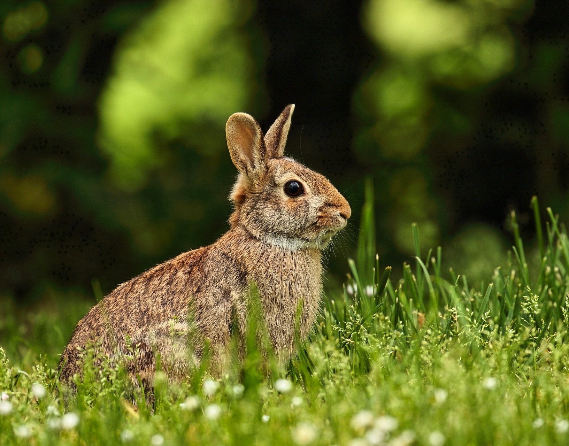

RECOGNIZE AND ASSUME OUR CHRISTIAN RESPONSIBILITY TO CARE FOR AND RESPECT THE RIGHTFUL PLACE OCCUPIED BY EACH ELEMENT OF CREATION IN OUR COMMON HOME.

