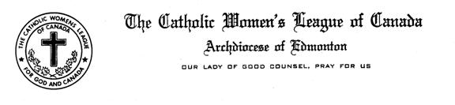

Resolutions and Legislation Report Midwinter Meeting
January 30, 2016

Madame President, Sisters in the League,

First, of last year’s resolutions, we were successful in record time on one of them. There will be a national inquiry into the missing and murdered aboriginal women. There was some movement on banning microbeads before the election but it has kind of been allowed to go dormant. The United States has recently banned them, so there is hope we will follow, hopefully before our market get flooded with the stuff that the US will no longer allow on the shelves.
On to potential resolutions for this year. I have received two proposals. One is a resolution proposal from Holy Cross in Grande Cache and deals with non-biodegradable hygienic disposable products. The second is from St. Rose of Lima in Onoway and it is a proposal to amend the CWL crest which by bylaw has gold stars representing the provinces and territories. Since we now have 14 of them, rather than the 10 existing when the original crest was designed, the resolution is that we should add 4 more gold stars. We are hoping to have both ready to bring forward at the Convention in April.
That concludes my report. Are there any questions?

Catherine Mardon

