Elsie Yanik
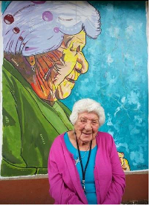
Members of the Catholic Women's League in Alberta are mourning the passing of Elsie Yanik, a beloved Metis elder who was a passionate supporter of the CWL and the Church in northern Alberta. She was 99.
Elsie spent much of her long life in Fort Chipewyan, where she was known for spreading kindness, preserving Indigenous heritage and promoting health and education in her community. She served as a lay minister, mentor and volunteer, and her efforts were recognized with many awards and honours. She received a blessing from Saint Pope John Paul II, a Governor General’s Commemorative Medal, and the duty of Olympic torch-bearer for the 2010 Winter Games. A new school in the Fort McMurray Catholic School District will bear her name when it opens in 2017. When Elsie received an Indspire Lifetime Achievement Award for outstanding indigenous achievement in 2015, she summed up her philosophy this way: “Make a difference. Create a better world by being kind. Kindness is enduring. Kindness is contagious. Kindness makes everyone feel good.”
The Alberta-Mackenzie CWL established the annual Elsie Yanik Award in 1997 to commemorate her leadership and service to the Catholic community in the Diocese of Mackenzie-Fort Smith.
Quid Novum Wednesday, November 30, 2016

