-
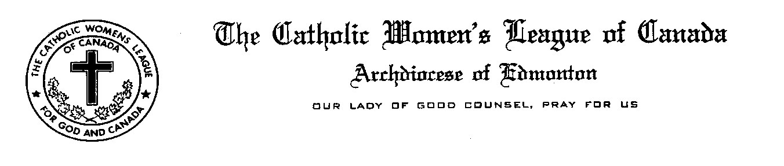

22nd Annual CWL Poster/Poem/Story/Essay Contest 2016-2017 School Year

Dear School Principals and Teachers,
The Edmonton Diocesan Council of the Catholic Women’s League of Canada would like to invite students in our Catholic schools to participate in our 22nd Annual Poster/Poem/Story/Essay Contest. We hope that students and their teachers are inspired by this year’s theme derived from our new CWL National Theme which is “Inspired by the Spirit; Women Respond to God’s Call”. For students in Kindergarten thru Grade 6 the theme will be “Where do I see God’s Spirit?” For students in Grades 7 thru 12 the theme will be “How does the Holy Spirit inspire me in serving others?”
Last year over eleven hundred entries were received from numerous schools throughout the diocese. Thank you to all the teachers who embraced this project and worked with their students. Winning entries are posted on our website at www.edmontoncwl.org . As has been done in recent years, the student’s posters and written entries will be sent to extended care centers in the towns and cities from which entries are received. Last names of students will be kept confidential.
Enclosed are instructions and an official entry form for this year’s contest. Please note that the deadline for submissions is March 17, 2017. We invite you to send us your comments on how we can improve this program. You may include comments with the contest entries or send us an email.
We hope your school will participate and look forward to receiving submissions from your students.
For God and Canada,

Kara Pelech
Education Committee Chair
Edmonton Diocesan Council
The Catholic Women’s League of Canada

4911 – 43A Avenue Edmonton, Alberta T6L 6J5
Email: karapelech@telus.net / Phone: 780-450-0632

