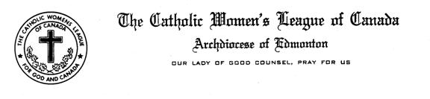

PAST PRESIDENT'S
COMMUNIQUE
AUGUST 2016
Gwen Elliott
6112-32 Avenue
Camrose , AB T4V 4R8
E-Mail: edmontoncwl.pastpresident@gmail.com

To: Council Past Presidents and Zone Chairpersons
Dear Sisters in the League:

As September begins so also do our councils become active again. I hope the summer break has allowed you to relax, share time with friends and family and think about continuing with the excellent work and sharing with our CWL sisters in councils throughout the Archdiocese of Edmonton. I find it a challenge to share something new about the position of Past President with you as there is information available in places such as the Past President Handbook, checklists for archiving and articles in The Canadian League.

A past President has had the experience of being the Leader of the council and because of this has knowledge, abilities and gifts to share with her council. Personal attributes may be:
mentor, listener, advisor, worker, collaborator, observer, cheerleader. Responsibilities may include: picture taker/ displayer, caretaker of materials such as: minute and reports, albums, correspondence, keepsakes, financial information/ recent and historical.

The preservation of the history of a council is a very important responsibility. Records should be stored in a safe accessible place. In the council it is usually the Past President who works in this area, in order to pass on the knowledge of how things are organized the past president should work with the president so that she can carry on the work when her term as president is completed. If your council has a member who thrives on archiving, she could be encouraged to be a continuous archivist who would work with the past president and those who come after. It would provide some continuity.
- HELPFUL TIP Try not to work alone when going through materials. It helps when deciding what to keep and what to discard.
- REMINDER: When discarding private information, make sure it is discarded properly.
SHREDDED or BURNED

The Diocesan Council is in the second year of its two year term, which means that there will be an election of officers at the Annual Diocesan Convention in 2017. Work will begin in September on updating the eligibility list and letters will be sent to all those who are eligible to stand for office. Information from the P & P.
- Present Diocesan officers (except for the past president) who, at the time of election, have served a full term
- Parish council presidents who, at the time of election, have served a full term
- Officers and council presidents shall remain eligible for three elections following their term last served
The letters that are sent are a Call to Serve the League at the Diocesan Level, the gifts and abilities that you shared with your council will be valued. Please consider saying YES!

The job of the Past President is part historian, part advisor, but also looking to the future to make sure that the information about your council will be there for our CWL sisters to come.

God Bless,
Gwen Elliott
Past Diocesan President

