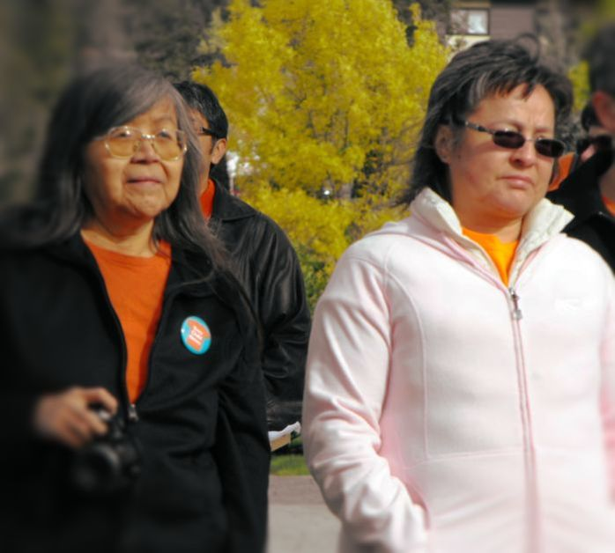
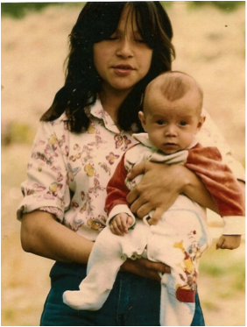
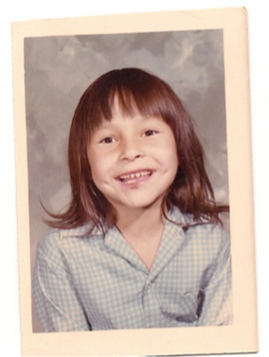

Phyllis (Jack) Webstad's story in her own words... https://www.orangeshirtday.org/phyllis-story.html

I went to the Mission for one school year in 1973/1974. I had just turned 6 years old. I lived with my grandmother on the Dog Creek reserve. We never had very much money, but somehow my granny managed to buy me a new outfit to go to the Mission school. I remember going to Robinson’s store and picking out a shiny orange shirt. It had string laced up in front, and was so bright and exciting – just like I felt to be going to school!
When I got to the Mission, they stripped me, and took away my clothes, including the orange shirt! I never wore it again. I didn’t understand why they wouldn’t give it back to me, it was mine! The color orange has always reminded me of that and how my feelings didn’t matter, how no one cared and how I felt like I was worth nothing. All of us little children were crying and no one cared.
I was 13.8 years old and in grade 8 when my son Jeremy was born. Because my grandmother and mother both attended residential school for 10 years each, I never knew what a parent was supposed to be like. With the help of my aunt, Agness Jack, I was able to raise my son and have him know me as his mother.
I went to a treatment centre for healing when I was 27 and have been on this healing journey since then. I finally get it, that the feeling of worthlessness and insignificance, ingrained in me from my first day at the mission, affected the way I lived my life for many years. Even now, when I know nothing could be further than the truth, I still sometimes feel that I don’t matter. Even with all the work I’ve done! I am honored to be able to tell my story so that others may benefit and understand, and maybe other survivors will feel comfortable enough to share their stories.

Phyllis Webstadis the Executive Director of the Orange Shirt Society, and tours the country telling her story and raising awareness about the impacts of the residential school system. She has now published two books, the "Orange Shirt Story" and "Phyllis's Orange Shirt" for younger children.
She earned diplomas in Business Administration from the Nicola Valley Institute of Technology; and in Accounting from Thompson Rivers University. Phyllis received the 2017 TRU Distinguished Alumni Award for her unprecedented impact on local, provincial, national and international communities through the sharing of her orange shirt story.
September 30th has been declared Orange Shirt Day annually, in recognition of the harm the residential school system did to children's sense of self-esteem and well being, and as an affirmation of our commitment to ensure that everyone around us matters. Orange Shirt Day has now changed to September 29th every year with the announcement that Sept. 30th will be designated as National Day for Truth & Reconciliation
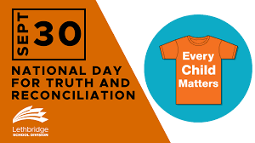

Lethbridge School Division

A bit of history about the Truth and Reconciliation Commission. It was officially established on June 1, 2008, with the purpose of documenting the history and lasting impacts of the Canadian Indian residential school system on Indigenous students and their families.
In June 2021, the House of Commons unanimously passed legislation to make Sept. 30 a National Day for Truth and Reconciliation to commemorate the history and ongoing trauma caused by residential schools and to honour the survivors, families and communities who continue to grieve for those who were lost. The day has been created to give everyone an opportunity to recognize and commemorate the legacy of residential schools, which more than 150,000 First Nations, Metis and Inuit children were forced to attend between the 1870s and 1997.
Having such a day was one of the 94 recommendations in the Truth and Reconciliation Commission’s final report, which was released in June 2015.
The decision to make this a National Day of Remembrance came shortly after the remains of about 215 children were discovered in late May by the Tk'emlúps te Secwépemc First Nation, on the grounds of the former Kamloops Indian Residential School. More remains have been found since then, and more searches are underway across the country. The original report estimated that 6,000 children died while attending the schools, although many people expect the number to be much higher.
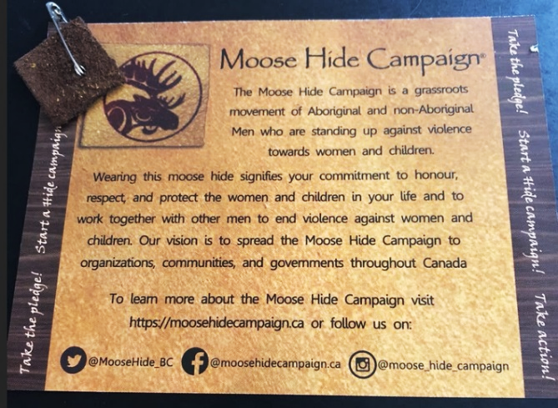

In 2015 we held our fall meeting in Lloydminster, all participants received a small piece of hide with an invitation to take the pledge on the image above. I always wear my hide with my CWL pin and have been asked on a number of occasions why I wear the hide or sometimes, what is that? I welcome the opportunity to educate others about the reason why I wear it and it is a constant reminder to me of the importance of doing everything I can to protect our Indigenous sisters. I encourage you to take this pledge and/or to wear a piece of hide/leather to show your support and solidarity.
