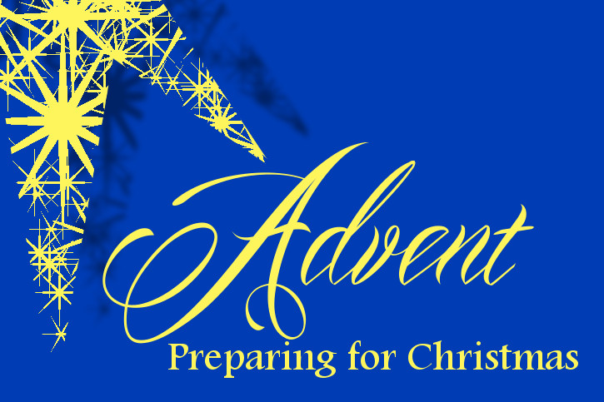

ADVENT RETREAT
December 5, 2020 11:00a.m. to 12:30pm CST (Winnipeg)
Presenter: Very Reverend Cornelius O’Mahony, EV
Topic: “This is a Time to Go Slow… a Time to Pause on the
Advent Journey in a Time of Uncertainty

Sisters in the League
An Advent Retreat has been arranged for The Catholic Women’s League of Canada. I have been asked to spread the word of this retreat so members from across Canada might join together during this beautiful time of anticipation and waiting as they prepare for the celebration of the birth of Christ. All are welcome.
Father O’Mahony is a well-known priest and presenter across North America with a delightful Irish accent and an infectious laugh. He is episcopal vicar of education for the Diocese of Hamilton and pastor St. Andrew’s Parish (Oakville).
Register online through the national website at cwl.ca
Mark your calendar.

