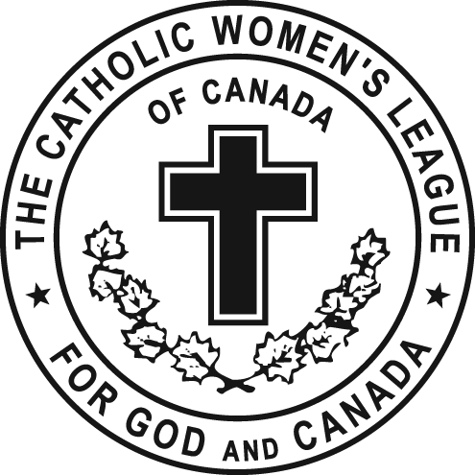
Secretary Report – January 30, 2016

Mid -Winter Meeting of Edmonton Diocesan CWL
As Secretary for the Edmonton Diocese -
Minutes
- Since our FALL meeting, I have continued to assist in the preparation of Edmonton Diocesan Officers’ Minutes for October, November the Informal Meeting in December, 2015 and January 2016 which are e-mailed out to Executive.
- Fall Minutes, October 3, 2015, were e-mailed to Council Presidents; Life Members, Zone Chairs, etc. and a copy has been included in your envelope to-day.
Council President Contact Roster
- As well, I have continued to update Edmonton Diocesan Presidents’ Roster, and other Rosters, through telephone calls and e-mails.
- Most importantly, I have e-mailed and/or mailed out to Council Presidents the updated version of our Council Roster.
2015-16 Parish Executive Council Rosters
  - We certainly do need to improve in this category to facilitate updating our Eligibility Roster. Please kindly recheck and ensure that a copy of this very important Roster is completed with a change in executive.
- 2015 Annual Secretary Reports.
  - Received 44 /67 thoughtful responses indicating their dedication, enthusiasm and hard work for their Council.
- 2015-16 Parish Executive Council Rosters
  - We certainly do need to improve in this category to facilitate updating our Eligibility Roster. Please kindly recheck and ensure that a copy of this very important Roster has been duly completed.
Website
- A reminder that all reports, forms and communiques are posted on our website edmontoncwl.org and can be quickly downloaded.

Lastly, I would like to recognize your Council secretary by extending my sincere and grateful thanks to each for their continued vital role they fulfill within your Council. Also, extent my welcome to new secretaries who are just beginning their term and who no doubt will have a lot to offer to your Council in the way of resources and information. As well, do take to time to give sincere thanks to your retiring secretaries, and, request that they please do take time to mentor the new secretaries at their request.

This concludes my report.

Mary Pat O’Neill, Secretary
CWL Edmonton Diocese

