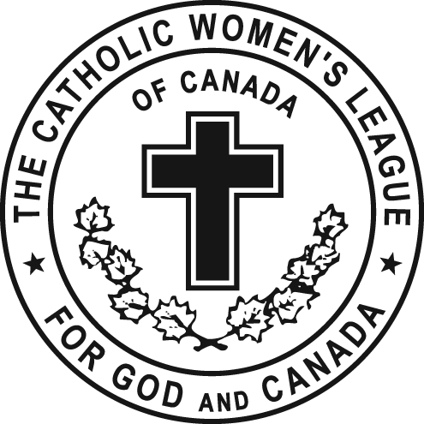
President's Report
Midwinter Diocesan Executive Meeting
St. Albert Parish, St. Albert
January 30, 2016

Dear Sisters in the League,

Much has happened in the Diocese since our inspiring Fall Meeting in Lloydminster in October.

Our Diocese experienced a small increase in numbers in 2015 and it is our hope that we continue this trend well in to the future. Sadly, we have been advised that St. Gregory The Great Council in Holden will be disbanding and amalgamating with a neighbouring council.
On a happier note, St. Stephen’s in Lacombe is moving ahead with re-establishing their council.

Based on the new Constitution & Bylaws, quorum became an issue for us at our Fall Meeting. It was decided at our January Diocesan Officers Meeting, to pursue an amendment to the C & B that would change the new formula for determining quorum at our Pre and Post Convention meetings and our Fall and Midwinter meetings. I brought the matter to the recent Provincial Meetings and Provincial President Cathy Bouchard will bring the matter to the national meetings she will be attending in February.

In order to achieve quorum in our Diocese, we require 40 which would mean the attendance of all 11 Diocesan Officers and 29 of the Council Presidents or their designate at any given meeting. Larger dioceses will have more difficulty in reaching quorum and we were surprised when we were advised by National that we are the first diocese that has contacted them regarding the problem.

For anyone interested, you will find in the Correspondence Binder a Calendar of Events that your Diocesan Officers have been involved in since April, 2015…almost six pages of them. Thank you for including us in your gatherings. There have been several wonderful anniversaries in the Archdiocese which were attended including the 90th Anniversary Celebration for St. Joseph’s Council in Three Hills, the 90th Anniversary Celebration for St. Anne of the Prairies in Trochu and a 20th Anniversary Celebration for St. Thomas More in Edmonton. In October I brought greetings at the Ukrainian Catholic Women’s Congress Conference which represented a wonderful learning opportunity for both organizations and may possibly pave the way for future collaboration and sharing. They will be at our convention in April.

Determined through evaluations we have received, five main Priorities for 2015-2017 for Edmonton Diocesan Council have been identified and are supported by bullet points as to how we will work to achieve them. Copies of the Priorities are available on your tables and you will also find them in the envelopes given out. We invite you to contact us with any suggestions as to how we may effectively collaborate in achieving these priorities.

The annual breakfast meeting with Archbishop Richard Smith and the Diocesan Officers was held December12th. Prior to the meeting we provided His Grace with a letter reporting on CWL activities in the Edmonton Diocese during 2015. This letter is available in the correspondence file for anyone interested. We were very pleased when the Archbishop posed questions to us about matters contained in the document. Further we know from various sources that he followed up on two concerns within days of our meeting.

We are excited that two of our councils have brought forward proposals for consideration as to a Resolution and another an Amendment to the National Policies and Procedures which Resolutions and Legislation Chair Catherine Mardon will discuss in her report.

Provincial Midwinter meetings were held January 22-25, 2016 in Leduc with a very full agenda. The weekend involved Spiritual Development, with Masses and spiritual programs, Meeting Sessions with Standing Committees reports, Financial and Policy work, and sharing ideas and concerns with other Diocesan Presidents. When the Diocesan presidents gathered the discussion focused on the drafting of letters respecting The Guidelines for best practices document issued by the Minister of Education pertaining to Creating Learning Environments that Respect Diverse Sexual Orientations, Gender Identities and Gender Expressions. In mid-November we were invited to attend one of Edmonton Catholic Schools Consultative Meetings regarding this issue. A broad cross section of “interested stakeholders” were present including several Diocesan priests. We were invited to complete a questionnaire and provide comments.
A sample letter that can be sent by individual members to the Education Minister is included in the President’s envelopes and copies are available at the Education & Health display along with a sample letter for an individual to send to their Member of Parliament regarding Physician Assisted Dying still urging the federal government to invoke Section 33 which gives the elected government the legislative authority to overturn or suspend a judicial court ruling. The letter goes further by stating that since the ruling of the Supreme Court of Canada has broad implications for all Canadian citizens and in particular the vulnerable in society facing end-of-life decisions, there is a need for more time – more than six months to ensure all of the safety-features and needs are addressed.

Zone 2 Councils are working diligently on preparations for the 94th Annual Diocesan Convention at Holy Family in St. Albert from April 22-24, 2016. Council Presidents, Zone Chairs, Life Members, and Past Diocesan Presidents in attendance today have received the Convention information in their envelopes. The theme for this year’s convention builds on the Midwinter Meeting theme and will be “With One Heart, One Voice, One Mission: Be the Face of Mercy”. Confirmed speakers to date include Archbishop Richard Smith, Bishop Sylvain Lavoie and Provincial CWL President Cathy Bouchard and two more speakers TBA.

The Diocesan Convention will be a great opportunity for Faith Fun and Fulfillment and we want you to be there. We urge you to please send in your Registration early (the sooner the better) which will help us in planning and preparing for your participation. Convention information will be available on the Diocesan Website next week and updated.

Don’t forget to check out our new Diocesan website at www.edmontoncwl.org Sister Susan has passionately worked on developing this attractive new site as a one stop place to go for information and links pertaining to the CWL in the hope of better serving the needs of our councils well into the future.

Thank you to those councils that have sent in photos of joyful occasions during the past year that can be used in a power point presentation at the Closing Banquet of our Diocesan Convention. Please do not forget to send in your council photos to Sister Susan…we want to see pictures from all 68 councils.

Thank you for your prayers and support so we might best fulfill the trust and mandate you have placed in your team of Diocesan Officers.

This concludes my report.

Mary Hunt, President
Edmonton Diocesan Council
The Catholic Women’s League of Canada

