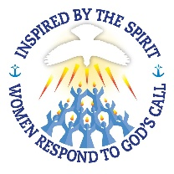
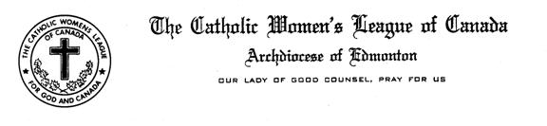
Vice President and Spiritual Development Standing Committee Report
Mid-Winter Meeting January 21, 2017
Madame President and Sister in the League:
Pope Francis encourages us to look for ways that unite us rather than ways that “divide” us. This morning as we gathered in prayer to open our meeting in celebration for the week of Prayer for Christian Unity, we renewed a commitment to break down the barriers between each other and to work in harmony. Our National theme “Inspired by the Spirit, Women Respond to God’s call, echoes how our love of Christ compels us to respect one another in the service of others. This year we want to highlight how women in many walks of life have responded to God’s call. We encourage you to highlight how women in your parish have answer God’s call – be they mothers, caregivers, daughters, teachers, doctors, clerks, nurses. All have a role in God`s plan.
We had a very busy fall; three workshops were held in Castor, Lacombe and Villeneuve topics were on Discernment, Catch the Fire and Spiritual Development. Planning for this meeting and for the convention in April has been inspiring as we contemplated our theme and looked for women who lived a faith filled life. As mentioned and discussed in our morning workshop, we are struggling with finding leadership among our members! This year we need to spend time reflecting on our mission call and how our members can respond in leadership to this mission call of the CWL...
On March 25th, members are invited to attend a reflection day at the Star of North Retreat Center. Sr. Mary Clare Stack, UJ will present a retreat incorporating our theme entitled `Women of the Church: A Rich Legacy of Discipleship``. The cost is $40.00 including lunch. If the day is overbooked, we will consider holding another retreat for those members who couldn`t attend.
Devon CWL will be hosting their Annual Interfaith Brunch on March 11 beginning at 9:30 a.m. to 2:00 p.m. Two women speakers have been invited to present; Megan Schuring, Mosaic Centre reflecting on their mission to serve the poor; Christine Foisy-Erickson will reflect on Mary, Mother of Jesus. Cost is $10.00 and you can check our Diocesan website for contact information.
World Day of Prayer will be held on March 3rd. This year the focus in the Philippines, I encourage you to find a service in your area and participate. International Women`s Day will be celebrated on March 8th. Both these days can be days to highlight women in our church.
Annette Patterson is our Diocesan CWL representative on Archdiocesan Mission Council. The council is addressing how to focus their work on not only on the Holy Childhood and Foreign Missions but on positive relationships with First Nation people in our diocese and country. CWL, has sisters in the north, we have a start on building these relationships with first nations people. If you have any ideas on how to further our ties with them, please contact Annette who can bring our ideas to the council. During lent the Mission Council has a drive entitled, Loonie for Missions`` in support of the Holy Childhood. All schools in the Archdiocese receive information on how participate. Councils may want to contact their catholic schools in their parish to see if there is any way to help this drive.
Habitat for Humanity is hosting Interfaith Build Days, February 23rd to April 26th. Many of our councils have assisted with these build days by helping at the build or providing lunches. Check out the Habitat for Humanity Website and consider how your council could might participate.

Do encourage members to say this prayer during the years or consider using it at your meetings.
I remind members to check our Diocesan Website, Provincial and the National Website for information related to Spiritual Development.
This concludes my report.
Respectfully submitted
Mary Molloy
Vice President and Spiritual Standing Committee Chair

