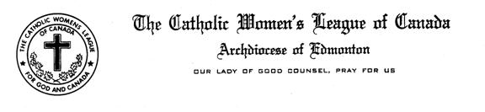

Madame President, Sisters in the League,

A few Councils have tested the Excel template that was provided this fall for managing their finances and found it helpful. If your Council is interested in having this template, please email me at treasurer.edmontoncwl@gmail.com .
We are pleased to report that we ended 2016 with a surplus of $1,970 rather than our budgeted deficit of $3,760. On the revenue side, we received more in the sale of National Supplies (net is ~$1,000). On the expense side, there were several areas where expenses were less than budgeted (postage, mileage, convention expenses). Meeting expenses and Honoraria were over budget because we invited more speakers to our Midwinter and Fall meetings.
We received many Parish Remittance forms in the last few months of 2016. Donation cheques were sent to Sign of Hope ($4,575) and to The Wilberforce Project ($1,930). This should have put both accounts at zero but an error was discovered after the cheques were sent. A cheque ($550) was also sent to St. Charles Council for the Refugee Bag Project. I would like to remind you that this is now on the Parish Remittance form which is available on the website. The Remittance form should be submitted to the Treasurer with one cheque for the total amount made out to ‘CWL Edmonton Diocesan Council’. Mailing them to former Treasurers delays my receiving and processing the cheques. I have a few copies of the Parish Remittance form with me if you would like to get one today.
The Field Workers Liability fund has also been reduced as it was decided to charge expenses for Catch the Fire sessions to that account ($338).
Budgets have been prepared for your approval at this meeting.
This concludes my report. Are there any questions?

