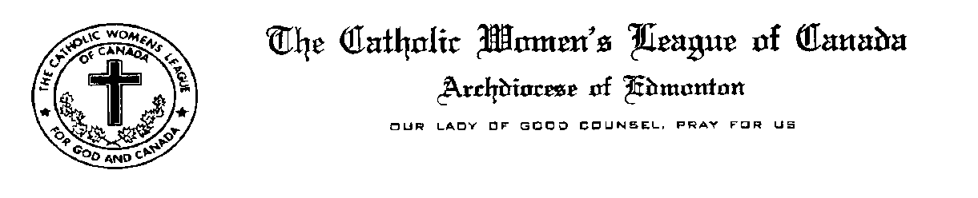
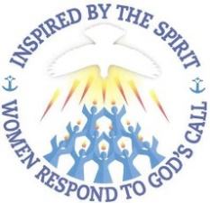
Edmonton Diocesan President’s Report
Midwinter Meeting January 27-29, 2017
OLPH, Sherwood Park

Dear Sisters in the League

Much has been happening since our inspiring Fall Meeting at St. Stephen’s Parish in Olds. Today you will hear about the activities being pursued by your Diocesan Officers in our service to God and Canada. Please know that we are honoured and humbled to be called to serve in this way.

The Edmonton Diocesan Council is presently comprised of 4,622 members in 67 councils which represents a small decrease in numbers of 12 over the previous year. Sadly, one of our councils, Blessed Sacrament in Wainwright provided us with their notice to become inactive and in late November at a meeting attended by myself, Cheryl Boom & Sister Susan they did vote to become inactive… needless to say it was a very sad trip home. Lack of members to assume leadership positions was cited as the overriding reason.

For anyone interested, you will find in the Correspondence Binder located on the head table, a Calendar of Events that your Diocesan Officers have been involved in since April, 2015. Thank you for including us at your gatherings.

In September I attended and brought greetings to the brunch and award presentations at St. Joseph’s Basilica. Father Kris Schmidt & the Basilica youth group provided an energetic overview of their experiences at World Youth Day in Poland.

A memorable 90th Anniversary Celebration was attended on September 17 for Our Lady of Grace in Castor followed by a Catch the Fire Workshop.

We had a good turnout for our Fall Meeting held at St. Stephen’s in Olds on October 3rd. The first guest speaker was Tammy Stankievich, a young teacher from Catholic Christian Outreach Programs who provided an overview of her work as a Missionary and her joy in putting into practice her faith. We were then introduced to four CWL ladies from the Olds area who shared their own personal heartfelt stories about dealing with hospice and palliative care relating to the establishment of the Olds and District Hospice Society and the building of their dream facility to serve the members of their community.

In November, along with Cathy Bouchard and June Fuller I attended the 50th Annual Convention of the Alberta Catholic School Board Trustees Association for their opening night where we were treated to a presentation by Dr. Josephine Lombardi who spoke to a very receptive audience about the cardinal virtues. All of Alberta’s bishops were in attendance.

In response to an invitation from Archbishop Richard Smith, I invited Cathy Bouchard to join me in making a presentation about the CWL on November 9th to the Assembly of Priests for Study Days in the Archdiocese. Our presentation was well received and is posted on the Edmonton Diocesan website. There were three Bishops in attendance as well as over 100 priests…it was great opportunity to reach out to our Spiritual Advisors.

In early December, I prepared a Christmas Message that was emailed to all of our Councils, Life Members and Zone Chairs and posted on the Diocesan website.

Nativity Display at Edmonton City Hall: The City of Edmonton indicated that they would not include the traditional nativity display at City Hall. With this news we sent a letter urging the Mayor and Councillors to reconsider. Reaction by the Christian Community in Edmonton was swift and effective. In response to our letter, we received responses from Mayor Don Iveson and City Manager Linda Cochrane indicating that moving forward the city has decided to strike a committee to determine a long term strategy to include other faiths and would not be removing the Nativity Display. Our letter and the letters in reply are in our Correspondence Binder.

Our Annual December Breakfast meeting with Archbishop Richard Smith and the Diocesan Officers was a wonderful success. Prior to the meeting, we presented His Grace with a letter reporting on CWL activities during 2016 and were very pleased when he initiated discussion based on the contents of the letter.

To date, generally the feedback we have received pertaining to the new Annual Reporting System has been positive and we are now in receipt of the collated reports from National and will use them to prepare reports for Provincial Council. Thank you to the councils who have sent us their completed instructed vote forms pertaining to the proposed increase in Provincial Per Capita Fees. Please remember to canvass your members, complete the form according to their direction and return them to us. We need to hear from you….

Edmonton Diocesan Council has received notice from Good Shepherd Council in Edmonton about their proposed Resolution that addresses the program concerned with the collection of organ donations via provincial drivers licenses. Currently Albertans & all Canadians are required to opt into a collection program to donate their organs whereas this resolution recommends a program be established in Alberta and all of Canada where donors will need to opt out of donating their organs. Countries that have implemented “the opt out” instead of “opt in” program have reported great success & pride in what is being accomplished.

On February 3rd Edmonton Diocesan Council CWL members have been invited to a Mass and reception at St. Joseph’s Seminary to celebrate the new administrative partnership for the Doreen Melton Scholarship which is annually presented to a seminarian. Most of the seminarians will be in attendance and will provide the music for the liturgy. Members of the Doreen Melton’s Family will be in attendance and so we hope for a good turnout. Information is posted on the Diocesan website.

On January 19th I attended an information session with the new Alberta Senior’s Advocate, Dr. Sharee Kwong See which was held at Holy Family in St. Albert. This initiative was brought forward by the ABMK Provincial Council and a petition was circulated throughout our Diocese advocating that appointment of an Independent Senior’s Advocate. Dr. Kwong See is passionate about her new position and at the beginning of her presentation made it clear that she has been given a 3 year contract as a secondment. She remains a Faculty Member at the University of Alberta. She indicated that she is “not afraid of losing her job” and will speak up for shortfalls and injustices as her office becomes aware of them and to that end, invites CWL members to contact her office with any concerns or observations they might have. Consider inviting Dr. Kwong See to one of your Zone meetings.

Several of our Councils will be screening the Euthanasia Deception Video in their parishes during the month of February. The President of the Euthanasia Prevention Coalition will be in attendance at some of the screenings. A list of locations is available on the Diocesan website and we urge you to find an opportunity to see this compelling documentary and learn more about why as Catholics we oppose Euthanasia.

The 95th Annual Edmonton Diocesan Convention will be held at Corpus Christi Church from April 21-23 2017 planned and hosted by South East councils in Zone 9 under the direction of Co-Chairs, Margaret Korte and Bea Salmon. The theme for this year’s convention builds on the Midwinter Meeting theme, “Inspired by the Spirit, Women Respond to God’s Call”. Come celebrate 95 years of faith and service in the Edmonton Diocese.
Thus far, confirmed speakers for the Convention include Archbishop Richard Smith, Edmonton Catholic Schools Superintendent Joan Carr and Madam Justice Debra A. Yungwirth of the Court of Queen’s Bench of Alberta. The women will share their thoughts on how they have brought their faith to their careers. Planning is well underway and we hope to attract around 250 attendees…
Planning for the Alberta Mackenzie Provincial Convention to be held on June 9 & 10 at St. Charles in Edmonton is well underway with a very enthusiastic group of ladies at the helm. Edmonton Diocesan Council has not had the privilege hosting a provincial convention for our ABMK League Sisters in over a decade and so we encourage you to attend what promises to be a great opportunity to be renewed and inspired in the company of our CWL Sisters from throughout the province.
Lastly, please be sure to send in your photos in of activities in your councils during the past year…they will be used by Sister Susan in putting together a power point presentation for our closing banquet at the Diocesan Convention. The power point was very well received at last year’s banquet.

This concludes my report.
Respectfully submitted,
Mary Hunt
Mary Hunt, President
Edmonton Diocesan Council
The Catholic Women’s League of Canada

