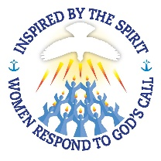
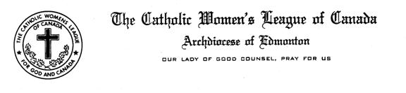

Madame President, Sisters in the League,

I am sad that I am unable to attend today’s Mid-Winter meeting and be with all of you but hope that you all are doing well.

Presently, Edmonton Diocesan Council has 1,487 members in 68 councils. I am anxiously awaiting submission of per capita fees from many councils in our Diocese. We are hoping to exceed last year’s membership of 4622, which was a slight decrease of 32 members from 2015.

As Organization Chair, Membership Renewal, Retention and Recruitment is a very important aspect of my responsibilities. This is a good time to follow up with long serving members who have not renewed their membership to ensure they are not forgotten. I encourage you to use personal contact in recruitment and retention of members as many members have said they joined because they were personally invited. Maybe offer someone a gift membership. CWL is a gift to each of us and our sisterhood has the potential to grow exponentially!

Thank you to each coucil who entered their Annual Reports into the new reporting system before the December 31st cut-off. I understand it went smoother than some would have thought. Annual Reports allow us to capture a unique view of the dedication, enthusiasm and love of the League displayed by our members throughout the diocese. They are an important means of communicating with others in the parish, community and country at large. I am looking forward to receiving the consolidated report from National in the very near future. I always enjoy reading the reports and continue to be in awe of the dedication, love and hard work of our members throughout the Diocese.

Please make sure that your council sent in a completed Service Awards form for 2016 as well as any updates of members that have passed away in 2016. We want to ensure this is included in our Diocesan Annual Report Convention Booklet and in the Book of Life. The deadline for this will be February 1st. Please send to edmontoncwl.presidentelect@gmail.com.

Also, please remember to celebrate the good works being done in your council by nominating members for the various awards available including the Maple Leaf Service Pin, the Bellelle Guerin Award or the Elsie Yannik Award. Provincial Council asks that you complete and submit the form for the Father Walter Krewski Award for membership recruitment. This can be sent to abmkprovpreselect@gmail.com.

I am pleased to inform you that we have 2 new Zone Chairpersons; Zone 1, Paula Nolan and Zone 9, Helga Pasichnyk. Thank you to outgoing Cindy Thompson and Margaret Korte for your dedicated service. I would like to recognize the Zone Chairs that are with us today. Would you please stand up? We are still looking for Chairs in Zone 6 and Zone 8 and ask that you prayerfully discern whether you might be interested in taking on this role within the Diocese. I look forward to hearing from you!

As this is an election year for many councils, including the Edmonton Diocesan, please know that we have Diocesan Officers and Life Members who are willing to come out and present workshops including Leadership Development, Conducting a Business Meeting, Constitution & Bylaws and Policies and Procedures. All you need to do is ask!

At this time I would like to encourage those who are eligible for the upcoming Edmonton Diocesan Council elections give serious consideration to letting your name stand. This is a wonderful opportunity to grow beyond your Parish CWL Council and meet many more members of the CWL in the Diocese. It is sure to be a rewarding, fun, spiritual rich experience. The National Theme for the next 2 years is “Inspired by the Spirit, Women Respond to God’s Call”. I am hopeful that you will be inspired and respond with a YES!

And lastly, please remember to check out our Diocesan, Provincial and National websites as these are kept up to date with important information and resources. Besides the websites listed, League Resource Materials available to you are the Constitution & Bylaws, National Manual of Policy and Procedures, Leading the League, Executive Handbook, to name a few. Please tap in to all these resources!

