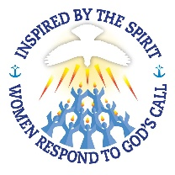
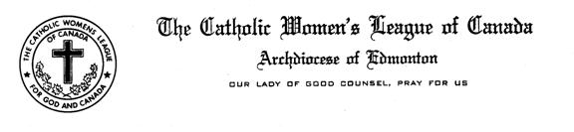

Madame President, Sisters in the Leaguer,

a. Christian Family Life, Katherine Tarras reported –

We have just completed the adoptions for the Adopt-A-Seminarian Project, Thank you for your participation in this endeavor. Please continue your support your Seminarian.

I have with me the raffle tickets for the 2017 March for Life CWL draw to be held at the Pasta Supper on Saturday the 6th of May the prizes are a hand made quilt, a wine basket and chocolate and a painting. We have sent out a letter to all councils requesting their aid in Participation, Funding and/or Silent Auction items for the March and Pasta Supper. The date of the March is Thursday the 11th of May. This will be the 10th Anniversary of the March here in Edmonton and we would like to see as many CWL members there as possible.

For more information www.albertamarchforlife.com

Fun for the Family -Faith and Fun Night with the Oil Kings

The Archdiocese is sponsoring a game between the Oil Kings and archival Regina Pats on Friday, February 10, 2017.

St. Anthony's Parish in Drayton Valley invites you to join us on the February 4-5 weekend for a youth and family ski trip to Marmot Basin and Way of Holiness Retreat Centre!

For more information or to register, please contact Ashley Rhyno, Youth Coordinator, at 780-542- 5254 or email Ashley. Rhyno@caedm.ca

The next weekend in Edmonton for Marriage Encounter is scheduled for June 2-4, 2017.

For more information see http://www.wwme.org.

Please check the National and Provincial web sites for their Communiques.

For the above contact and web site information please our Edmonton Diocesan web site: http://www.edmontoncwl.org

This concludes my report. Are there any questions?

