The Catholic Women’s League of Canada
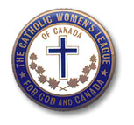
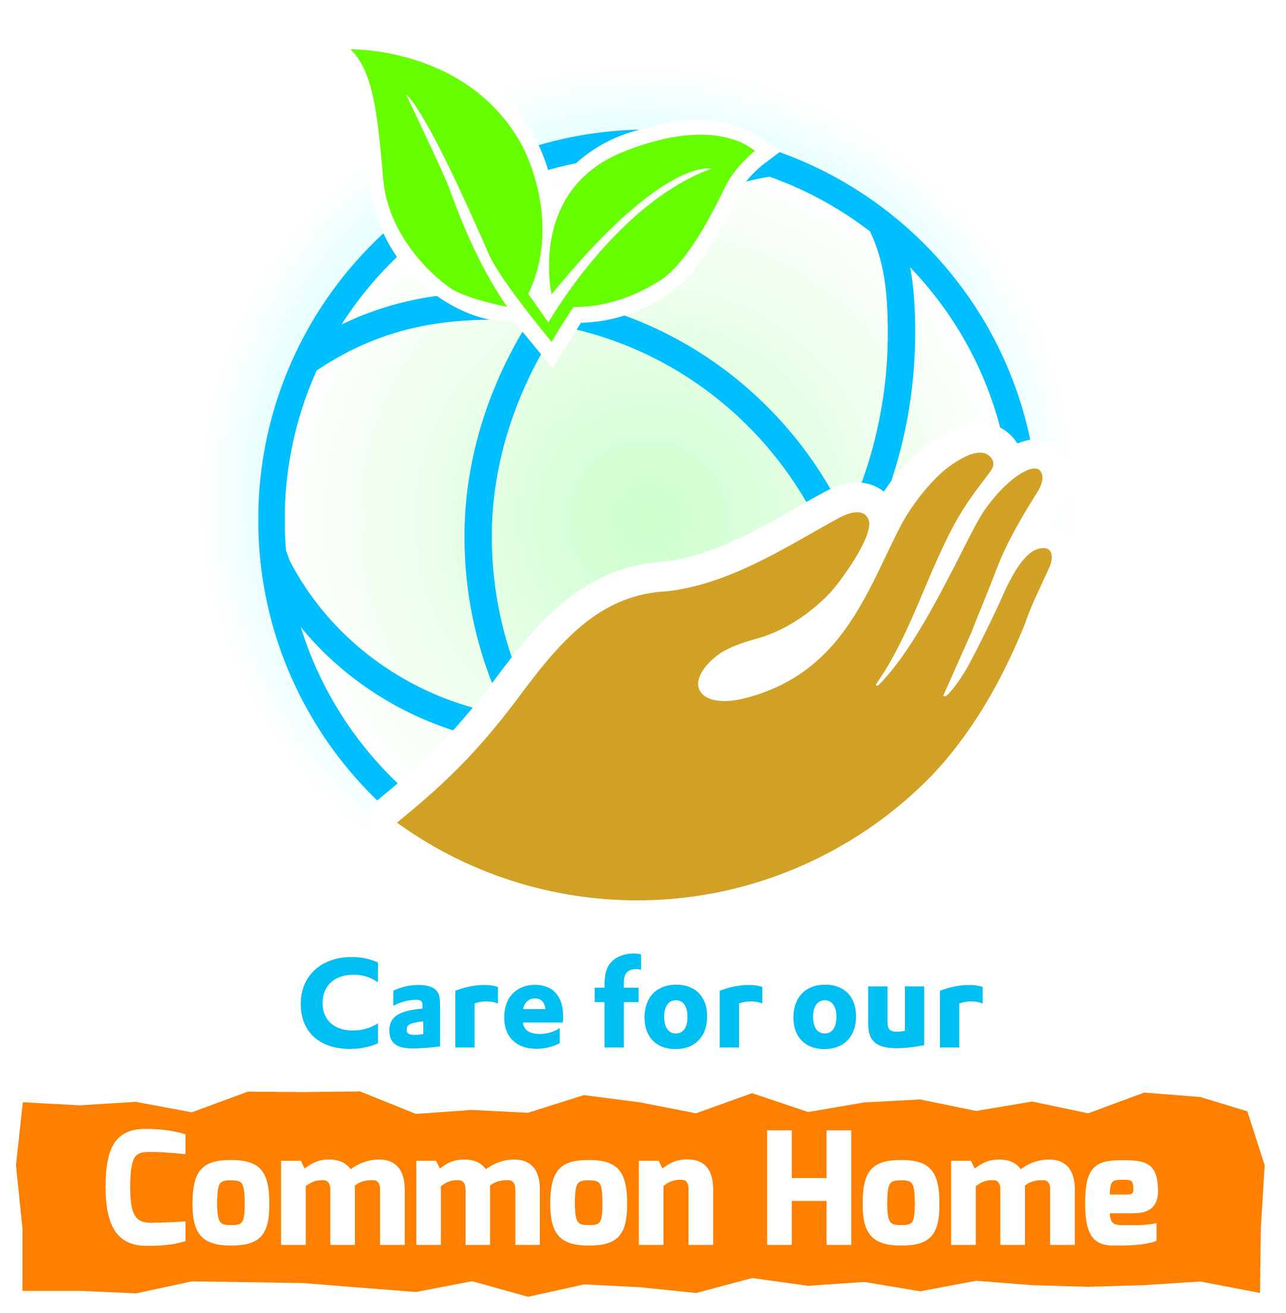
Edmonton Diocesan Council
Memorandum
DATE: November 12, 2020
TO: Council Presidents cc -Diocesan Officers; -Life Members
FROM: Mary P. O’Neill, Resolutions and Legislation Chair, Edmonton CWL Diocese
SUBJECT: Abuse of Seniors in Long Term Care Facilities
Public knowledge of the large number of seniors suffering and dying in long term care facilities due to Covid-19 has raised our awareness of the need to take action and stop the abuse of seniors living in long term care.
Unfortunately abuse may also be happening to a senior living in proximity to you today, who may be a relative, friend or neighbour.
Would you please send an email to Monica Morrison, Treasurer for the Alberta Elder Abuse Awareness Council to express your dismay over what is happening and demand a system for identifying, reporting, treating, and eliminating all cases of elder abuse in Alberta.
A draft wording of an email below is included to assist you when composing your email.
Email: mmorrison@goldencircle.ca
Monica Morrison. Treasurer for the Alberta Elder Abuse Awareness Council
Subject: Request to Eliminate Elder Abuse in Alberta
﻿I believe we urgently need a fully developed system for identifying, reporting, and treating cases of elder abuse. This system would operate at the provincial level, the federal government’s involvement being limited to supporting a national center, which would give technical assistance and funding to the province for elder abuse prevention services.
Initially the focus should be on educating the public on all the forms of senior abuse, how to identify, and the steps everyone is obligated to take to prevent or stop abuse. In addition, the public needs to know how to monitor every seniors’ environment to ensure no senior, they come in contact with, is subjected to any form of abuse whether it be:
Physical abuse – the infliction of pain or injury, physical coercion, or physical or drug- induced restraint. .
Psychological or emotional abuse – the infliction of mental anguish. .
Financial or material abuse – the illegal or improper exploitation or use of funds or resources of the older person. .
Sexual abuse – non-consensual sexual contact of any kind with the older person or
Neglect – the refusal or failure to fulfil a caregiving obligation. This may or may not involve a conscious and intentional attempt to inflict physical or emotional distress on the older person.
Thank you
Sincerely
(Please insert your name, address, phone number as you deem appropriate)

