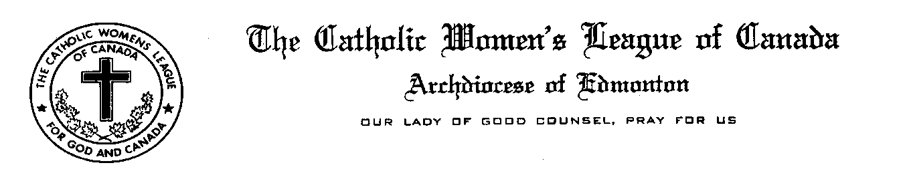
Mary Hunt Telephone (780) 487-3165
7416 -181 Street e-mail maryhunt1982@gmail.com

Edmonton, Alberta
T5T 2H1

October 20th, 2016

Most Reverend Richard W. Smith,
Archbishop of Edmonton,
8421-101 Avenue
Edmonton, Alberta
T6A 0L1

Dear Archbishop Smith:

At the Fall Meeting of the Edmonton Diocesan Council of the Catholic Women’s League of Canada held on October 1st at St. Stephen’s in Olds, a motion was passed that a letter be written to the Catholic Bishops of Alberta commending you collectively for creating and publishing General Principles and Reflections on Sacramental Ministry to the sick and dying in light of the new legislation pertaining to Assisted Suicide and Euthanasia.

On behalf of the 4596 members of the Catholic Women’s League in the Diocese of Edmonton, please accept our gratitude for your leadership, prayers and support. As Catholic women, we are called to assist in serving the needs of the Church and this excellent document is an important reference and guide for anyone ministering in this way. Please know that you and all of the Alberta Bishops remain in our prayers as you continue your important mission on our behalf.

Respectfully yours,
In Service For God and Canada

Mary J. Hunt, President
Edmonton Diocesan Council
The Catholic Women’s League of Canada
ONE Heart, ONE Voice, ONE Mission

cc. Most Reverend Frederick Henry, Diocese of Calgary
Most Reverend Gerard Pettipas CSsR, Diocese of Grouard-McLennan
Most Reverend David Motiuk, Eparchy of Edmonton
Most Reverend Gregory Bittman, Auxiliary Bishop of Edmonton
Most Reverend Paul Terrio, Diocese of St. Paul

