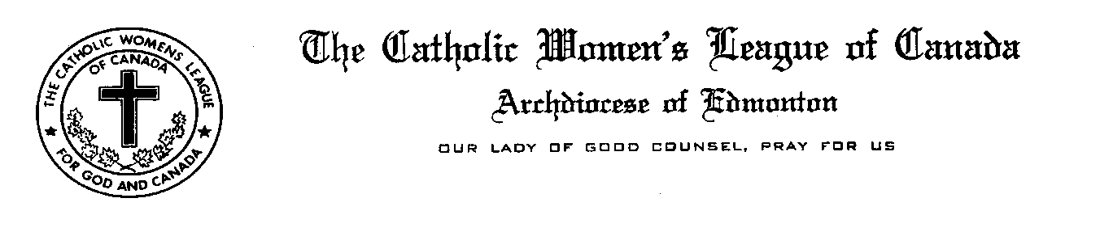
May 1st, 2016

Prime Minister Justin Trudeau
80 Wellington Street
Ottawa, Ontario
K1A 0A2

Dear Mr. Prime Minister,

On behalf of the almost 4600 members of the Edmonton Diocesan Council of the Catholic Women’s League of Canada, I am writing pursuant to a Resolution that was passed at our 94th Annual Convention that was recently held in St. Albert. The Resolution pertains to the Right to Quality End of Life Care availability for Canadians wherever they may reside whether it be in a rural or municipal setting.

To that end, we urge the Government of Canada to develop and promote a hospice and palliative care strategy which makes having access to quality, comprehensive and integrated palliative and hospice services, regardless of where one lives in the country available to all Canadians.
This will impact thousands of Canadians annually and is a cornerstone to the fundamental belief held by Canadians that their health care system is both caring and compassionate.

We believe in the power of prayer and please know that we will keep you in our prayers as you consider and enact strategies and policies pertaining to hospice and palliative care in Canada.

Together in Service
For God and Canada,

Mary J. Hunt, President
Edmonton Diocesan Council
The Catholic Women’s League of Canada

7416 – 181 Street Edmonton, Alberta T5T 2H1
Phone: 780-487-3165
Email: maryhunt1982@gmail.com

