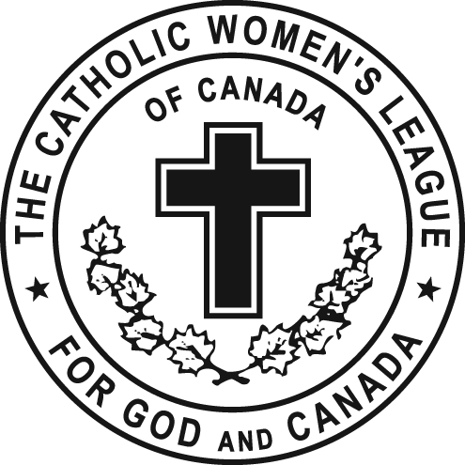

Edmonton Diocesan CWL Convention 2016
Family Life Oral Report

Madam President,
This was the 21st year for the Diocesan Poster -Essay-Poem Contest theme came from Laudato Si by Pop Francis. “Hear both the cry of the earth and the cry of the poor” In hope that students would be inspired by seeing what they could do help both the poor and the earth. The Question that was asked of the Kindergarten to grade 6 was “How do you think God would want you to take care of the earth and the poor?” For the 7 to 12 they were asked “How can you and others make a difference in protecting the earth and its environment in helping the poor and less fortunate?” We received 1007 entries this year with 25 school and three home schooled students participating. The Awards will be presented on Sunday at 11:00 am. If you would like to have a package with some of the art work, please let me know as I have some prepared so for you to take back to the extended care facilities in your area. I would like to thank my committee for all their help and a special thank you to Annette Paterson the past Education Cahir your kindness and help has been a blessing.
It has become a tradition that at convention that we have a memento of some sort from Edmonton Catholic Schools. This year we have a Prayer Coin. … Celebrating our faith, Catholic Education and the CWL. On the one side we have one heart one voice one mission with the CWL at the center of it. on the flip side we have Edmonton Catholic Schools with the cross and we share the spirit of the dove that represents both of us. This year’s theme for the district is LIFE OF GRACE … JOURNY OF LOVE… if you look closely you can see how they both relate. We would like to acknowledge and thank Joan Carr for her continued support of the CWL and for providing this year’s token... We have the coins at the front. we are asking Council Presidents to collect the number that is needed for each council.
This years World Catholic Education day will be on Thursday May 5, with the theme “opening the doors of Mercy” Please take a moment and pause, reflect and pray for the gift of Catholic Education. The Minister of education has received all but one Gender inclusions policy from Alberta School Boards. At this point, he is just reviewing and having dialogs with some of the Boards. An official statement is not expected anytime soon.
A new initiative that my self and Katheryn Tearres from Christian family life will be working with the students form the woman’s residents of St. Josephs collage at the U of A that something very similar to adopt a seminarian… we will be bring forward more information at the fall meeting.
Newman Theological College offers flexible learning in various formats: online, face to face, and a blended program. students can work towards certificates in Catholic studies or variety of other programs, The Bursary & Scholarship Application Form. is a detailed application process, but those willing to go through the process stand a good chance of receiving a bursary. The deadline for application is July 15 for the next school year.
Hats on for mental heath, Mental health awareness Week May 2 to 8 for 2016. The Canadian Mental Health Association wants to empower people to live with better mental health and to break the stigma of mental illness. Statistics show that only one in 5 youth with a mental illness will receive the mental health services that they need.

The Alberta Teacher Association have asked schools to relax school rules and encourage students to show support for mental heath by wearing a fancy fedora or a charming chapeaux to school on May 4th to bring awareness to this issue.
Janet French journalist from Edmonton Journal wrote Alberta doctors stepping forward to offer physician- assisted death it starts off with “nearly 80 doctors have told Alberta Health Services that they are willing to preform physician-assisted death. And I quote “we need to start thinking about this in terms of normalizing it (because) this is where we are going” Doctors will also be able to prescribe a deadly cocktail that allows patients to drink a slurry on their own at
The Prime Minister has scheduled the debate of bill C-14 to start on Friday… which would have been yesterday at 10:00 am… He says that it’s a matter close to his heart saying its “important and personal” a few good things on this… You still have time to write your MP’s and MLA’s and express your selves… Some MP’s have been very open about still wanting to consult their constituents on the matter that they have not come to a decision so it leaves me with a glimmer of hope that maybe our voices will be heard. I could stand here and tell you all the horrible things that are yet to come… but I’m sure you are aware… take the time and write a letter and let your voices be heard. I do have so sample letters at my booth or get creative and write you own… and encourage others to do the same
I would like to conclude by reading the Catholic Education Week Prayer.
God of love and compassion,
Help us to open the doors of mercy in our school communities,
In our families and in the world.
Let mercy guide our living and bring us closer to the heart of the gospel.
May we live as Jesus with mercy that welcomes, loves, forgives and calls us to live the gospel joyfully.
Amen

Thank you…This concludes my report are there any questions….
Madame President I have one resolution under this convenorship.

Respectfully submitted,
Cahir Education and Health
Kara Pelech

