The Catholic Women’s League of Canada
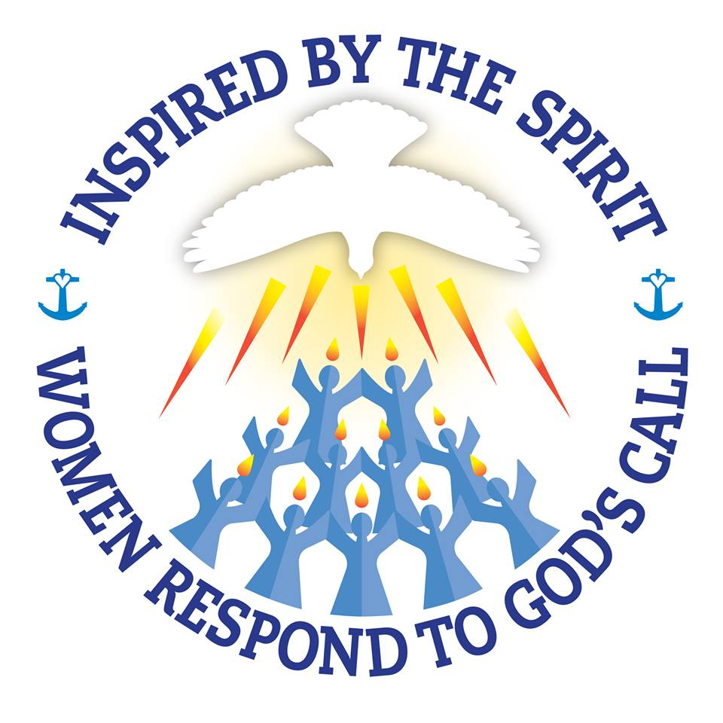

Edmonton Diocesan Council

Education and Health Report – September 29, 2018

Madame President,

Education
Each of our CWL Edmonton Diocese Councils are encouraged to celebrate, preserve, promote and enhance Catholic education.

“Being Catholic” means that, our Catholic faith is a foundation and embedded in everything we do. Our Catholic faith permeates all aspects of a child’s educational experience—in what they learn and how they live. All Alberta district schools have an established Catholic Community of Caring based on the values of faith caring, respect responsibility, trust and family.
Our Alberta Catholic education is a unique partnership between the school, home, and parish. Together, this triad seeks to develop a student’s whole person by integrating academic excellence and faith. The central focus of Catholic education is Jesus Christ.

Our Alberta Catholic Schools are distinctive faith communities that nurture the spiritual, academic and physical needs of students through the integration of the Alberta Education curriculum with gospel values and sacramental life. Christ is the centre of the Catholic school and his presence and teaching permeate the school building.

To be sure, Alberta Catholic schools offer an integrated curriculum of faith formation and academic development in an endeavour to form the student’s whole person. This puts our Alberta Catholic schools in a unique position within the publicly-funded education system, on that is celebrated by the community; and, guided by the work of our Alberta Catholic school trustee.

As a CWL member we are all called to live out our faith every day at home, and in our community to be good citizens. When we care for others we treat them with love and kindness. God has created each one of us uniquely; and, has given us special gifts and talents to become contributing members of society.

Health
The leading cause of injury in Canada is falls, according to Alberta Health Services, falls accounted for 46% of injury related hospital admissions in 2017. Good balance can help prevent falls and along the way, ensure we live active and healthy lives. Particularly, as an older adult we need to pay attention to stay steady on our feet.

Good balance is needed to do just about everything physical, including walking, getting out of a chair and bending over to tie our shoes. Balance can be improved by being active every day and participating in a variety of activities such as yoga, tai chi and resistance exercises. The most effective balance building movements involve moving your centre of gravity and building lower body strength.

Worries about falls don't need to keep you indoors. Outdoor activities like walking have big benefits for your health. You will need to watch your step and learn a few safety measures.

If you are worried about having a fall outdoors, ask your doctor about exercises, classes, or physiotherapy that may help. You can learn ways to gain strength, flexibility, and balance. Ask if it might help to use a cane or walker.

It’s a good recommendation to check out activities at your local seniors centre or talk to your healthcare provides for strategies to help you keep your balance.

This concludes my report. Are there any questions?

Mary Pat O’Neill,
Education and Health

