'Ecological Island' in Vatican aims for optimum disposal of waste
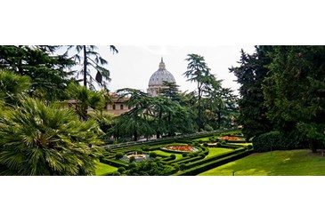
2016-11-14 Vatican Radio
(Vatican Radio) A so-called “Ecological Island” has sprung up in the Vatican with the aim to recycle and dispose waste in the most sustainable manner.
As from Monday, 14 November, a special area has been set aside inside Vatican City State to optimize waste management in accordance with the most advanced waste legislation and technological means available.
Although the Vatican’s territory is extremely small, the tiniest State in the world does produce waste and started a formal waste and recycling collection program back in 2008.
More than 200 drop-off containers for household trash and recyclables were strategically placed throughout the 110-acres that make up Vatican City State. 42% percent of those were designated for source-separated paper, glass, plastic and aluminum containers.
The newly inaugurated ‘ecological island’ provides a space where all types of waste will be dealt with and disposed of according to the specific indications of its category.
The first category being processed is that of paper and cardboard which will be compacted and recycled by some thirty workers who have been trained also to deal with bulk waste, white goods, tires, household hazardous waste, outdated pharmaceuticals, fluorescent bulbs, renderings from the butcher shop and of course organic compost – which is put to good use in the Vatican’s lush gardens.
A press release points out that Pope Francis’ encyclical ‘Laudato Sii, on the care for our common home’ played an important part in jolting the system into action! And yes; this is no small contribution towards a waste and recycling program which has ended up boasting a pretty impressive array of services by anybody’s standards.
(from Vatican Radio)

