St. Alphonsus Parish
Divine Mercy Chaplet

Date: Sunday, April 24, 2022
Where: St. Alphonsus Church
Time: After the 11:00 am Mass

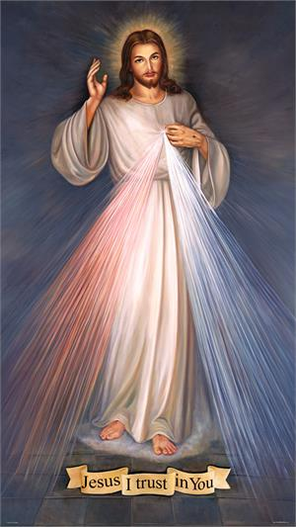
The message of The Divine Mercy is simple. It is that God loves us – all of us. He wants us to recognize that His mercy is greater than our sins, so that we will call upon Him with trust, receive His mercy, and let it flow through us to others. Thus, all will come to share His joy.

The St. Alphonsus CWL invite you and your families to join us in praying the Divine Mercy Chaplet to proclaim the timeless message of God’s merciful love. This powerful prayer draws us back to the great Sacrament of Mercy, the Holy Eucharist, where the living Lord, who suffered and died on the Cross and whose Heart was pieced with a lance, pours forth His mercy on all humankind, and grants pardon to all who draw near and honour Him.

We look forward to praying the Divine Mercy Chaplet with all of you on Sunday, April 24, 2022.
Please plan to attend.

