Discovery of plastic-eating caterpillar could prove a boon in waste disposal
Beekeeper's accidental find offers hope of a biodegradable solution to plastic garbage
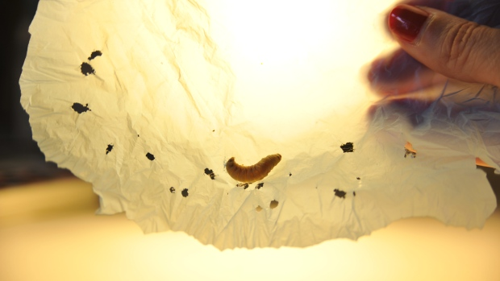
An accidental discovery of a caterpillar that eats plastic could one day lead to the elimination of plastic waste, researchers hope. The fast-eating caterpillar known as Galleria mellonella, a wax worm, is sometimes used as fish bait. But the caterpillars are also known to beekeepers as parasitic pests that lay eggs in hives where the offspring grow and feed on beeswax. Paolo Bombelli, lead author on the paper published in Current Biology, said the discovery occurred purely by accident. His colleague Frederica Bertocchini, an amateur beekeeper (and a co-author of the paper), was puzzled after finding holes in the plastic bags in which she'd deposited wax worms removed from her beehives. She asked him what he thought about it. "I said, 'I was thinking perhaps you should use plastic bags that are not biodegradable,' and then we just laughed about it," he told CBC News. "One year later, she got in touch with me again, and said, 'Listen we're having the same problem, but this time I'm sure they're not biodegradable plastic.'" After further study, they discovered it was the wax worms causing the holes. In order to probe deeper, researchers from the Institute of Biomedicine and Biotechnology of Cantabria as well as the University of Cambridge collected about 100 wax worms and exposed them to a supermarket plastic bag. Within 40 minutes, holes began to appear. After 12 hours, the wax worms had reduced the mass of the plastic bag by 92 milligrams. But it's known the caterpillars are able to break the extremely stable molecular chain in the polyethylene plastic, transforming the polyethylene to ethylene glycol, essentially breaking the bonded molecules. It's the chain's stability that makes plastic so difficult to break down in nature. The wax in beehives has a chemical composition similar to that of plastic bags. "I was surprised about the similarity of the chemical structure between wax and the plastic," Bombelli said. "The caterpillar is able to munch through the wax the same way they are able to munch through the polyethylene.… The caterpillar probably doesn't really notice that there is a difference between the wax and the polyethylene."
The researchers are quick to note that another species of wax worm was known to be able to biodegrade plastic as well. In 2014, scientists discovered the Plodia interpunctella could chew through polyethylene. They isolated the bacterial strain responsible for the biodegradation, though it acted significantly slower than in the recent discovery. As well, the biodegradation in that case didn't transform the polyethylene to ethylene glycol.
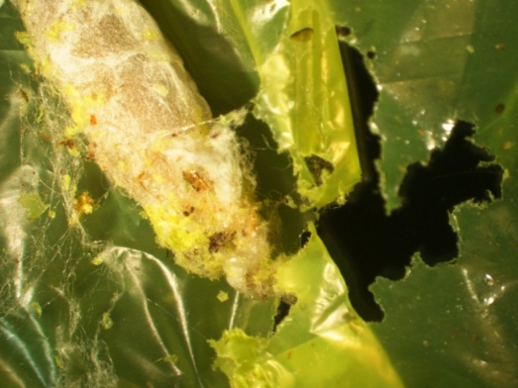
A 2015 study estimated that about 275 million tonnes of plastics was generated in 2010, with approximately eight million tonnes entering our oceans. A subsequent study estimated that the number of microplastic particles — those measuring five millimetres or less — ranged from about 93,000 to 236,000 tonnes. This new discovery could pave the way to the creation of a biodegradable solution, Bombelli said.

