Celebrate World Day of Prayer 2022

‘I know the plans I have for you.’ Jeremiah 29.11
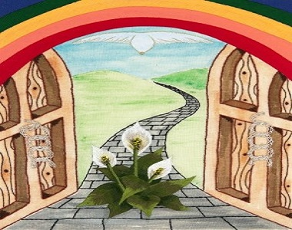

Angie Fox, the artist for this year’s poster describes her images included in the drawing:
Freedom: an open door to a pathway across an endless open vista.
Justice: broken chains
God’s Peace and Forgiveness: the dove of peace and a peace lily breaking through the pavement.
Over all: the rainbow represents the overreaching love of God.’

Join Us for This Year’s Virtual World Day of Prayer Service!
When: Fri Mar 4, 2022 7:30pm – 9:30pm Mountain Time - Edmonton
Where: ZOOM
Follow link to register:

https://us02web.zoom.us/meeting/register/tZIufuirqTwvE9bsRWyYfVXmecxBosjD8KZh

Click on register to receive the link you will use on March 4th to join us.

