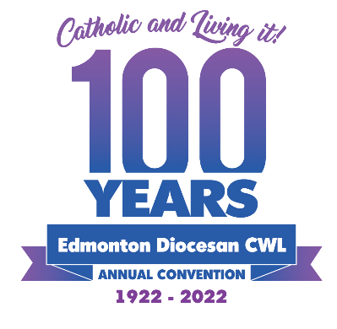

February 28, 2022

Dear Sisters in the League and Spiritual Advisors:

Planning is well underway for the 100th Annual Convention of the Edmonton Diocesan Council to be held on April 29th, 30th and May 1st, 2022 at the Norseman Inn, 6505 – 48 Avenue in Camrose, Alberta. We have so much to celebrate in our 100th Year! We have some catching up to do after not being able to gather in person for the past two years!

Enclosed is the Annual Convention Package including: (1) Notice of Annual Convention, (2) Registration Form, (3) Credentials Form and, (4) 100th Annual Convention Program Outline. Also, one important reminder to all Council Presidents: Please bring your council’s instructed votes and your council’s banner to the Convention.

We are pleased to announce that His Grace Archbishop Richard Smith of Edmonton, will be a Guest Speaker on Friday, April 29th at 3:00 p.m. His Grace will preside at the Opening Mass at 5:00 pm at St. Francis Xavier Catholic Parish. We encourage you to invite your Spiritual Advisors to join you on Friday afternoon and to attend the Opening Mass.

Sandra Prather will open our three days together with a Retreat entitled “Catholic and Living It! Walk in the Light”. We look forward to welcoming the 2021 and 2022 Doreen Melton Scholarship winners and we will also be acknowledging Council Anniversaries that were missed due to COVID restrictions.

At the meetings, we will be selling a souvenir convention coffee mug for $10.00 with the proceeds going towards the Sacred Heart Catholic Parish of the First Peoples - Stained Glass Window Project. These souvenir mugs can also be pre-ordered. The Convention Committee will supply the morning refreshments but, to keep our convention environmentally friendly, we ask you to bring your own coffee or tea cup.

I am looking forward to welcoming you for a weekend of faith and fun. If you have any questions or need clarification, do not hesitate to reach out. We are more than happy to help you.

See you on the 29th of April! Stay safe and God Bless!

Mary Molloy
Edmonton Diocesan CWL President

