The Catholic Women’s League of Canada
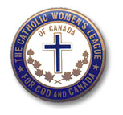
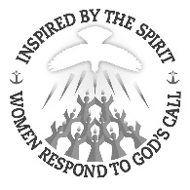
Edmonton Diocesan Council
Memorandum
DATE: December 9, 2020
TO: Council Presidents cc -Diocesan Officers; -Life Members
FROM: Mary P. O’Neill, Resolutions and Legislation Chair, Edmonton CWL Diocese
SUBJECT: Pamphlet for Resolutions; Archived Resolutions – 2020; and Outline for letter writing
Attached to this memorandum, you will find a new guide for resolutions, for your files and for distribution to your members. Also attached is a chart of resolutions archived by National Office. Once resolutions are archived, a council can write a new updated resolution to be relevant today. As well, attached is an outline for CWL letter writing.
Please encourage your members to continue to write letters, make phone calls and visits to their MLAs or MPs. It’s still not to late to write a letter with regards to Bill C-7. You can go to the Government of Canada website of Bill C-7 under “LEGISinfo”.
As we continue to fight the pandemic, I pray that each of you are staying healthy and keeping well. The end does not appear in sight.
/mo’n

