Feast Day of Our Lady of Guadeloupe December 12th
National Day of Prayer in Solidarity with Indigenous Peoples
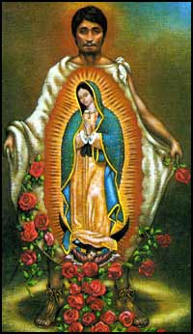
O Great Creator, we give praise and thanks for our lives and for our families
Your gift to us of human community, is one of Your greatest blessings
We thank you for our Elders-our grandfathers and grandmothers-whose patience and wisdom guide our lives.
We thank you for our fathers and mothers, who by giving their love to each other bring us into the world, nurturing and leading us.
We thank you for our brothers and sisters, with whom we come to know what sharing and caring really means.
We thank you for young people, whose hope for a better world, energizes and inspires us.
We thank you for the little ones-the children- whose innocence and promise brings gladness and joy.
O Creator, may our families always be that blessed and first community that we honor and trust.
As you continue to make all things new, may we hear Your invitation-in all creation- to receive and share all that is good and true with each other.
O God, we also face many challenges and crisis in our lives and world.
May our families continue to be the first and constant community that shows us how to live intimately and respectively with all people, and all Creation.
May the Glory, Praise, Honour and Thanksgiving be shown to You, Father of all mercies and compassion, Jesus Savior and Guardian of our souls, and Spirit of peace and communion. Amen

