VIDEO: “The Pope is with You”
Archbishop Richard Smith explains what occurred within today’s emotional papal encounter as the Assembly of First Nations delegates shared time together with Pope Francis at the Vatican today, March 31, 2022.
https://www.youtube.com/watch?v=vPIr3tDB98M
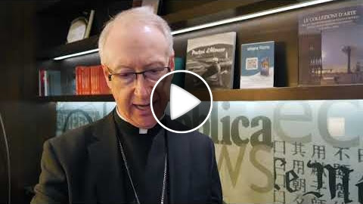
In Spiritual Support and Prayer for Reconciliation
Father Les is celebrating a prayer day today Thursday, March 31, with a Living Rosary at 5 p.m. (with candles) and Mass 6 p.m. (includes smudging, Elders' prayer and Elders' message, Four Directions) at Our Lady of Mercy Parish in Enoch, just west of Edmonton. You are invited to attend and join together in prayer and support.

https://www.youtube.com/watch?v=bcL3cPvpYRo
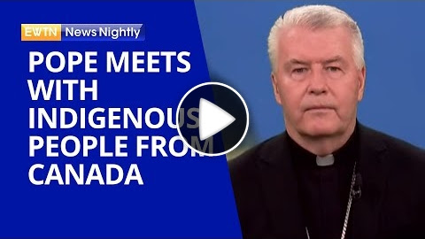
Bishop William McGrattan (Diocese of Calgary) shares how the meetings between the Holy Father and the indigenous groups are going so far. With talk that the Holy Father might travel to Canada soon, possibly even during this coming summer, Bishop McGrattan explains what a visit from Pope Francis to Canadian soil would mean for everyone involved here at home.

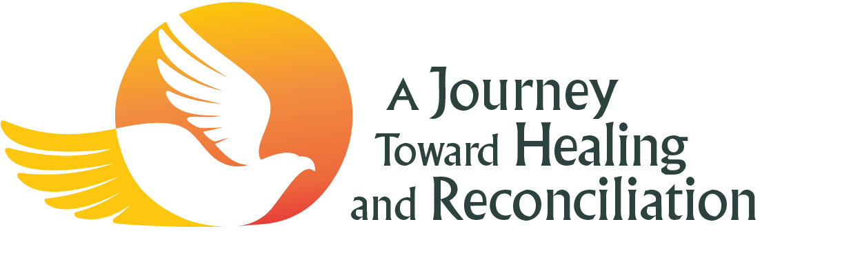
After each of the delegations’ private encounters with the Holy Father, media briefings are held. Today, the media briefing was held with First Nations delegates including Elder Fred Kelly, Regional Chief Gerald Antoine, Kukpi7 (Chief) Roseanne Casimir (Kamloops), Dr. Wilton Littlechild, former AFN National Chief, Phil Fontaine, Grand Chief Mandy Gull-Masty as well as Youth Delegate Rosalie LaBillois, accompanied by Archbishop Smith and Bishop Raymond Poisson.
For readers who may be unfamiliar with this setting, it is traditional to patiently listen to a full context before hearing a powerful message, so that it can be properly understood and fully grasped.
Their testimony is detailed and heartfelt, and sometimes painful, bringing to mind the suffering of saints...similarly, these stories also offer amazing hope and optimism that all of us as a Church can "#WalkTogether" and create a new path to acknowledge, understand, learn, atone, forgive, reconcile, and move toward a hopeful future of dignity, respect, and healing.
Tomorrow's papal encounter will feature all three groups, Inuit, Métis, and First Nations together with the Holy Father Pope Francis, and until then we pray together for his Christ-filled response.
NOTE: You may need to FAST FORWARD to 49 minutes, where the action begins.
https://www.youtube.com/watch?v=783B5huN348
