Today was the third day in Rome for the Indigenous delegations to the Vatican seeking reconciliation
After the adrenaline of meeting the Pope and the excitement of intense and emotional meetings, all which came after long international flights, many were feeling the jet-lag. So today was a bit quieter, after delegates visited the Anima Mundo Museum to discuss the Indigenous items collected there, and got ready for a "field trip" tomorrow....a bus trip two hours north of Rome to Assisi, the birthplace of St. Francis (1181–1226).

The world's media have their attention focused on the Vatican, so there were plenty of interviews to do...
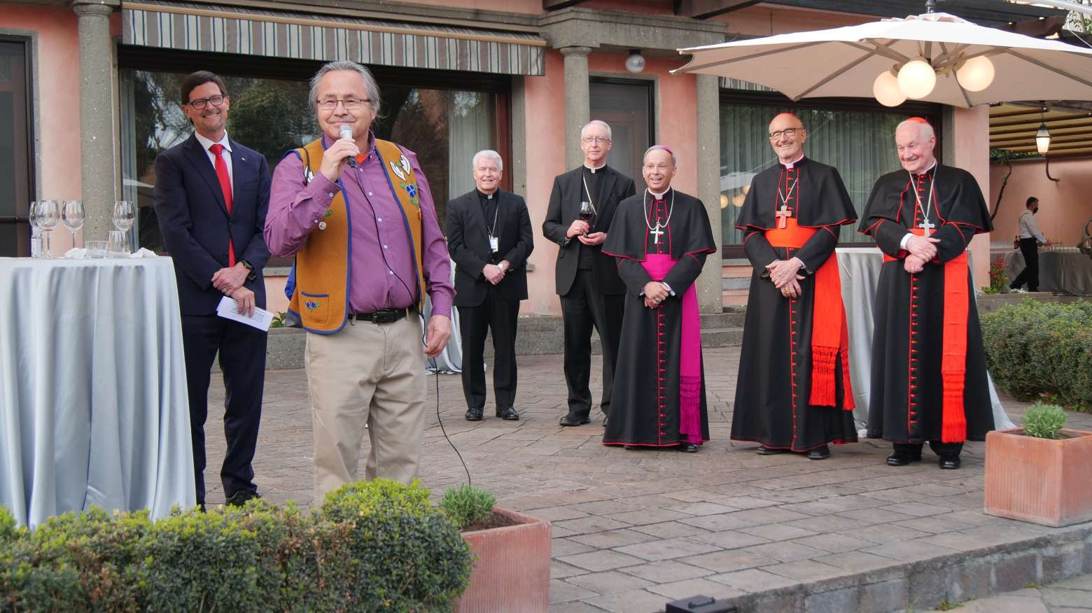
Chief Antoine (Dene National Chief) spoke outside the Canadian Embassy to the Holy See, hosted by charge d'affairs Paul Gibbard. Among those you'll recognize behind him are Cardinals Oullette and Czerny. Everyone is enjoying Chief Antoine's warmth and humour, as he quipped "Our elders told us that our land was very big, so we thought we'd come check it out over here [in Rome]!"
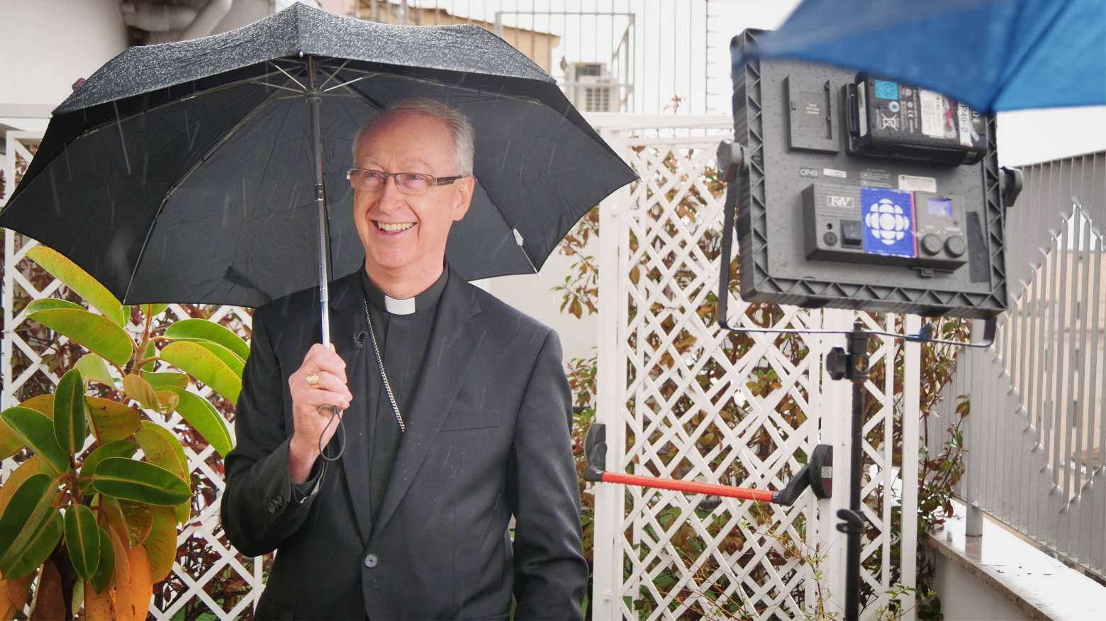
Even in the rain, Archbishop Smith was ready to explain what was happening with a smile on his face. Here he's speaking to Kate Kyle, a producer with CBC National News, while on the terrace at the Best Western Plus Universo Hotel where Canadian delegates and their supporting staff are staying.
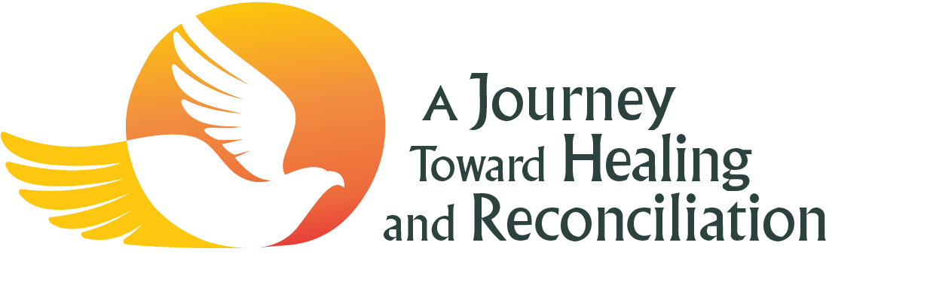
Salt + Light TV will have livestreamed coverage of each event available to watch at
slmedia.org/he....

VIDEO: Watch the Media Briefing following the meeting between Pope Francis and the Inuit delegation at https://www.youtube.com/watch?v=nf6VuvIrnos (click on the YouTube link as the image below is not a link)

