#Walking Together – Towards Healing & Reconciliation
Today was the first day of historic private meetings between Canadian Indigenous delegations and the Pope at the Vatican. We heard heartfelt and passionate remarks from the delegates following their meetings with Pope Francis, including important reflections on the path forward for truth and reconciliation.
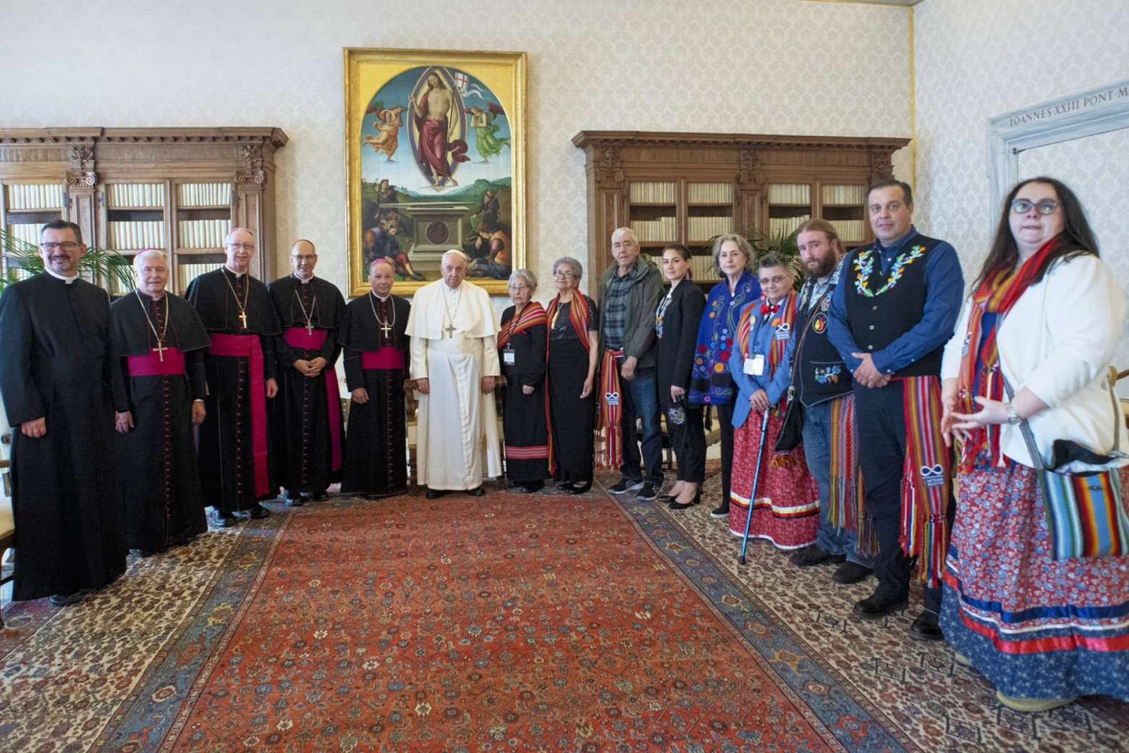
The Métis delegates (above) and Inuit delegates (below) each arrived at the Vatican for their private encounters, separately sharing an hour in meetings with the Holy Father.
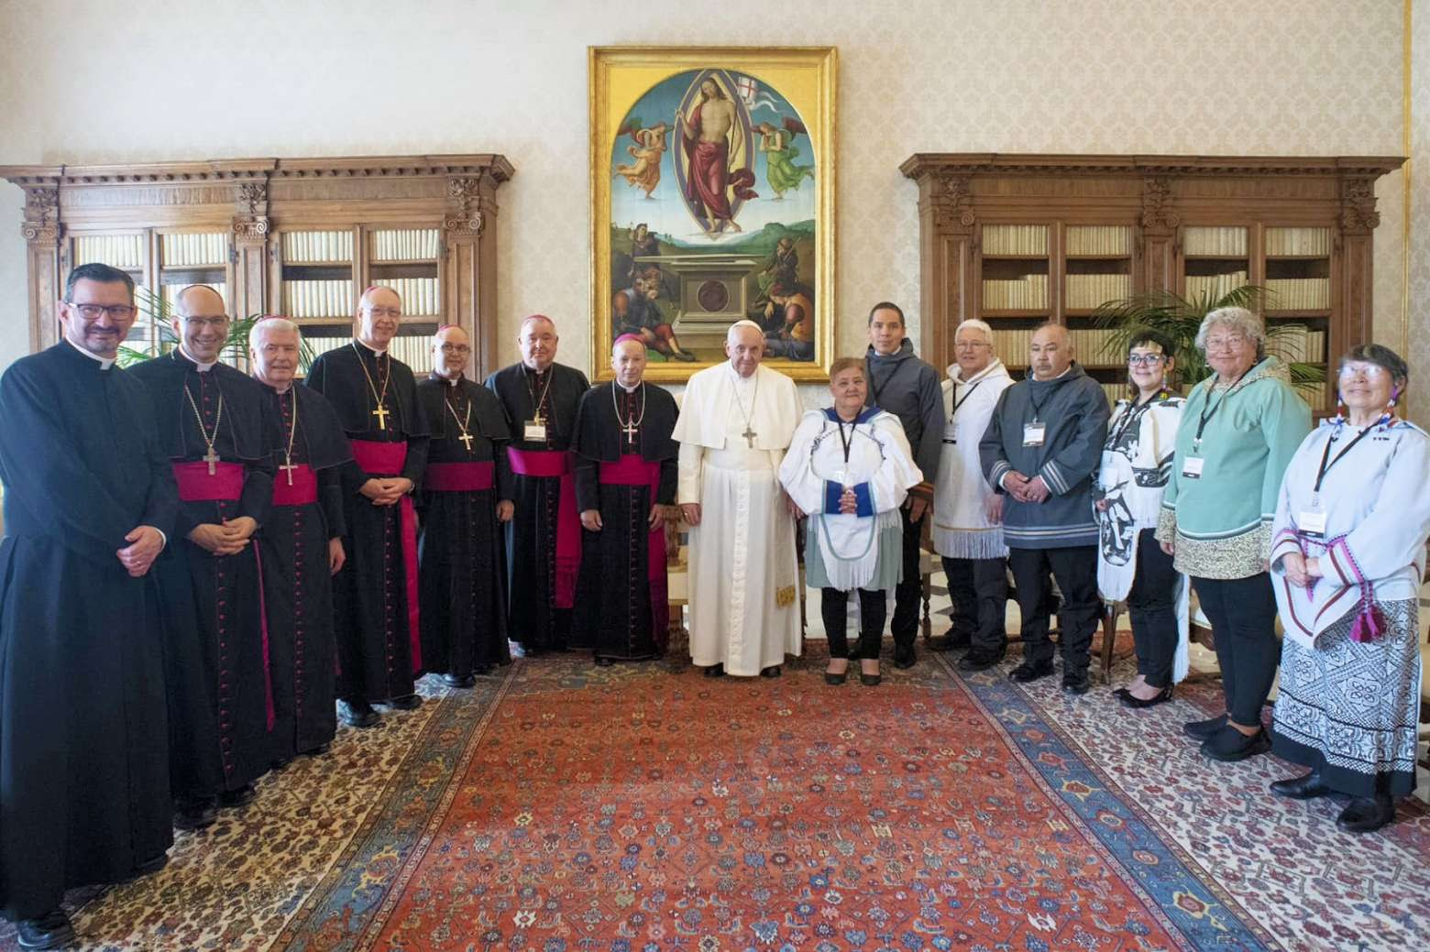
These two private encounters this morning between Pope Francis and Métis delegates and with Inuit delegates symbolized an important step on the journey towards reconciliation. We remain committed to #WalkingTogether.
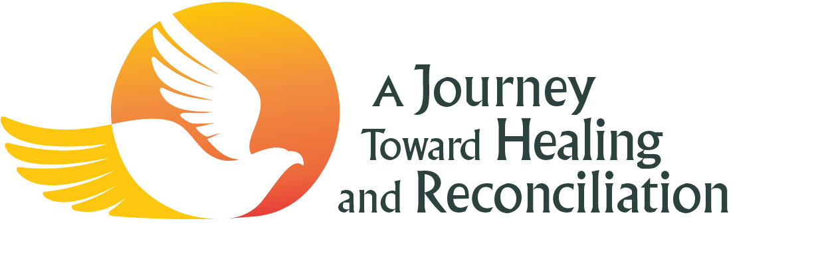
Salt + Light TV will have livestreamed coverage of each event available to watch at
slmedia.org/he....

VIDEO: Watch the Media Briefing following the meeting between Pope Francis and the Inuit delegation at https://www.youtube.com/watch?v=nf6VuvIrnos (click on the YouTube link as the image below is not a link)
