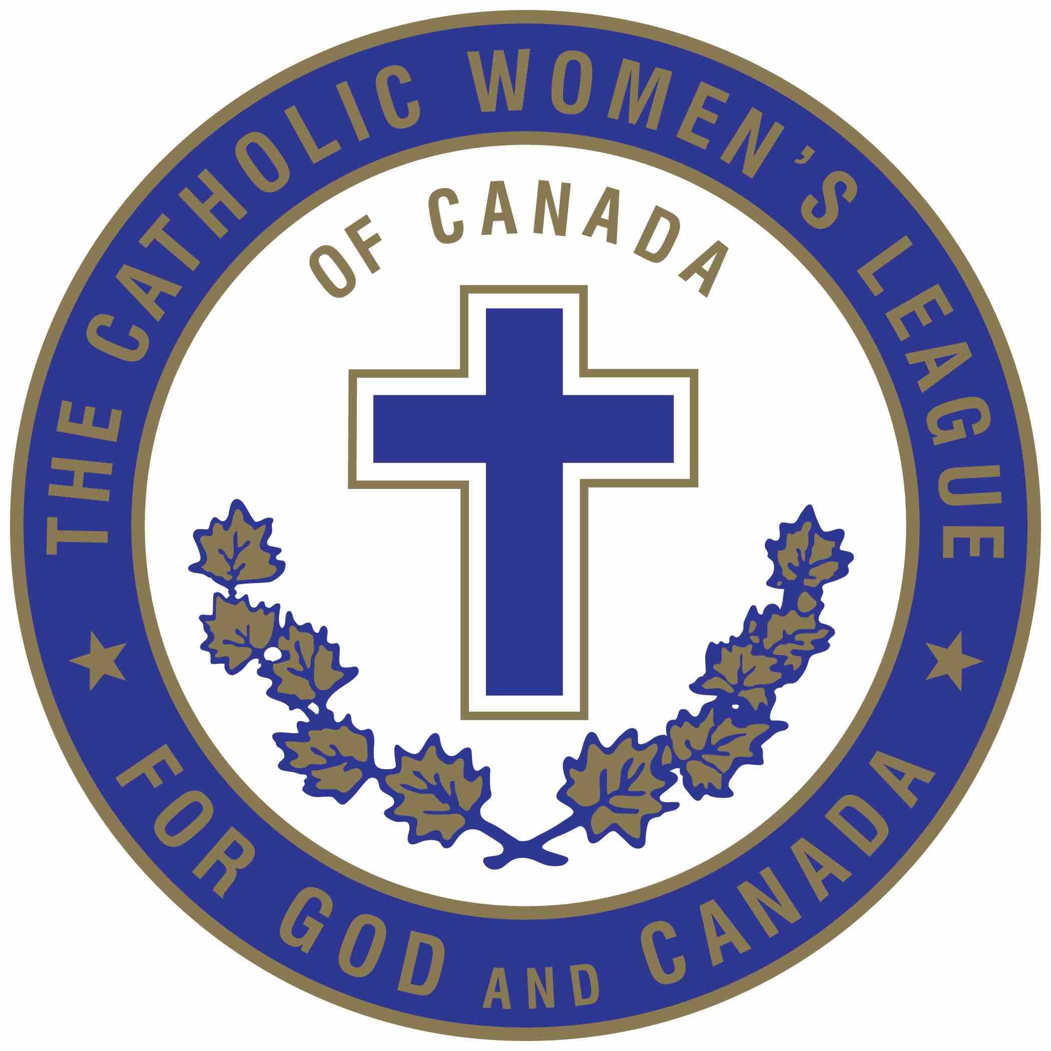
The Catholic Women's League of Canada
Alberta Mackenzie Provincial Council

Christian Family Life Chair
Communiqué 10
DATE: March 26, 2022
TO: Diocesan Chairpersons Christian Family Life
CC: Provincial Executive (for information)
CC: National Chairperson of Christian Family Life (for information)
FROM: Celine Berlinguette, Provincial Chairperson of Christian Family Life

“There are two victims in every abortion:
a dead baby and a dead conscience.” – Saint Teresa of Calcutta

During the past two years, our activities have been curtailed by the corona virus pandemic. Individuals were asked to work from home wherever possible, events were cancelled, lock-downs became common events, and even our churches were limited to the numbers allowed to attend the Holy Masses. Many people lost their employment or had to take a cut in hours of work and pay. Times were tough!

Two areas that were not affected by the pandemic were abortions and medically assisted deaths. Over 100,000 abortions take place in Canada every year, with nearly 14,000 of those taking place right here in Alberta. Abortions have become the number one cause of death in Canada.

Since the legalization of medically assisted deaths in June 2016 until June 2020, 21,589 Canadians ended their live with medical assistance, with a whopping 35% of deaths taking place in 2020.

Over forty years ago, the following article appeared in the “Catholic Quote”. It was written by the Archbishop of Canterbury:

Nation damnation – Materialism – Secularism -
One of the most urgent functions of the Church today is to proclaim
that it is possible for a nation, as for an individual,
to progress materially and regress spiritually,
to gain the world and lose the soul;
to reach the moon and have hell on earth;
to know a great deal, and be very foolish;
to have a house well furnished, and a mind like a sewer;
to feed, clothe and educate our children, yet so neglect their spiritual
welfare as to set their feet on the path to destruction;
to be so broad-minded as to be utterly shallow;
to be so “with it” as to be without Him;
to refuse the absolutes of God’s law, and land in the sands of moral chaos.

My dear sisters, is that not what is happening in our world today, are we not living in a state of chaos?

When a woman has no quorum about killing her unborn child or an individual is euthanized because of sickness, mental health issues or is disabled, what does that tell us about our moral values?

The lives of unborn children are subject to unprecedented threats. Catholics are called to do more than merely avoid complicity in killing. We are called by Christ Himself to come to the aid of the vulnerable, the weak and the oppressed. We must, by word and deed, bear witness to the sanctity of all human life.
The Catholic Women’s League, as well as the Knights of Columbus have been involved in prolife activities with letter righting campaigns to our politicians, participating in prolife marches put on by the Alberta March for Life and making monetary donations to the Alberta March for Life (AMFL), to help promote the culture if life.
The Alberta March for Life committee works diligently to organize the yearly March for Life. Unfortunately, during the pandemic our activities were limited. In 2020 our March was cancelled at the last moment, and in 2021, a “Virtual March” was held. This year, Alberta March for Life is planning a “Rally” for May 12th, at the Alberta Legislature at 12 noon.

There are many costs involved in organizing a “March or Rally”. We are grateful to all our benefactors, however on a yearly basis the Alberta March for Life also puts on a Pasta Supper which also includes “Sister Elizabeth’s Bake Table” as a fund raiser. This year, our pasta supper will be held on Saturday April 30th at 5:30 P.M. at St. Joseph’s Basilica in Edmonton.

The theme for our March this year is ‘All Lives Matter: From Conception to Natural Death’. Alberta March for Life has produced a pamphlet for the 2022 March that contains a lot of information about the Rally as well as other pertinent information. Please check out our website @ albertamarchforlife.com.

My dear sisters, I am extending an invitation to all of you, please join us for the Rally on May 12th and please bring your CWL banners. Individual hand held signs will be provided. Come join us, make your voice heard, all live do matter!

In 1972, the year before the US government sanctioned the legal ability to put a human to death while growing inside his/her mother, Fay Clayton wrote and published this poem seeing what was coming.

“The Ballad of the Unborn”

My shining feet will never run on early morning lawn;
My feet were crushed before they had a chance to greet the dawn
My fingers will never stretch to touch the winning tape;
My race was done before I learned the smallest steps to take
My growing height will never be recorded on a wall;
My growth was stopped when I was still unseen and very small
My lips and tongue will never taste the good fruits of the earth;
For I myself was judged to be a fruit of little worth
My eyes will never scan the sky for my high-flying kite;
For when still blind, destroyed were they in the black womb of the night
I’ll never stand upon a hill spring winds in my hair;
Aborted winds of thought closed in on motherhood’s despair
I’ll never walk the shores of life or know the tides of time;
For I was coming but unloved, and that my only crime
Nameless am I, a grain of sand one of the countless dead,
But the deed that make me ashen grey floats on seas of red.

“The world will not be destroyed by those who do evil, but by those who watch them without doing anything!” – Albert Einstein

Yours in Christ,

Celine

