Aurora Living Prayer Rituals
In October 2021, Star of the North will launch a signature 3-year program–Aurora Living: Formation Through Word and Creation.
In the nine previous months we are celebrating free, online prayer rituals in relation with the themes of the modules. We invite you register below in order to participate and invite others to join us.

Monthly Prayer Rituals

Event Details
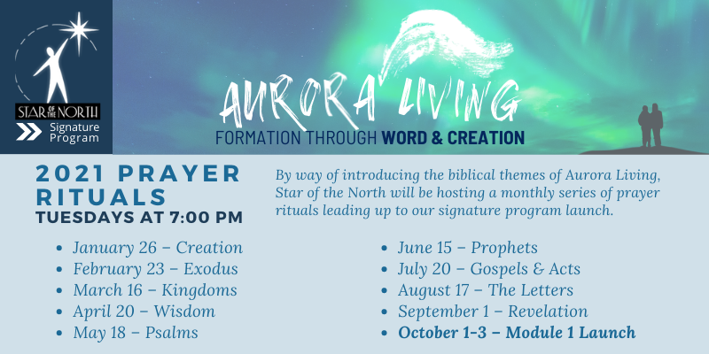

Register Aurora Living: Formation Through Word & Creation
** hover your mouse over the link above while holding the CRTL button on the left of your keyboard until a small hand pops up, then click with your mouse.
Top of Form
Bottom of Form

