August 2016

Edmonton Diocesan Council
Fall 2016 Newsletter

Fall Meeting: Olds October 1st
St. Stephen’s Church, 4302 - 57 Avenue
To register please contact Carol Hudec 403-638-4089 or e-mail her at jchudec@telus.net
The Fall Meeting is open to all members in the Diocese and we especially encourage CWL Parish Council Presidents or their designate to attend this Diocesan Executive Meeting. We are begin- ning the day slightly later to allow travel time for those of you who have a greater distance in
order to join us. We so look forward to having as many of you as possible be there with us! Guest speakers include the topic of Hospice & Palliative Care as well as Catholic Christian Outreach Ministries Speaker, "Tammy Stankievech. Tammy is an ele- mentary teacher in Central Alberta and has a background in youth ministry through many years working at Our Lady of Victory Camp. After completing her first two years of teaching, she an- swered God's call to serve as a missionary with Catholic Christian Outreach (CCO). Tammy relocat- ed to Ottawa, ON and worked as a missionary at CCO's National Headquarters last year. She is eager to share about her time with CCO and how we are all called to mission in different ways, the topic for her presentation in the morning of our gathering.

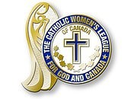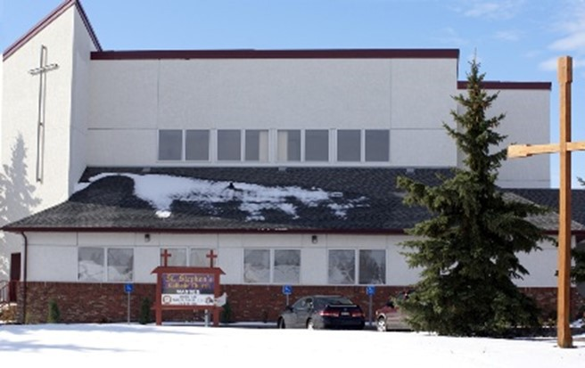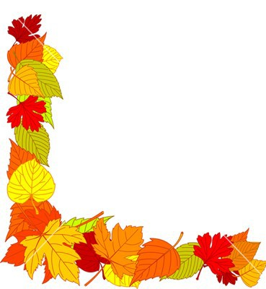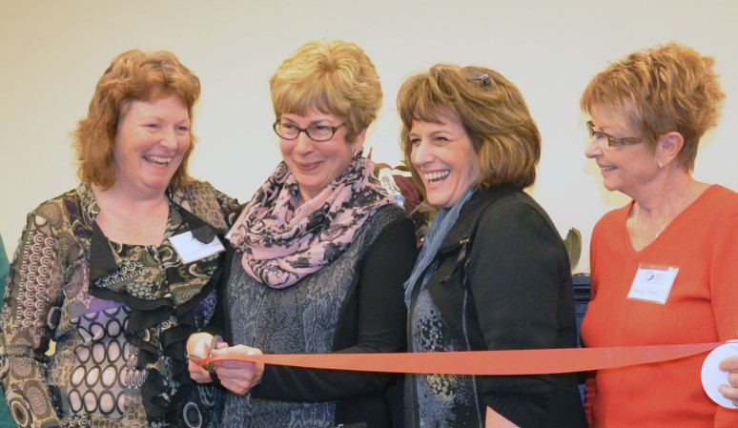
Olds & District Hospice Society began by someone in our faith com- munity asking the question; ‘What is a good death?’ With the experiences of the four people that this question was posed to, began an exploration of Hospice Palliative Care and the possibility it could be available in a better way in our small community. We discovered that it was important for those with a terminal illness in our rural community to stay close to their families and support systems as they walk through the days of end of life. While the desire for a Hospice
in our community was a preference, we discovered that hospice palliative care is bigger than a building and can be offered where ever the person may be. We have worked hard over the last nine years with amazing support from our Community to achieve many milestones. We have developed a Model of Care that addresses the gaps we had discovered through our investigations, and this includes volunteer support in the home. We have opened two hospice suites within a new support- ive living facility in our community in collaboration with Alberta Health Services and the private contractor. This model is unique in Alberta from what we have been told. We have trained over 60 volunteers and supported close to 140 families in their palliative journey and with our bereave- ment program in the last five years. We have connected with provincial organizations and with twelve communities across Alberta to offer our support as they move to build programs in their communities.
In addition to the two keynote speakers, the workshop offered will be about the new national annu- al digital reporting system .

INSIDE THIS ISSUE
Walter Krewski Recipients 2
Elsie Yanik Recipient 3
Special Awards/Honours 4
Diocesan Convention Notes. . 5-6 Diocesan Officers Notes…….7—12 Upcoming Events 13—15
Final Notes 16

SPECIAL POINTS OF INTEREST

- Fall meeting Olds: Oct. 1
- Officers fall communiques
- Diocesan Convention High- lights
- Provincial Convention mem- bership awards
- New National Resolutions

PROVINCIAL MEMBERSHIP AWARD RECIPIENTS
In 2007, the Alberta Mackenzie CWL established the Father Walter Krewski Awards which recognize councils that strive to increase membership within their councils. This award is now an annual event at our Provincial conventions.
The criteria for these awards are as follows:
  - The first award will go to the council that has the greatest number of new mem- bers in the previous year. The purpose of this award is to encourage all councils to promote the ‘League’ in their parishes and to recruit new members that have not previously joined.
  - The second award will go to the council that has the greatest increase in mem- bership in the previous year. This award will benefit those councils that not only strive for new members, but also work to have all members renew each year.
  - The third award will go to the council that has the greatest percentage increase in membership in the previous year. This award will benefit small councils who do not have a large membership, but also do not have a large parish population from which to recruit members.

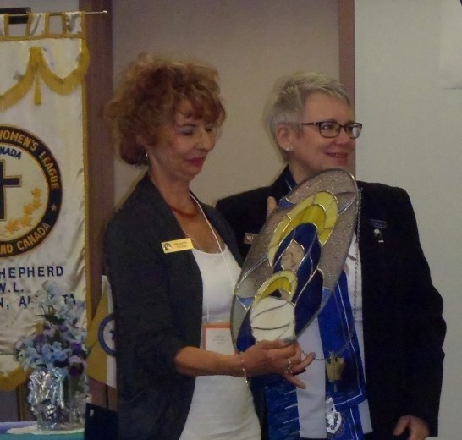
For the greatest increase in NEW members, this year’s recipient is Our Lady of the Angels from Ft. Saskatchewan in the diocese of Ed- monton. Last year this council recruited 19 new members. Well done ladies!

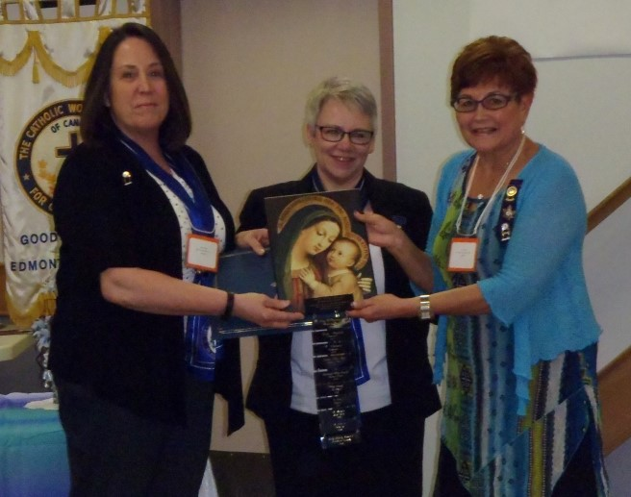
This year’s recipient for the greatest in- crease in membership is Parkland Holy Trinity from Spruce Grove in the diocese of Edmonton, Last year this council had 32 ladies join. We are proud of you . . . Keep up the good work!

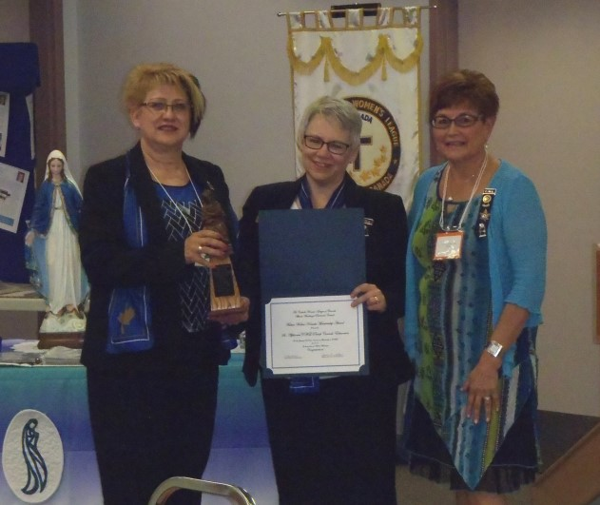
This year’s recipient for the greatest percentage increase in membership, is St. Alphonsus Council, Edmonton. St. Alphonsus had a 34.78% increase in their membership. Great work ladies!

2

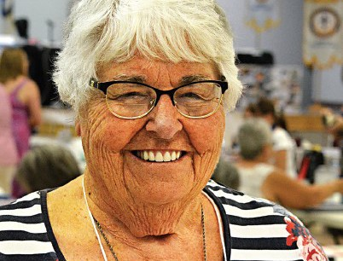

ELSIE YANIK RECIPIENT: Rose-Marie McCarthy St. Thomas More CWL, Diocese of Edmonton

Rose-Marie has been a member of the Catholic Women’s League for over 50 years. She has held leadership roles on parish, diocesan and provincial councils and was president of the Provincial CWL from 1983-85.
Rose-Marie’s passion for the CWL led to many hours of mentoring members unfamiliar with keeping the books for their councils. In 1988, she helped to organize the Edmonton Diocesan Field Workers who prepared an orientation presentation on all things relating to CWL. Rose- Marie chaired this committee for 15 years and presented workshops to most of the councils in the Edmonton Diocese. As a member of the National Field workers, she helped create and facilitate a workshop ‘Spirituality – Day of Discovery’, to help women discover their God given gifts and strengths.
Rose-Marie recognized the importance of preserving the history of the Catholic Women’s League and was instrumental in compiling a CWL Archdiocesan history book, a Diocesan archive (now in the Provincial Archives in Edmonton) and while Provincial secretary, collected and assembled 30 years of CWL history that was deposited with the Glenbow Museum in Calgary. From 2009- 2012, she co-chaired a committee to produce a pictorial history of the one hundred years of the League in the Edmonton Archdiocese. This project was shared throughout the province and was on display at the 2012 CWL National convention held in Edmonton. Rose-Marie also led the Life Members in producing a ‘Memories and Stories’ compilation.
Like Elsie Yanik, ministry and leadership go hand-in-hand for Rose-Marie. Her passion for car- ing for women was demonstrated in both her personal and professional life. She was at the fore- front of the Women’s Sheltering movement in the late 1960’s, when violence against women was becoming recognized as a societal issue. Her commitment to this issue led her to speak to CWL councils, Knights of Columbus as well as other church and secular organizations to raise aware- ness and funding.
When WIN (Women in Need) Housing became a reality Rose-Marie volunteered as a board mem- ber and also volunteered as a board member of WINGS (Women in Need Growing Stronger). She became the director at KARA (Kids Are the Responsibility of All) and while there organized an annual CWL golf tournament with proceeds going to Kara. Eventually, a foundation for KARA was established. She was also a board member of the Alberta Council of Women’s Shelters. During Rosemarie’s term as Provincial President, the League petitioned the Government of Alber- ta for a family institute and when this was established Rosemarie was asked to become the chair.
A highlight for Alberta in 1984 was the papal visit by Pope John Paul II. Under Rose-Marie’s direction the Papal Banner Project was initiated and every CWL council in the province and the Northwest Territories participated in making 2000 banners that lined the papal route.
Rose-Marie’s contributions to the Catholic Women’s League and the community are immeasura- ble. We are privileged and honored to be able to present the Elsie Yanik award to this most de- serving recipient. Congratulations Rose-Marie!

3

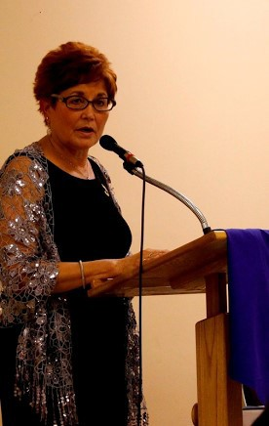
NEWEST LIFE MEMBER: JUNE FULLER

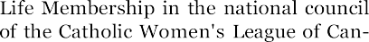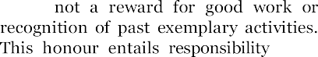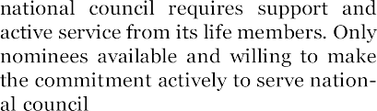Life mem- bership is a very special recognition we bestow on a member who has been exem- plary in the duties that she has fulfilled and in the leadership that she has demonstrat- ed in service to the League.
June joined the CWL over 25 years ago and is currently a member of Holy Family Council in St. Albert. Not only did she serve on the executive at the parish level, but she willingly stepped up to hold posi- tions at the Diocesan level for 10 years and then moved on to the Provincial level where she is currently serving as President- Elect and Standing Committee Chair of Organization.
June is an amazing woman who is devoted to her faith, is quick to smile and possesses a calm demeanor that places at ease any- one who has the good fortune of knowing her. She brings a love of life and high ener- gy to all that she does. She has an under- stated keen sense to detail and is prepared to deal with anything that is given to her.
June has worked in a medical setting— most recently with Alberta Health Services where she remains working to this day. June volunteers in her parish as Co- ordinator of the Ushers Ministry. In recent years, June has very much enjoyed serving on the organizing Committee for the Faith, Fitness & Fun Run/Walk in support of Newman College and St. Joseph Seminary. Fran Lucas, 1st Vice-President has said of June: “She has been in love with the League since she joined years ago. She has brought along many new members and continues to be a support bar-none for our beloved League. Dedicated to her family she continues to find immeasurable time to give in service to God and Canada. June never does things half hearted. For exam- ple, for the 100 anniversary gala I chaired she was on the decorating commit- tee. Decorations have never looked so good at an event! And the displays she coordinated were spectacular and used at other events later. “Half way of doing things” is not in June’s vocabulary. I en- joyed having her on the executives I was a part of and look forward to her continual leadership in the League. June, National would look really good on you. “ Congratulations June! We are so very proud of you!

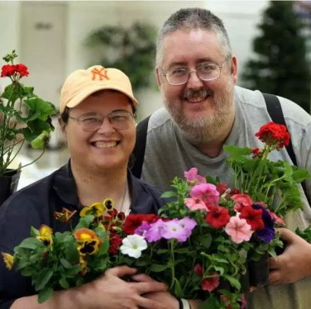
Congratulations to Diocesan Officer Catherine Mardon who has been selected to receive the Lieu- tenant Governor of Alberta's Circle on Mental Health and Addiction 2016 True Grit Award in early Octo- ber. This award honours an individual who has been successful in their efforts to reduce stigma, encour- age recovery and strengthen programs and services in the area of mental health and addiction in Alber- ta. Way to go, Catherine!

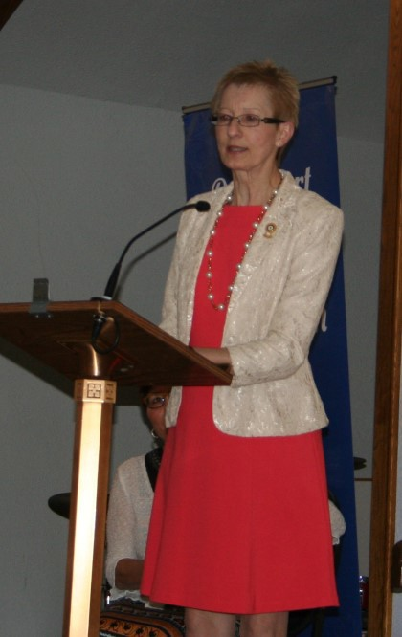
Congratulations to Fran Lucas (St. Joseph's Basilica Council) At the national convention in August, Fran was elected 1st Vice- President, National Chairperson for Education & Health. We are so proud of you, Fran!

4

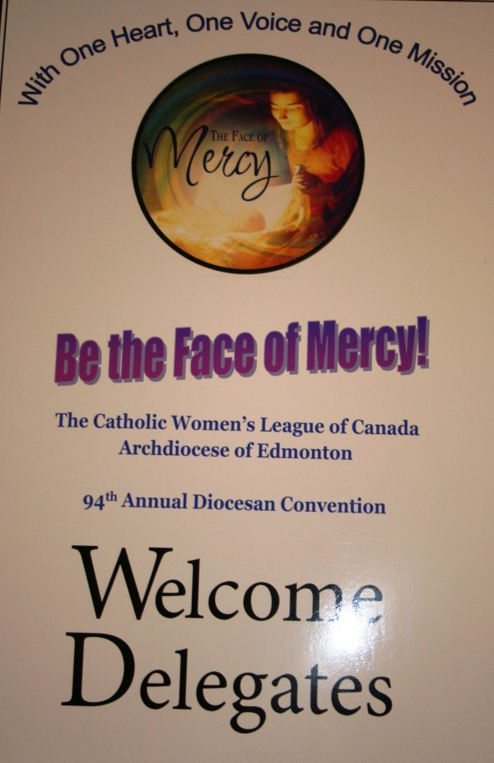
DIOCESAN CONVENTION HIGHLIGHTS
What a gathering of women from across our Archdiocese! We convened in large numbers at Holy Family Parish in St. Albert to celebrate, learn, pray, debate, sing, share meals together and renew friendships, while making some new ones! Our keynote speakers all addressed the theme for the convention: Be the Face of Mercy. Elsie Paul of the Kohkom Kisewatisiwin Society and Bishop Sylvain Lavoie spoke from the perspective of our Indigenous sisters, the panel of Greg Yanda, Debra Birkett and Dr. Gordon Self, spoke from the perspective of Palliative & Hospice Care, and finally, Archbishop Smith spoke passionate- ly from the perspective of CWL women as the Voice of Mercy. The recipient of the Doreen Melton Schol- arship this year was Tin Tran. Our opening litur gy, cerem o ny and wine & cheese reception took place at St. Albert Parish with greetings from Archbishop Smith, Provincial President Cathy Bou- chard, June Fuller the Convention Co-Chair, National Executive representative Fran Lucas, the Mayor of St. Albert and a representative of the Knights of Columbus and Diocesan President Mary Hunt. Saturday morning, we celebrated and mourned the passing of many of our league sisters with a beautiful memorial service dedicated to their memory. Two resolutions were presented and discussed; both of which were approved for presentation at the Provincial Convention. An amendment to the Constitution & By-laws was likewise presented and approved for presentation at Provincial Convention. Our officers rededicated themselves to the service of our diocesan sisters at the Saturday Mass which was followed by a banquet catered by the Holy Family Knights of Columbus. Highlights of the banquet program included the presentation to June Fuller of the honour Honorary Life Member. On a sad note, we honoured the ladies of the council from Holden and retired their banner as they are no longer able to continue as an active council. Entertainment was provided through the wonderful music of Sandra Brenneis & Family The evening included a PowerPoint presentation of images highlighting the multitude of activities of our councils across the archdiocese collected over the year. There is far too much to include in this short space and you are encouraged to visit our diocesan web site ( Edmonton Diocesan Web Site). Click on the “Convention 2016” tab for officers’ reports, pictures, resolutions and so much more!
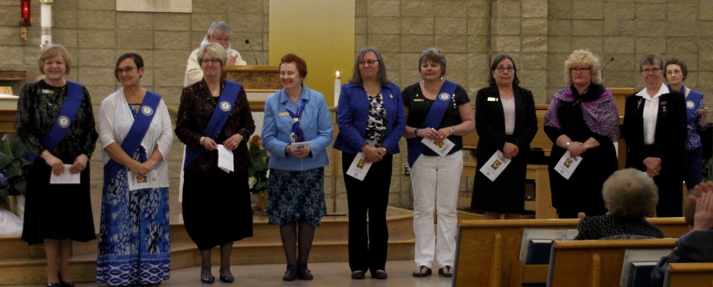
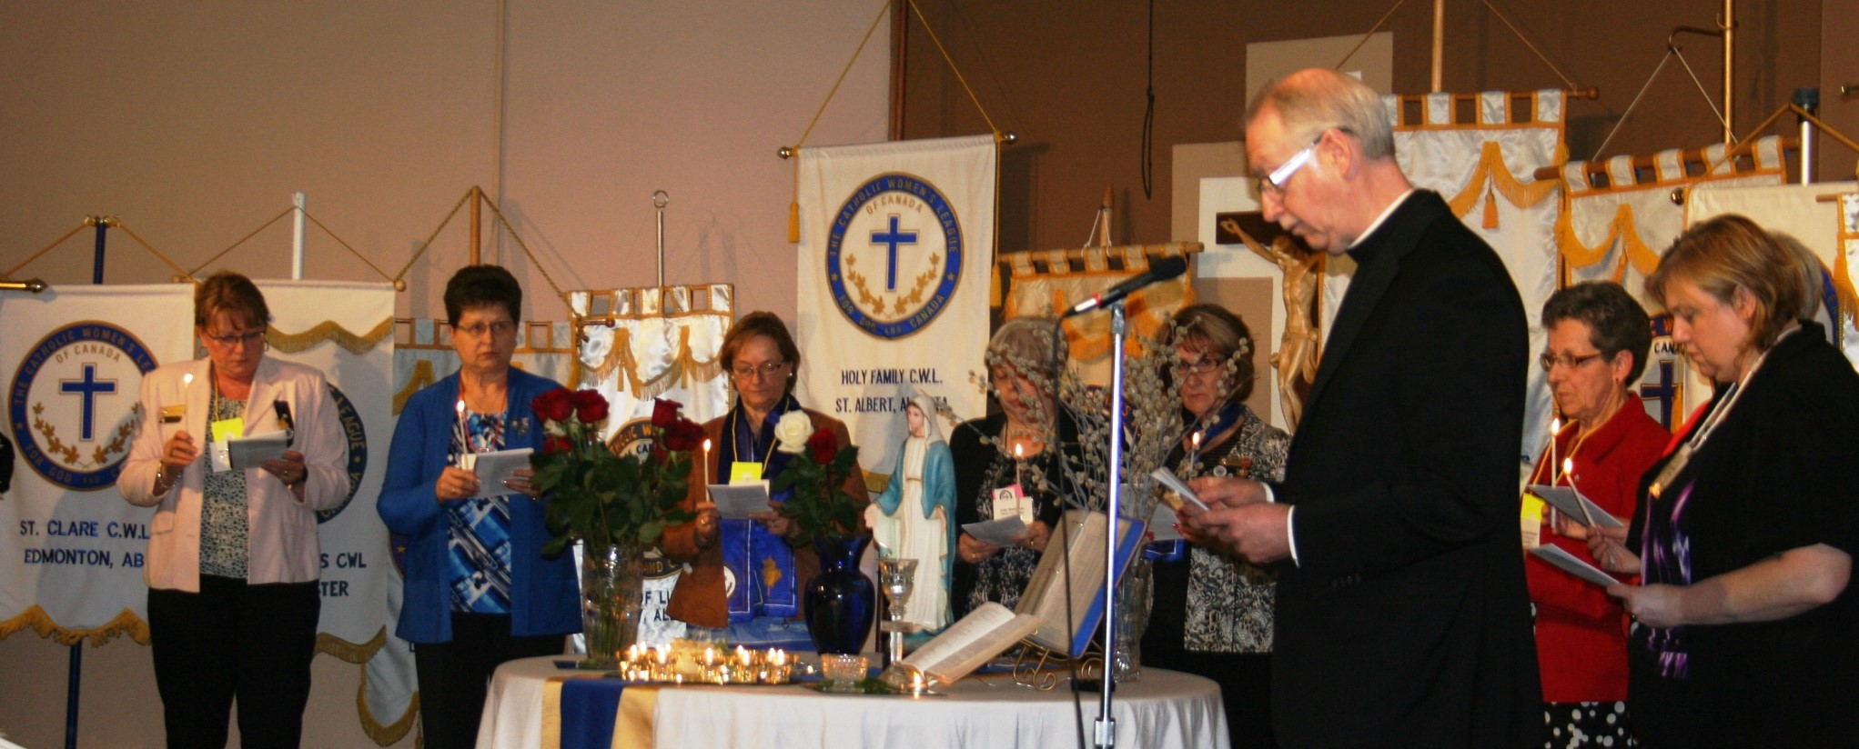

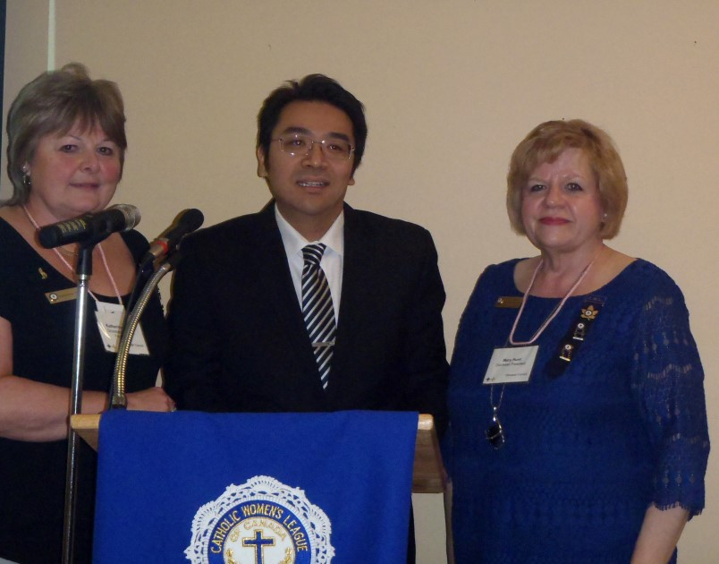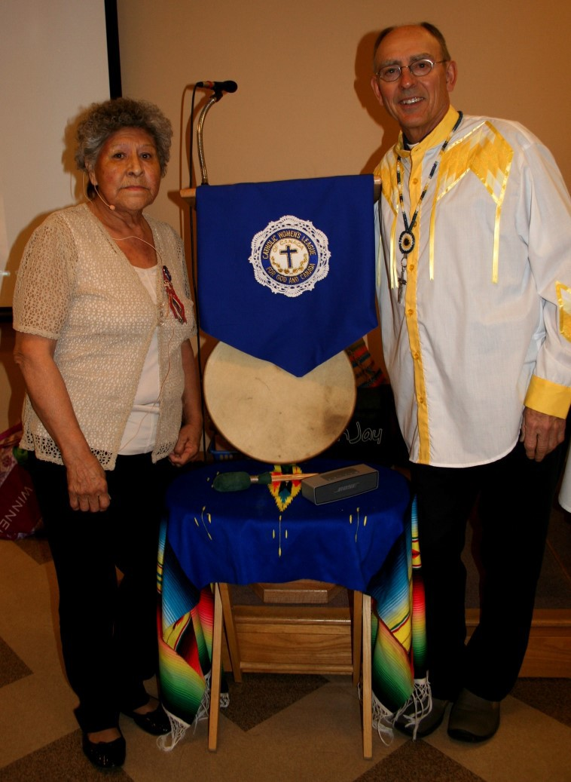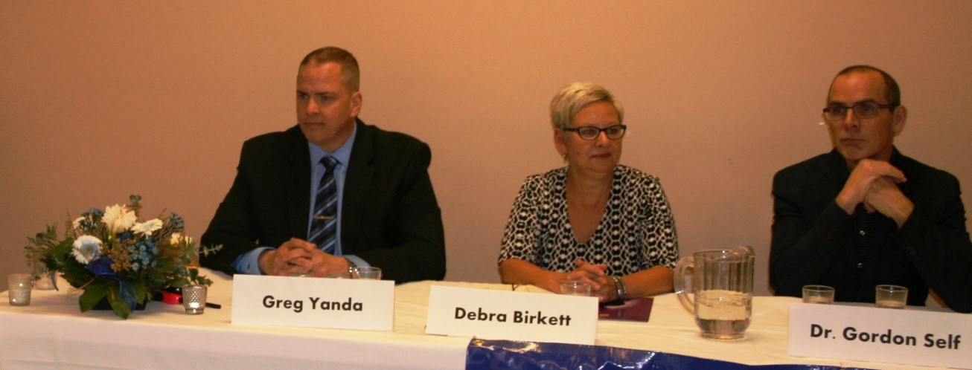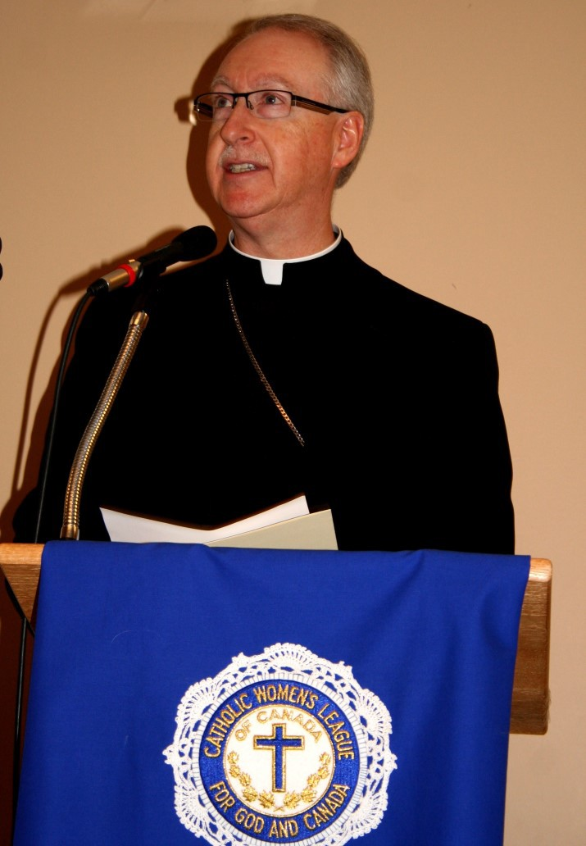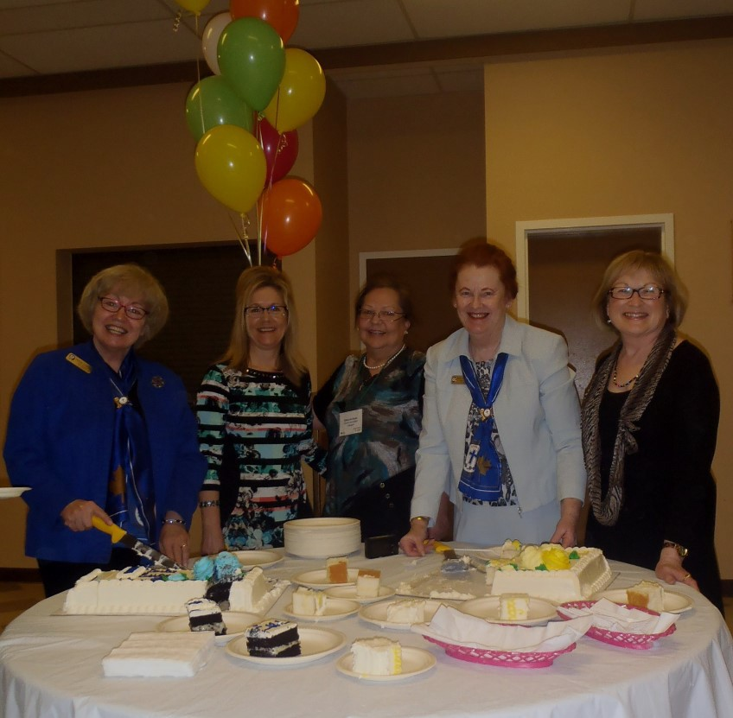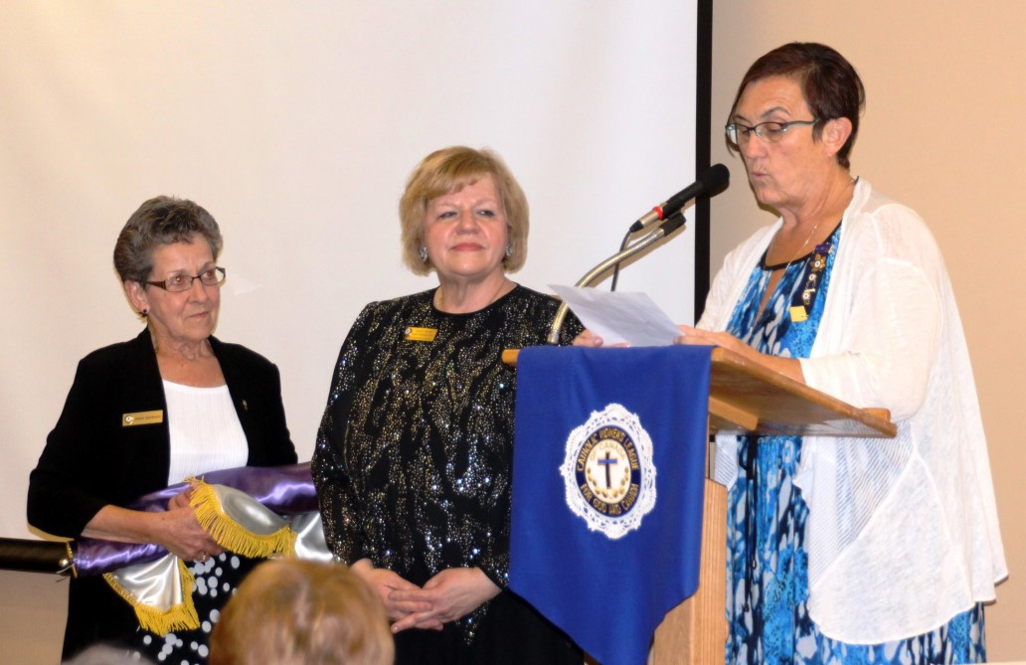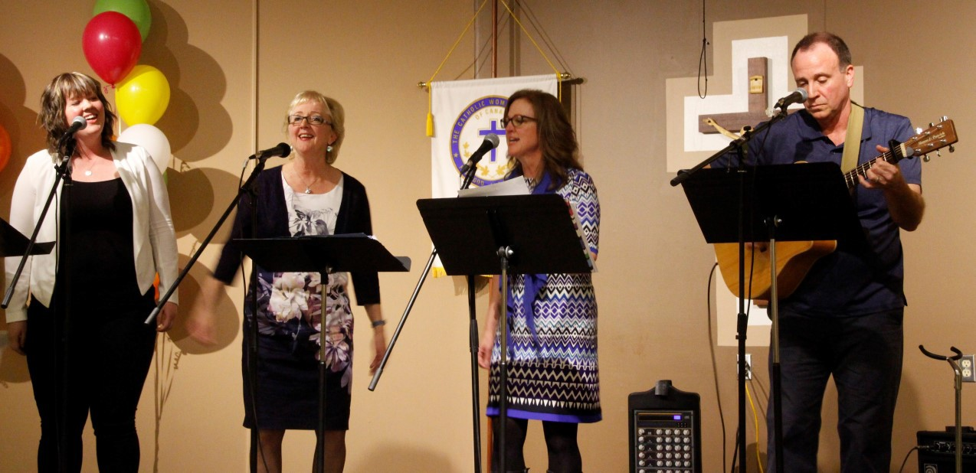

PRESIDENT’S COMMUNIQUE

My Dear League Sisters
I returned from the National Convention held in Halifax in August renewed, inspired and eager to resume our important work in col- laboration with the CWL councils throughout our Archdiocese. I was happy and grateful for the opportunity to attend this well planned annual gathering…the attention to detail was apparent. Thank you to Edmonton Diocesan Spiritual Advisor, Fr. Jozef Wroblewski for attending and supporting us. A very special thanks to Archbishop Richard Smith for co-presiding at the Opening and Closing Masses.
We were reminded that CWL strength is rooted in our unity as a national organization.
Our call to social action was reaffirmed and captured by outgoing National President Barb Dowding when she said in her closing re- marks: “From prayer to parliament – our voices must be heard”.
In saying this, we were disappointed to be advised by a disposition letter received just prior to the convention that the two resolutions brought forward by OLPH in Sherwood Park pertaining to Support for Post-Traumatic Stress Disorder Victims and Holy Rosary in Grande Cache pertaining to Reducing the Impact of Disposable Hygiene Products would not be brought to the floor at the National Convention. Our proposed Amendment to the National Constitu- tion & By-Laws will be brought forward for consideration at the October meeting of the new national executive.
Please remember that what we choose to do today becomes what we are or what we are not in the future. St. Mother Theresa was once quoted as saying “I used to believe that prayer changes things, but now I know that prayer changes us, and we change things”… in other words, we are meant to act and to invoke change. Medically assisted death is a subject that will require our continuing prayers, attention and action.
In his address, National Spiritual Advisor, Bishop William McGrat- tan reminded us that the CWL needs to continue to be parish based and parish focused. He encouraged us to prepare for the future of the League by mentoring the next level. Our focus should be on
welcoming new members…all women should feel wel- come in the League even if they do not yet belong. Our compass should be the 8 Objects of the League acknowledging that change can be difficult but sometimes necessary.
The new theme chosen by incoming National President Margaret Ann Jacobs is "Inspired by the Spirit, Women Respond to God's Call". W e look for w a r d to r eceivin g a descr iption of the theme elements and meaning which should soon become available to us. Provincial President Cathy Bouchard advises that the Nation- al Executive will be working on spirituals and workshops to develop this theme and if any members feel inspired to create something along this line, please let Cathy know so these can be shared across Canada. We are reminded to be careful about copyright laws and get permission for all non-original work.
On your behalf, I have written a letter to new National President Margaret Ann Jacobs inviting her to attend our 2017 Edmonton Diocesan Convention to be held at Corpus Christi Church in Ed- monton from April 21st thru April 23rd, 2017. It is hoped that if she attends she can personally provide us with more information on the theme she has chosen.
We have been invited to make a presentation about the CWL at the November Assembly of Priests in the Archdiocese. Ideas and sug- gestions would be most welcome and appreciated.
Edmonton Diocesan Council will be hosting the Alberta McKenzie Provincial Convention from June 9th thru June 11th, 2017 at St. Charles Parish in Edmonton. As information becomes available it will be posted on the Diocesan and Provincial websites.
We have been challenged to turn information into transformation. I look to the future with optimism and anticipation as we continue our CWL journey together.
I hope to see you at the Fall Meeting in Olds on October 1st… Blessings & Graces to you always,

Mary Hunt
Edmonton Diocesan President
The Catholic Women’s League of Canada

National Theme for 2017—2019“Inspired by the Spirit, Women Respond to God’s Call

PRESIDENT ELECT/ORGANIZATION COMMUNIQUE

Dear Sisters in the League,

Summer is almost over and soon it will be time for us to return to our regular activi- ties. I hope you all enjoyed a nice break, spent time with family and friends and appreciated all of God's beauty and gifts. I enjoyed a nice extended vacation in Nova Scotia and was blessed to attend the 96th Annual National CWL Convention. Hear- ing the new theme "Inspired by the Spirit, Women Respond to God's Call" has invig- orated me and I am ready to go where God leads me!

Membership is key, however, our member- ship numbers have been steadily declining Catholic women are looking for faith-based opportunities for social interaction, per- sonal enrichment and community service. Catholic women want to develop their faith, have fun and feel a sense of fulfill- ment. What do we need to do to make this happen?

Father James Mallon, in his book Divine Renovation says we do not HAVE a mis- sion; rather, we ARE the mission. By living the life God calls us to live, by being wel-
coming, as the earliest members welcomed the stranger to this vast country, by invit- ing all women 16 years of age and older, by being concerned more about “feeding” women than by simply adding members, the membership will follow.

So ladies, we need to personally invite new members and entice them to join, invest time in them, engage them in parish activi- ties and educate them. We need to retain the members we have and celebrate achievements and recognize dedicated years of service. We need to make this rewarding and fun!

Thank you for your service to the League. I look forward to continuing to serve you and I hope to see all of you at the Fall Dioc- esan Meeting in Olds!
Blessings, Cheryl Boom
President-Elect, Organization Chair Edmonton Diocesan Council,
The Catholic Women’s League of Canada

2016 National Convention

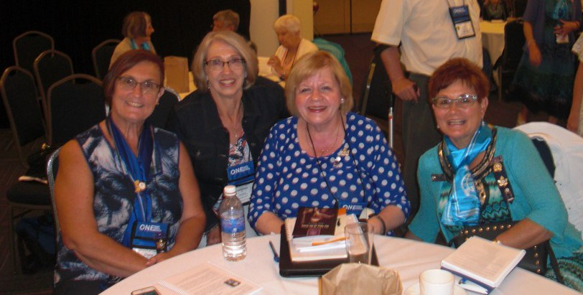

Left to right: Cheryl Boom (Diocesan President-Elect), Connie Asp (President OLPH Council) Mary Hunt (Edmonton Diocesan Presi- dent) & June Fuller (Provincial President-Elect )

7

POPE FRANCIS’ PRAYER FOR CREATION FROM LAUDATO SI

All-powerful God, you are present in the whole universe and in the smallest of your creatures.
You embrace with your tenderness all that exists. Pour out upon us the power of your love, that we may protect life and beauty. Fill us with peace, that we may live as brothers and sisters, harming no one. O God of the poor, help us to rescue the abandoned and forgotten of this earth, so pre- cious in your eyes. Bring healing to our lives, that we may protect the world and not prey on it, that we may sow beauty, not pollution and de- struction. Touch the hearts of those who look only for gain at the expense of the poor and the earth. Teach us to discover the worth of each thing, to be filled with awe and contemplation, to recognize that we are profoundly united with every creature as we journey towards your infinite light. We thank you for being with us each day. Encourage us, we pray, in our strug- gle for justice, love and peace.

Reminder:
The National Bursary Program is awarded biannually.
The next submission deadline is November 30, 2016.

SECRETARY COMMUNIQUE

Madam President, Sisters in the League

A special warm welcome to all Secretaries, whether you are starting your term or in your second year, I do look forward to working with you and with our CWL Councils. I welcome your comments, questions, suggestions and ideas as they pertain to our role as Secretary. We learn from one and another, support one anoth- er and encourage one another.

The main mission you undertake as secre- tary is to listen to the proceedings during the meeting; and to record accurately what you have heard so as to prepare the minutes - correctly, concisely and com- pletely. I strongly urge you to appoint a member to assist you in taking notes at meetings; so that you don’t miss any im- portant information. Thus said, as a sec- retary, you must remember to provide and file a hard copy of minutes as they clearly tell the story and maintain a clear picture of your Council’s activities. Minutes are intended to tell exactly what happened at meetings – not what was said. An accu- rate paper trail tells the story of your Council. Therefore, you must focus on maintaining the files in the most efficient and up-to-date manner. Years into the future as members look at the archives, the minutes will tell the story and these future members will know what actions and deeds were completed

Furthermore, keep in mind when sending e-mail messages that those reading your e- mail do not hear your voice, see your body language and feel your need. The use of gentle and kind words is important to convey what may sometimes be an urgent message. Harsh and abrupt words have no place in e-mail messages. With re- gards to maintaining Council rosters, please keep in mind that in accordance with the provincial privacy policy this information is for league use only, and is not to be shared.

I encourage all of you to obtain a copy of the Handbook for Secretaries, which can be downloaded from the national website. Other resource materials that you might find helpful include the Constitution and By-laws, the National Manual of Policy and Procedure and Robert’s Rules of Or- der.
Respectively submitted, Mary Pat O’Neill
Secretary, CWL Edmonton Diocese

“Start by doing what’s necessary, then do what’s possible; and suddenly you are doing the impossible.”
St. Francis of Assisi

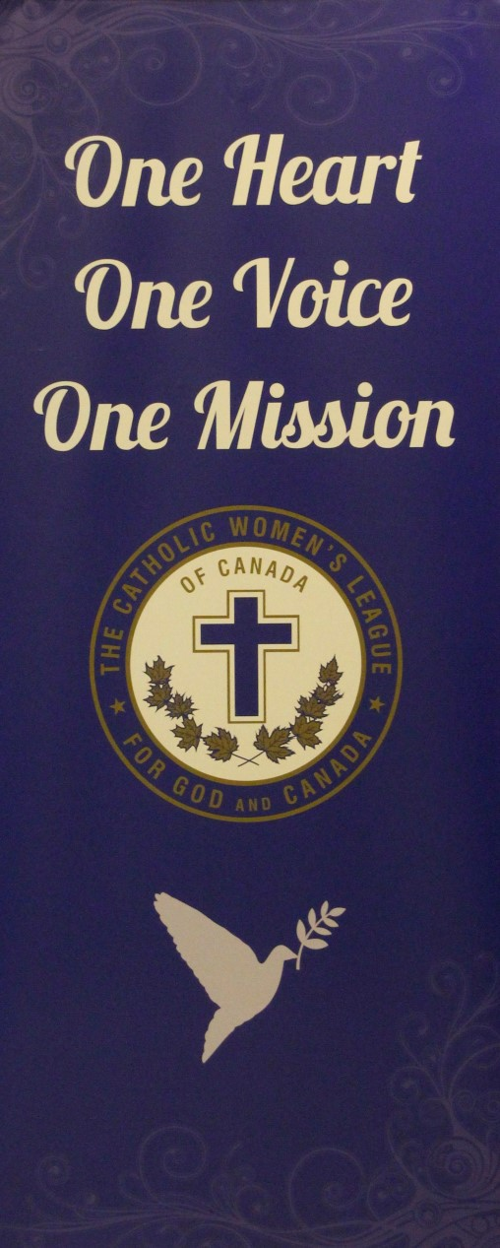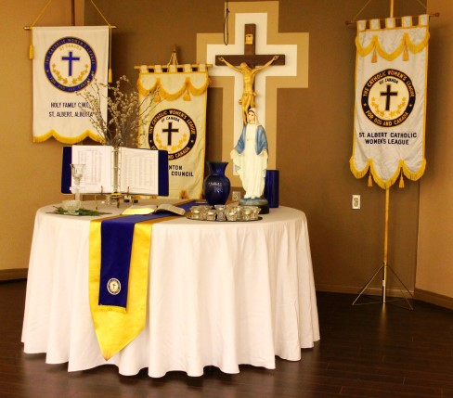

8

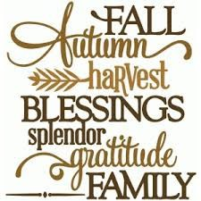TREASURER’S COMMUNIQUE

I love the energy that is generated in the fall by the kids going back to school and so many activi- ties starting up again. It compels us to get active again after some lazy, hot summer days spent relaxing and vacationing.
I am happy to announce that after some discus- sion, an agreement with the Foundation of St. Joseph Seminary and Newman Theological College to establish the fund for the Doreen Melton Scholarship was finalized and signed off by President Mary Hunt and Archbishop Smith. The fund now resides with the Foundation where it can be invested and earn higher invest- ment income than before. We are currently doing some research to add to the information we have about the contributions Doreen Melton made in our Diocese and to compile a list of the winners of the scholarship since 1979. If you knew Doreen Melton or have information that you would like to contribute, please contact me. This information will enable both us and the Foundation to tell the story about the scholar- ship and the person who inspired it.
Several Treasurers have requested help in find- ing programs to help manage their Council financial records. For most Councils, using an Excel spreadsheet is probably the easiest espe-

cially if it can be based on one that another Council is using. If you are using Excel for your Council and would be willing to share what you do, please send me an example of your template. Many councils will be making decisions in the next few months to support various charities or programs. Please keep in mind those that Dioc- esan, Provincial and National CWL levels are suggesting. If you do support any of them, please complete the appropriate form and send your cheque to the applicable level.
Diocesan:
* Sign of Hope (Catholic Social Services)
- The Wilberforce Project (Alberta Pro-life) Provincial: Nickels for the North National: *Canadian Catholic Organization for Development and Peace
  - Catholic Missions in Canada
  - Catholic Near East Welfare Association
  - Coady International Institute Fund
  - Euthanasia Prevention Coalition (until Aug. 18, 2020)

Jean Ashdown Diocesan Treasurer
treasurer.edmontoncwl@gmail.com

PAST PRESIDENT’S COMMUNIQUE

Dear Sisters in the League:
As September begins so also do our councils become active again. I hope the summer break has allowed you to relax, share time with friends and family and think about continuing with the excellent work and sharing with our CWL sisters in councils throughout the Archdi- ocese of Edmonton. I find it a challenge to share something new about the position of Past Presi- dent with you as there is information available in places such as the Past President Handbook, checklists for archiving and articles in The Canadian League.
A past President has had the experience of being the Leader of the council and because of this has knowledge, abilities and gifts to share with her council. Personal attributes may be: mentor, listener, advisor, worker, collaborator, observer, cheerleader. Responsibilities may include: picture taker/ displayer, caretaker of materials such as: minute and reports, albums, correspondence, keepsakes, financial infor- mation/ recent and historical.
The preservation of the history of a council is a very important responsibility. Records should be stored in a safe accessible place. In the council it is usually the Past President who works in this area, in order to pass on the knowledge of how things are organized the past president should work with the president so that she can carry on the work when her term as president is completed. If your council has a member who thrives on archiving, she could be encouraged to be a continuous archivist who would work with the past president and those who come after. It would provide some conti- nuity.
HELPFUL TIP: Try not to work alone when going through materials. It helps when deciding what to keep and what to discard.
REMINDER: When discarding private information, make sure it is discarded properly. SHREDDED or BURNED
The Diocesan Council is in the second year of its two year term, which means that there will be an election of officers at the Annual Diocesan
Convention in 2017. Work will begin in Sep- tember on updating the eligibility list and let- ters will be sent to all those who are eligible to stand for office. Information from the Policies & Procedures manual:
- Present Diocesan officers (except for the past president) who, at the time of elec- tion, have served a full term
- Parish council presidents who, at the time of election, have served a full term
- Officers and council presidents shall remain eligible for three elections follow- ing their term last served
The letters that are sent are a Call to Serve the League at the Diocesan Level, the gifts and abilities that you shared with your council will be valued. Please consider saying YES!
The job of the Past President is part historian, part advisor, but also looking to the future to make sure that the information about your council will be there for our CWL sisters to come.
We now have a new national executive who are beginning their work. Barbara Dowding is now Past President and I was pleased to see that she has already posted Communique #1 on the national website. I encourage to you take a few minutes to check it out, there may be an idea that you have not thought about.
A list of recipients of the Bellelle Guerin Award is still being compiled. I have heard from some our councils but I hope to make a complete list. If someone in your council has been presented with the award, please contact me at 780-679- 2454 or edmOtoncwl.pastpresident@gmail.com Some information about the member and presentation date and picture would be appreci- ated.
God Bless, Gwen Elliott
Past Diocesan President

League Objects
The 8 objects of the League shall be to unite Catholic women of Canada:
- to achieve individual and col- lective spiritual development
- to promote the teachings of the Catholic church
- to exemplify the Christian ideal in home and family life
- to protect the sanctity of life
- to enhance the role of women in church and society
- to recognize the human dignity of all people everywhere
- to uphold and defend Christian education and values in the modern world
- to contribute to the under- standing and growth of reli- gious freedom, social justice, peace and harmony 9

CHRISTIAN FAMILY LIFE COMMUNIQUE

Dear Sisters in the League:
September brings us to the end of summer and the beginning of fall, schools starting a new year, including our Seminarians will be back to another year of studies. Please remember to pray for our Priest and Seminarians. We will be also starting another year of Adopt-A-Seminarian, please be ready to sign up at our Fall Meeting on 01 October in Olds. I would like to also include in our prayers, all of our Sisters and anyone in Religious Life in the various orders through our Diocese.
There is a new program in our Federal Government - “Prime Minister's Youth Coun- cil” - they are the advise the Prime Minister on national issues: employment, access to education, building stronger communities, climate change, and clean growth. This program is open to young people between the ages of sixteen to twenty-four years who can bring a range of knowledge. For more information you may visit:
www.canada.ca/en/campaign/primeministersyouth-council.html.
Lady of Victory Camp is a summer camp owned and operated by the Archdiocese of Edmonton and run by young adults with youth, for youth. OLVC provides a week- long faith experience for young people which will last a lifetime. We invite you to help support OLVC's ministry to youth by playing in our annual Charity Golf Tour- nament on Saturday, September 10, at the Gull Lake Golf Course near Rimbey. The tournament is 9 holes, best ball format, on an executive par 3 course. Registration fee for a five-member team is $400. Registration fee for individual golfers is $80. This includes a hamburger lunch and a banquet. Register online at www.caedm.ca or call 403-986-OLVC (6582).
Registration is now open for the Wild West Catholic Youth Conference, set for Sep- tember 30 – October 2, 2016 in Red Deer. This conference is ope n to youth in Grades 9-12 from Alberta, B.C., Saskatchewan, and Manitoba. Join keynote speaker Father Tony Ricard and special guests Panic Squad for great music & food, inspiring sessions, meaningful prayer and spiritual development. Our theme is "Come! In! Stay!" We invite teachers and youth ministry leaders to consider bring- ing a group to this first event of its kind in Western Canada. For more info and to register your group, visit http://caedm.ca/workshops.
Every human life deserves respect and protection, but many people will be put at risk through the legalization of physician-assisted suicide and euthanasia: persons who are elderly, disabled, mentally ill, depressed, or who have dementia.
Information on the Euthanasia Prevention Coalition: The following links will allow
you to donate and follow the blogs of EPC - http://www.epcc.ca/contact-us/donate/

or http://alexschadenberg.blogspot.ca/In addition, we have books and other re- sources available:
- Culture of Death Book by Wesley Smith
- Exposing Vulnerable People to Euthanasia and Assisted Suicide by Alex Schaden- berg
- Do You Call this a Life? By Gerbert van Loenen
- The Euthanasia Deception Video – Released within the next month; (we don’t have a firm release date yet)
- Protecting People Pamphlet: $25.00 for 100 copies. (we can ship higher amounts based on availability and price).
- Do Not Kill Me wallet cards – for a donation.
This is a partial list of our resources; you can also sign up for our monthly newslet- ter and we can send paper copies also.
A message from our Provincial CFL Gladys Brown on the Senior Advocate: “The Alberta Government has recently filled the Seniors Advocate position with a perma- nent person rather than a temporary person. We have not yet received any infor- mation as to whether the position is independent as we requested. We, the Alberta Mackenzie Council, are asking all members to follow up with their individual MLAs, asking them what is happening re: CWL request for an Independent Seniors’ Advo- cate. We need to have a concentrated follow up on our request in order to have the government move on this very important issue.”
Over the summer I have been attending the March for Life meetings in preparations for next years march 2017, it will be the “10th Anniversary” for the march here in Edmonton. Please mark your calendars: the Pasta Supper 06 May 2017 and the
March 11 May 2017. there is also a Gala being planned, please keep an eye open for the date and Mass times. Last year we, the CWL collected $826.00 from our raffle, please if you have something to donate towards the raffle or help in any way, please contact me – Katherine Tarras at 780-488-5521 or on my cell either call or text 780- 916-9728.
See you all at our Fall Meeting in Olds, May God Bless you as you get ready for fall.Our Lady of Good Counsel pray for us,
Yours in Christ, Katherine Tarras
Christian Family Life Chair
Edmonton Diocesan Council

Last year 54 Councils collected $2970 through “Nickels for the North” Let’s offer additional help to our sisters in the North next year!

POSTER CONTEST WINNERS

How do you think God would want you to take care of the earth?
Kindergarten
Acadia M. Christ- King, Stettler Scarlett S. St. Clement, Edmonton Tucker Z. Christ-King, Stettler
Grades 1&2
Mya M. St. Joseph, Spruce Grove
Tyson E. St. Joseph, Spruce Grove Makayla K. Saint Andre Academy, Beaumont
Grades 3&4

Jennifer H. St. Joseph, Spruce Grove Averi W. St. Joseph, Spruce Grove Brandon F. St. Joseph, Spruce Grove
Grades 5 & 6

How can you and others make a difference in protecting the earth and its environ- ment and in helping the poor and less
fortunate?
Grades 7 -9

Kate D. Holy Family, Edmonton Brad Chris A. St. Jerome’s, Vermilion Camden S. St. Thomas Aquinas, Provost
Grade 10 – 12
Chelsea T. St. Peter the Apostle,
Spruce Grove Zachariah B. St. Jerome’s, Vermilion Melenna M. St. Peter the Apostle,
Spruce Grove

Avangeline P. St. Patrick, Camrose Katelynn B. St. Patrick, Camrose Julia M. St. Patrick, Camrose

10

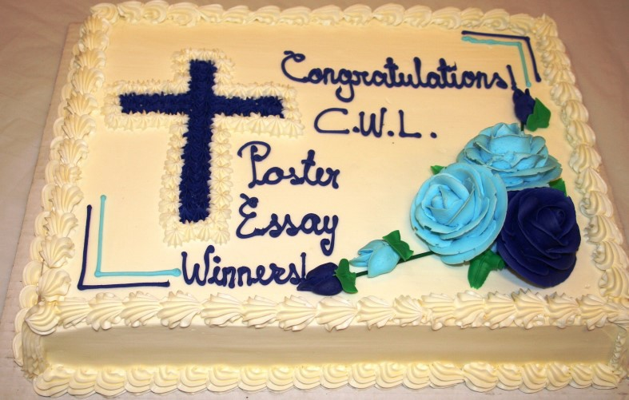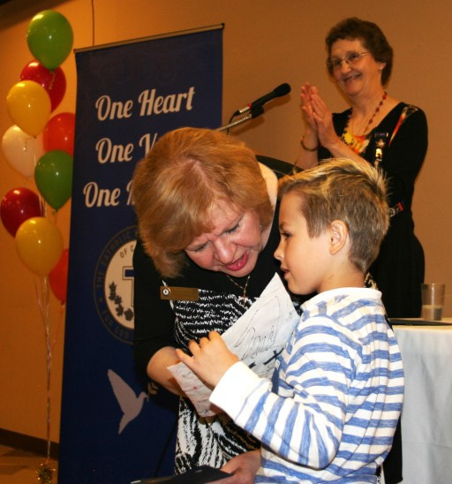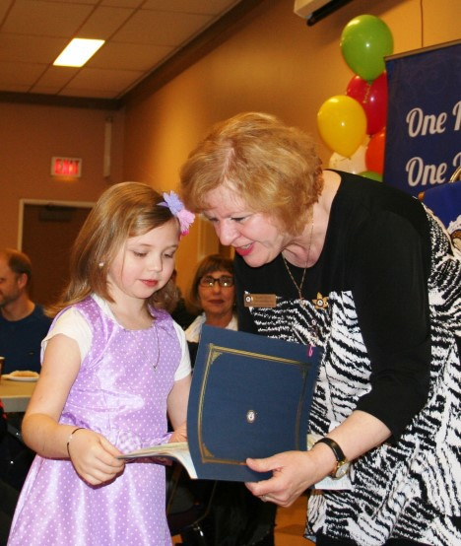

Did you know that this year, all our annual reports will be done online in
digital format? Keep your eyes and ears open for more information!

COMMUNICATIONS & ENVIRONMENT COMMUNIQUE

Dear Sisters in the League,
As I sit down to write this document, we are celebrating with Pope Francis and the global community, the second annual World Day of Prayer for Creation. There are many resources on our Diocesan website, under the “Environment” tab that I encourage you to use at any time! They lend themselves well to either personal reflection or for discussion and prayer at one of your monthly meetings. In addi- tion, the Global Catholic Climate Move- ment website is an outstanding place to keep up to date on what we as Catholics have done and are doing to support Pope Francis’ passion for the Care of Our Com- mon Home. Further to the national reso- lution on petitioning the government to eliminate the use of Neonicotinoids, I invite you to visit this link to a Canadian organization dedicated to protecting the legal rights of Canadians to a safe, clean, healthy environment and the protection of all species within our country. This link will give you information on their ongoing commitment to supporting our national resolution from 2015. Ecojustice: Neon-
icotinoids Fight
At the Provincial Convention in June, we learned that this year our annual reports will be done digitally using a standardized format prepared and distributed at the National Level for all councils to adopt across the country. It may seem frighten- ing or disorienting to some ladies, but I can assure you that everything will be done to support you in this new process.
Who knows, we may come to relish the opportunity and we anticipate that the forms will be prepared and distributed at a much earlier date, allowing more reflec- tion and the ability to focus our tasks and energies on specifics that the National team wants us to evaluate ourselves with.
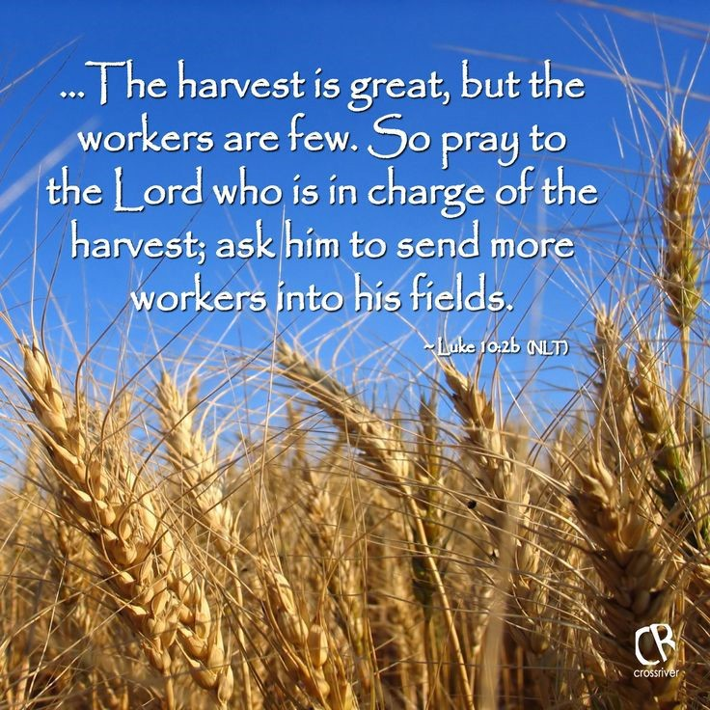Do take some time to read through our most recent newsletter that will be distrib- uted digitally through all council presi- dents. The document can also be found on our diocesan web site under the “News” tab. Please begin to collect and send me any photos of special events that happen within your council.
Use my Diocesan Gmail address: (edmontoncwl.communications@gmail.com) to send these photos as well as for any help you may require. I can’t tell you how much I enjoyed receiving all the photos from last year – it truly is a wonderful way to keep in touch with the good works that our women are doing for others. May God bless you in your efforts to deepen your commitment to be rooted in Gospel values as you grow in holiness and service to God’s people.
Your sister in Christ, Sr. Susan Scott
Communications & Environment Officer

11

RESOLUTIONS & LEGISLATION COMMUNIQUE

Dear Sisters in the League,
Welcome back to a new year in the CWL. Our resolutions weren’t suc- cessful the first time around at National, but they were important topics and well worth the effort. For Councils that would like to put forward resolutions this year, here’s a good basic foundation to start with. You must decide if you’d like them to be a Diocesan, Provincial or National resolution. If the issue is local, choose Diocesan. If it is something that is only of interest to Albertans, choose Provincial. If it is an issue that can be addressed at the National level, that’s the direction to take it. t is important to narrow your focus to a specific, doable topic. If the topic is too large, it can seem impossible or unmanageable. For example, if we are concerned about global warming, and we should be, a resolution about it generally would seem undoable. However, a topic about a spe- cific issue that we can actually impact such as a pledge to not idle our car engines, or for each Council to plant a tree for every plane trip we take, is more narrow, doable, and easier to pass at the National level.
I am very willing to help Councils interested in putting forward resolu- tions with the brief information that must accompany the ideas. It’s important to have good communication back and forth with the Council, and my hearing doesn’t allow me to use the telephone properly, so hav- ing a member with regular email usage to serve as liaison is important.
For the new year, the National convention put forward a new slate of Resolutions. The first asks the federal government to amend the Immi- gration and Refugee Protection Act so that foreign workers may apply for permanent resident status regardless of their occupational classification. The second Resolution asks the federal government to revise the Cana- da’s Food Guide and to review the guide every five years. The third Resolution urges the Canadian government to require detailed warning labels on food and drug products to list all inactive ingredients that may cause adverse reactions. The fourth Resolution is an attempt to get the federal and provincial governments to make palliative care an insured
health service covered under the Canada Health Act. The final Resolu- tion urges the federal government to include home care as an insured health service under the Canada Health Act. These Resolutions are a confirmation that our Catholic Women’s League continues to be a dy- namic, engaged organization. We are involved in caring for not only our families, but for those without a voice in our society. As we go forward this year, let us all keep these Resolutions in mind and push for them at every opportunity. The new Resolutions that have come out of the National Convention are outstanding as usual. The two dealing with adding palliative care and home care to the Health Act are especially important. Both are aimed at preventing individuals from availing themselves of the new Medical Aid in Dying. Palliative care is an obvious issue; however, home care is just as important. In my work on the bio- ethics committee at the Glenrose, I have been confronted with individu- als who have experienced devastating strokes or a diagnosis of dementia that has left them asking for death rather than being placed in a nursing home. Home care would solve a portion of that problem.
In the last two months, I’ve had the opportunity to meet with Amarjeet Sohi, the Federal Minister of Infrastructure, Sarah Hoffman, Provincial Deputy Premier and Minister of Health, Irfan Sabir, Provincial Minister of Human Services, David Eggen, Minister of Education, Joe Ceci, Minis- ter of Finance, and Brandy Payne, Associate Minister of Health. I’m always impressed by their willingness to listen to information or new ideas. I think that we sometimes forget that they are also ordinary peo- ple with families and similar concerns.

Catherine Mardon

Resolutions & Legislation Chair

Check out the resolutions passed at the National Convention in Halifax

  - 2016. 01 Equal Access to Permanent Resident Status, an Amendment to
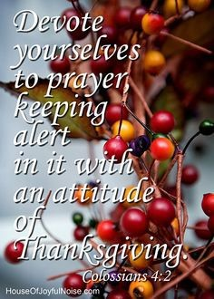
the Immigration and Refugee Protection Act
  - 2016.02 Eating Well With Canada’s Food Guide
  - 2016.03 Warning Labels on Food and Drug Products for all Inactive Sub-
stances and Additives

  - 2016.04 Amend the Canada Health Act to Identify Palliative Care as an
Insured Health Service
  - 2016.05 Amend the Canada Health Act to Include Home Care as an In-
sured Health Service
Did you know that according to CBC news that as of Sept. 2nd More than 100 Canadians have opted for assisted death since the law passed!
- Doctors and nurse practitioners have helped hasten the deaths of more than 100 Canadians since the federal law governing medical aid in dying was passed in June.
- The actual number of deaths is probably significantly higher because sever- al provinces could not, or would not, provide complete data. Quebec, which was the first province to adopt a law on doctor-assisted death, provided no data whatsoever.
- The federal law governing medical aid in dying came into effect June 17, after weeks of passionate, and sometimes very personal, political de-
bate. However, the federal government isn't yet officially tracking the num- ber of deaths.

12

Aging Gracefully:
the Gift of Years
Saturday, October 22nd
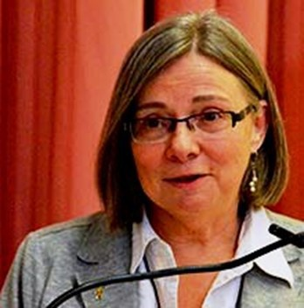
Day of Retreat at Holy Trinity Catholic Church Sandy Prather retreat director
“Grow old along with me! The best is yet to be…”
In a culture that glorifies youth, many today would not agree with these words from the poet Robert Brown- ing. Getting older is often seen as synonymous with loss: our health, status, freedom and meaning. However, em- bracing one’s advancing years can be an exciting adven- ture. We will hear about the blessings and beauty of em- bracing the senior years. Sandra will also explore the pos- sibilities and opportunities that come with one’s advancing years. Sandy will include in her presentation specific refer- ences to the need for palliative & hospice care.

9: 00 a.m. registration
Retreat 9:30—3:45 p.m. (Confessions 4:00 – 5:00, Sunday mass begins at 5:00 p.m.)
Cost: $20 (includes lunch) ** registration deadline October 16th
To register for this inspiring day contact Mariette H. by phone (780- 962-4599)
or by email (mehuot@hotmail.com)

Sponsored by Holy Trinity Catholic Women’s League

REGISTRATION FORM for October 22, 2016 Retreat (Use a separate form for each person registering)

Last Name: _ First Name: _ _ (Please print) (Please print)
Phone No: Email: _

CWL Member _ _ Guest
CWL Council: _

Please keep this gathering “Scent Free” and bring your own mug for coffee

Fee: $20.00 which includes lunch and health breaks
Please check if you require: Vegetarian, Dairy free Gluten free Indicate if you have nut allergies
Forward registration form(s) to: Mariette Huot

38 Deer Park Cres
Spruce Grove, AB T7X 4Z2
Make cheques payable to: Holy Trinity CWL
Registration deadline is: October 16, 2016
Location: Holy Trinity Parish is located at 200 Boundary Road, North of Highway 16A (Stony Plain Road) in Spruce Grove. Boundary Road is the road in between Spruce Grove and Stony Plain. To find the Church, you simply need to get on Highway 16A and head West (from Spruce Grove) or East (from Stony Plain) and look for the Church in the field between both communities.

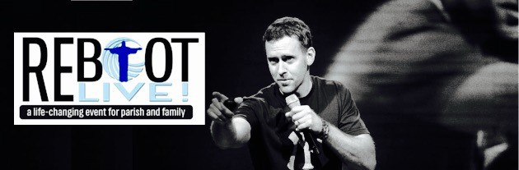

Do you long to be happy?....We all do…
Do you have a thousand questions about your faith?
Are you confused and searching? Then, this event is for you…
Check out realifecatholic.com and see why Chris Stefanick was
asked to Emcee World Youth Day

Good Shepherd Catholic Church
18407 – 60 Avenue in Edmonton
Is very pleased to announce that
Renowned and Much Sought After Speaker Chris Stefanick
Will be speaking at our church on
Thursday, December 8th, 2016 at 7 p.m.
Appropriate for Ages 12 to 112.
Tickets are $25.00 (only 650 available)
For info & tickets, please call Mary 780-487-3165

Come See Your/Our Faith in a New Way…

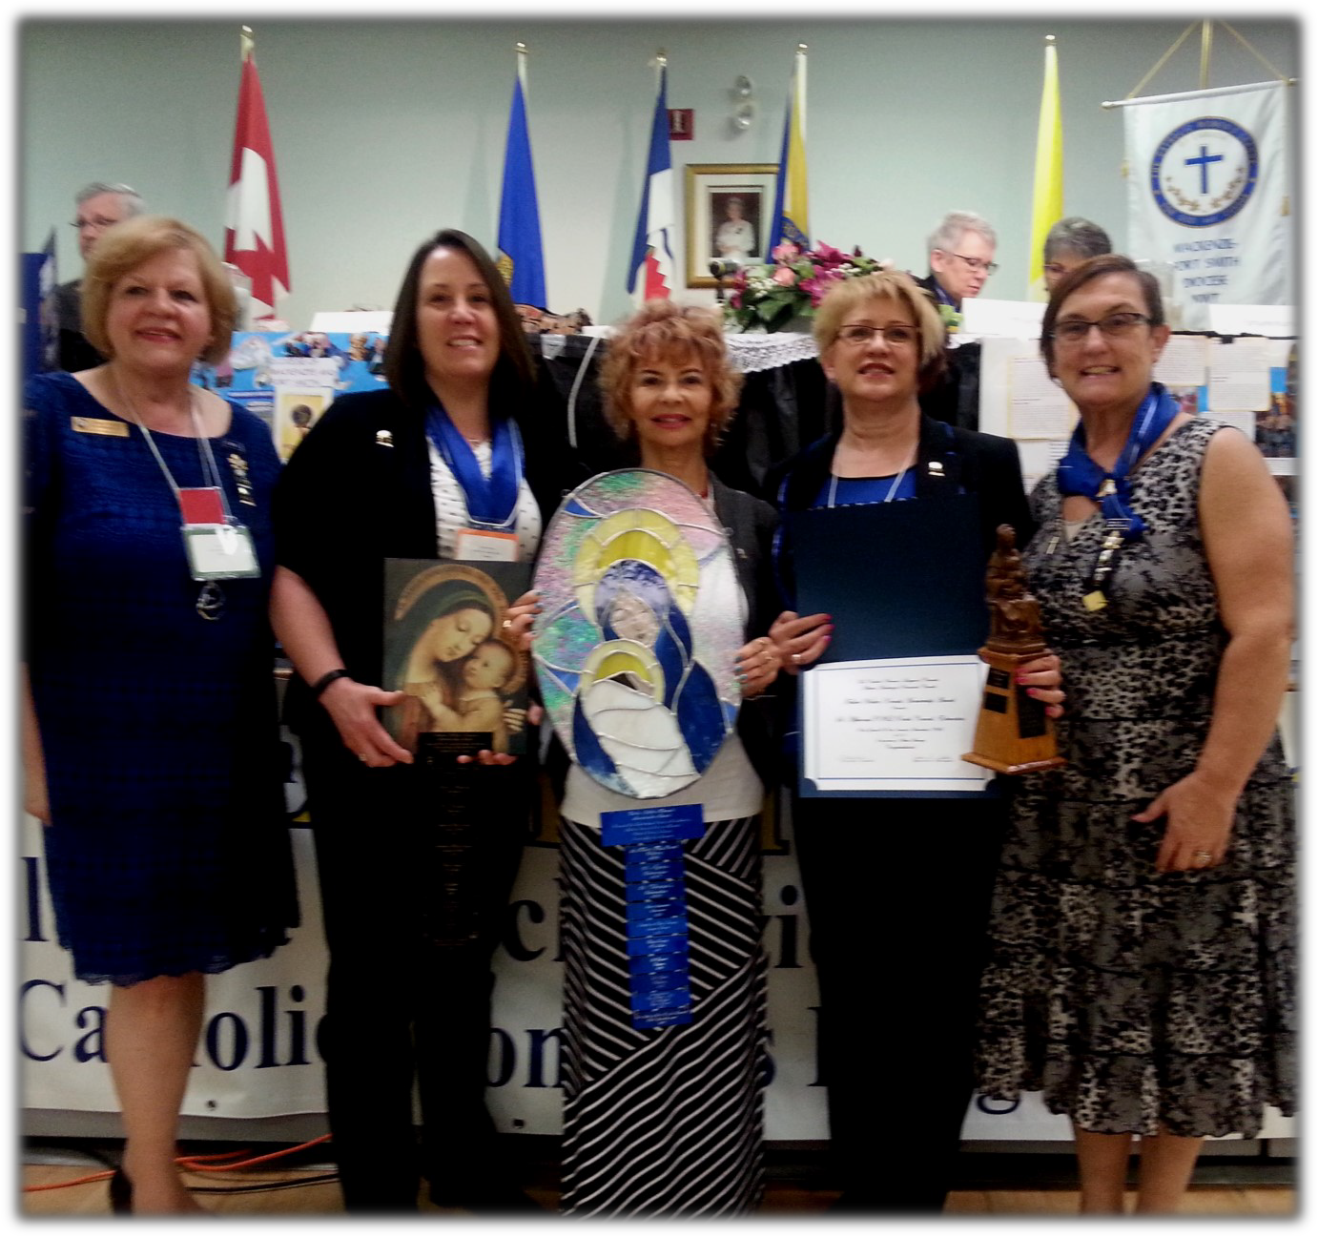
edmontoncwl.communications@gmail.com

Send your photos to:
Send your photos of special activities or
projects to the communications officer’s Gmail account for posting on our web site and inclusion in the PowerPoint presenta- tion that will be presented at the diocesan convention at Corpus Christi, Edmonton in
April, 2017
*** be sure to include the name of your
council, the zone, the activity taking place and any additional information you would want to share.
To register for the Fall
Meeting, please contact Carol Hudec at
403-638-4089 or
e-mail her at
jchudec@telus.net

WALTER KREWSKI AWARD WINNERS

