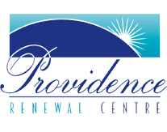
PROVIDENCE RENEWAL CENTRE
ADVENT PROGRAMS 2020
Register at www.providencerenewal.ca
or call 780-701-1854
________________________________________________________________________
Dreams: Guidance through Uncertain Times
Kathy Sperling via Zoom
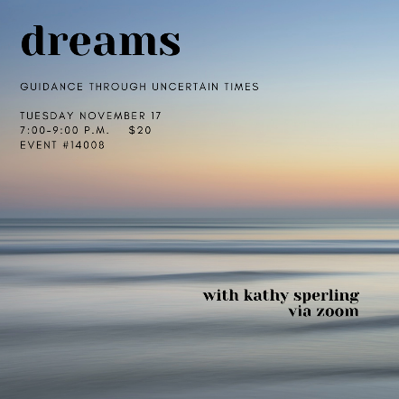
When our outer life is unpredictable or has experienced upheaval, God invites us to look inside for insight. During the Covid pandemic many people have experienced significant increases in dream frequency and intensity. If we are willing to be open and curious and pay attention, dream work can offer a deeper connection to God and the Wisdom from within. Come learn practical ways to explore this powerful doorway to spiritual insight and wholeness.

Tuesday November 17, (7:00 pm to 9:00 pm)
$20.00
Event # 14008 Register by November 12

Kathy Sperling is a wisdom seeker, a listener for truth and a lover of wholehearted living. She is a Spiritual Director and graduate of the Haden Institute Dream Training Program (NC) who helps people live true to themselves by embracing the mystery and wonder of inner life work.

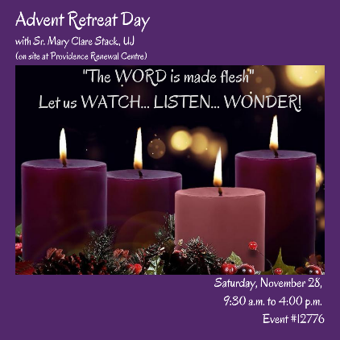
“The WORD is made flesh”: Let us WATCH, LISTEN, WONDER”
Sr. Mary Clare Stack, UJ (via Zoom)
Take a day for silence and stillness to listen with the “ears of your heart” to our God, Word of Love. Through prayerful pondering, we will listen, watch, wait, wonder at the miracle of God’s love manifested in Jesus, who “pitches His Tent among us”. Our hearts will be especially attentive to the most vulnerable among us- a lesson which COVID 19 has taught us all. We will write, our “Magnificat”- a song of joy and thanksgiving for the marvels our God has done for us! Be sure to bring your Bible. This retreat will be on Zoom. If you need a quiet space to come away for the retreat you can choose the ”Zoom in a parlour at PRC” option (bring your own device for Zoom, and your bag lunch.).

Saturday, November 28 (9:30 am - 4:00 pm) Event #12776 Register by November 23
$50.00 (Zoom from home) $65.00 (Need a quiet space? Zoom from a room at PRC)

Sr. Mary Clare Stack, UJ: “Our loving God, has abundantly blessed me in my family, my congregation, and through the rich web of relationships fashioned over many years. As an Ursuline of Jesus, my life is “rooted and grounded in the Word of God”. This retreat is a sacred moment to share these blessings.”

Through Mary’s Eyes
Rooney-Punyi Theatre via Zoom

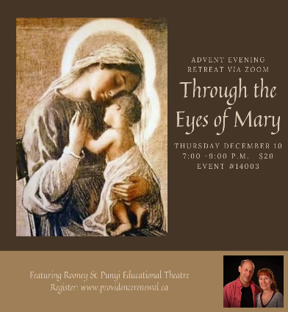
Enter into Advent in a special way by joining in on Zoom for a powerful and prayerful presentation of live music, reader’s theatre, and a power point presentation of beautiful art exploring moments in the life of Mary.
- Be led through the life of Christ as seen through the eyes of his mother.
- Meet a young Mary who is frightened of what others will say, after she has said “Yes” to God.
- Follow her story as a hard-working mother, who loses her child Jesus, and then finds him in the temple.
- Experience the tearful passion and joyful resurrection as seen through Mary’s eyes.
Music effortlessly bridges these three parts together as you make the journey through the life of Mary and her son Jesus. Back by popular demand, we gather online with Maureen Rooney and Paul Punyi who will be available after the presentation to share in conversation and prayer.

Thursday December 10 (7:00 pm – 8:30 pm)
$20.00
Event # 14003 Register by December 4.

Maureen Rooney and Paul Punyi are a husband-&-wife team who have acted professionally since 1979 with some of Canada's finest theatres and in film & TV. They have led retreats nationally and are presently touring schools with performing arts residencies, and with a repertoire of more than 20 shows including the popular “Interview History” and “Saints Come Marching In” programs. They are recipients of the St. Albert 2013 Mayor’s Lifetime Achievement in the Arts.
__________________________

We are happy to provide assistance if you are unfamiliar with using Zoom.

