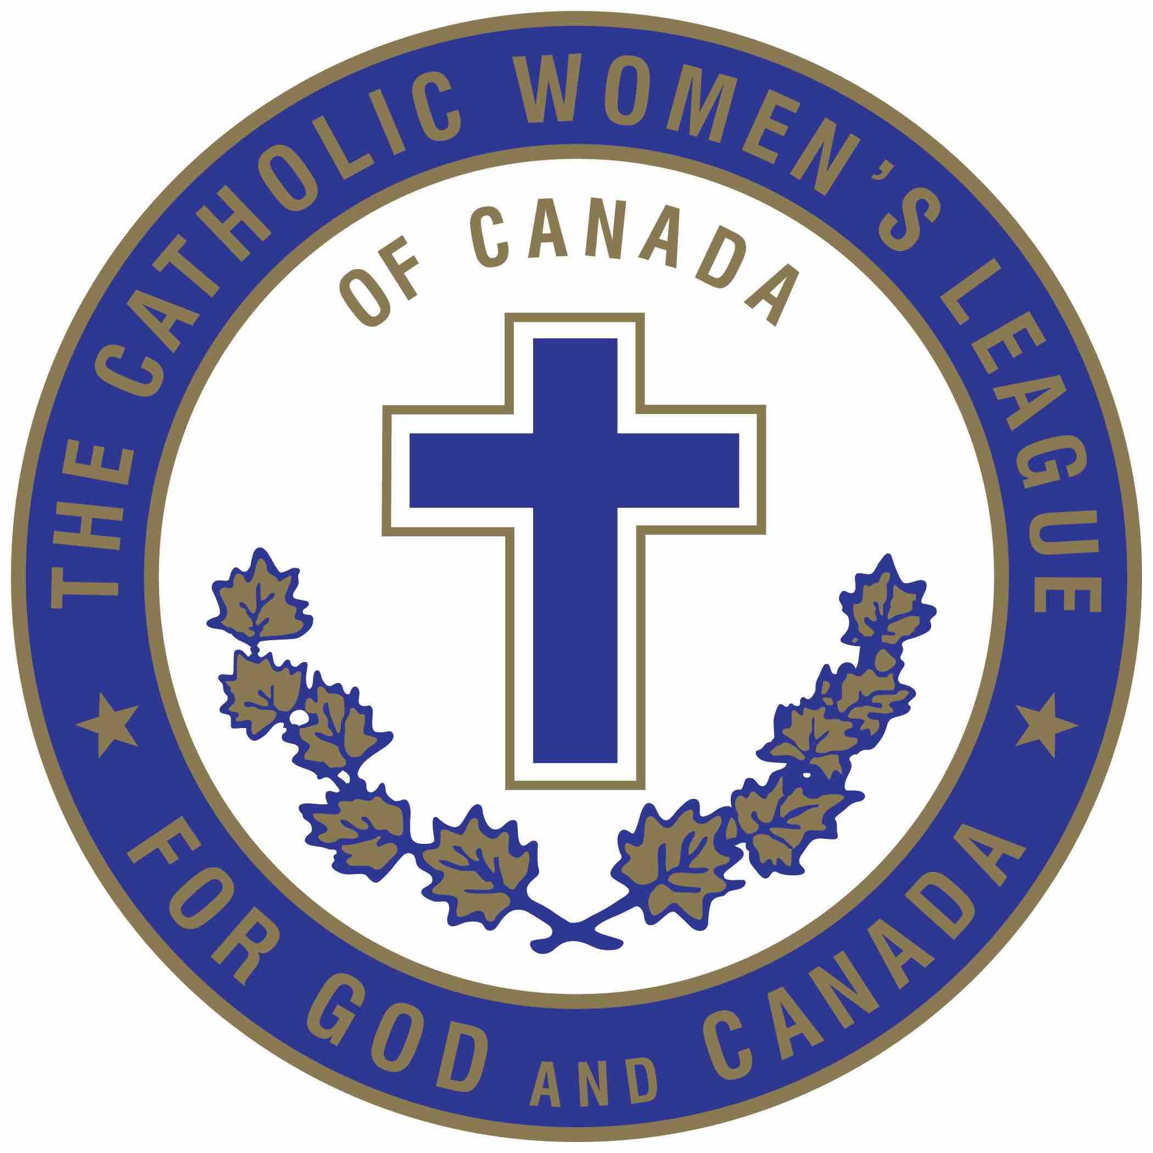
The Catholic Women's League of Canada
Alberta Mackenzie Provincial Council

Spiritual Development Chair
Communique # 7
DATE: November 18th, 2021
TO: Diocesan Spiritual Development Chairperson
CC: Provincial Executive (for information)
CC: National Spiritual Development Chairperson
CC: Diocesan Presidents (for information)
FROM: Gladys Brown, ABMK Spiritual Development Chairperson

RE: Preparation for the Advent Season

Sisters in the League,

Advent Prayer
Come, long-expected Jesus. Excite in me a wonder at the wisdom and power of Your Father and
ours.
Receive my prayer as part of my service of the Lord who enlists me in God’s own work for justice.
Come, long-expected Jesus. Excite in a me a hunger for peace, peace in the world, peace in my hone, peace in myself.
Come, long-expected Jesus. Excite in me a joy responsive to the Father’s joy. I seek His will so I can serve with gladness, singing and love.
Come, long-expected Jesus. Excite in me the joy and love and peace it is right to bring to the manger of my Lord.
Raise in me, too, sober reverence for the God who acted there, hearty gratitude for the life begun there, and spirited resolution to serve the Father and Son.
I pray in the name of Jesus Christ, whose advent I hail. Amen.

Advent Resources
There are several Advent resources to assist members prepare for the Advent season.
- “Hope and Joy at Advent” (December 1st) part two of Living with Christ Webinar Series.
- Stepping Beyond, an Advent retreat offered by Pray as You Go, inspired by Pope Francis’ encyclical letter Fratelli Tutti, on fraternity and social friendship.
- My Catholic Life! Enjoy reading the materials for daily reflections, prayers, inspiring quotes.
- Prayers for Advent by Loyola Press. There are various resources and can be downloaded
From loyolapress.com/catholic-resoures/liturgical-year/advent/prayers/.
- Advent Examination of Conscience. Available at waterloocatholics.org/documents/2019/12HO-Advent%20Exam%20ofo/o20 Conscience.pdf.
The Advent Resources listed above was taken from the Communique #03 dated November 10, 2021 and prepared by Cathy Bouchard, National Second Vice-President and Chairperson of Spiritual Development.

Providence Renewal Centre and Star of the North Retreat Centre have several Advent Resources as well and can be found on their website.

Pope Francis has opened a two-year synodical process entitled “For a Synod Church: Communion, Participation and Mission”. This is a two year process: October 2021 to 2023.
The Synod process take us to a deeper sense and meaning of listening to the word of God. Synodality demands that we listen and engage in dialogue to establish binding relationships that build Church. The Church is a Church of Churches. What is the FUTURE CHURCH? What we need is a fresher model of being church, imagining and building new structures that reflect a more synodal model and that involves the laity much more in decision making processes. The faithful can join in conversation with one another and again listen with your heart.

On December 13th, 2021, Sandra Prather will be facilitating an Advent Retreat via Zoom titled Communion, Participation, Mission: Towards a Synodal Church. Most important what does this mean? How do we understand this idea, synodality? This retreat will last two hours, 7:00 pm. to 9:00 p.m. with break-up rooms to share with one another of what this means. In order to participate, registration is necessary and will become available as the date draws near.

Respectfully submitted
Gladys Brown

