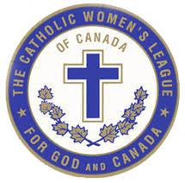

The Catholic Women’s League of Canada
ALBERTA MACKENZIE PROVINCIAL COUNCIL
Annually Awards the

Father Walter Krewski Membership Award
for the Most New Members in the year 2021

This form is to be completed by the Parish Council President.

The purpose of this award is to give recognition to the council that had the greatest number of new members in the previous year. Please note that new members are only members that have never previously held a CWL membership.

Name of Council _______________________________________________________

President’s Name _________________________________________________________

Address _________________________________________________________________

Postal Code __________________ Telephone number ________________________

Email ___________________________________________________________________

Number of New Members ____________________

Please complete this application form and submit the information by email or by regular mail.
The deadline for submission of this information is February 29th, 2022.

If you have any questions, I invite you to call or email me.

Mary Hunt, Organization Chair & President-Elect
Alberta Mackenzie Provincial Council
The Catholic Women’s League of Canada
Postal Address: 508 Caldwell Court N.W. Edmonton, Alberta T6M 2X4
Email: abmkprovpreselect@gmail.com
Phone: 780-221-3165

