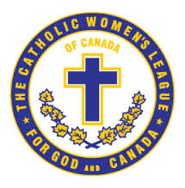
The Catholic Women’s League of Canada
Edmonton Diocesan Council

Education and Health Standing Committe
Communique - Fall 2021

November 10, 2021

TO: Diocesan President,
Parish Presidents,
Parish Community Life Chair
Life Members

FROM: Kara Pelech, Education and Health Standing Committee

RE: Everybody’s Welcome Book Project
Sisters in the League,
Thank to all the councils that have participated in the book project this far. PLEASE keep sending the photos. Keep the stories coming. The response to the project has been so positive. Teachers and school principals have been cooperative in receiving the book from members and allowing pictures during the presentations.
For the Edmonton city councils, please let me know the Edmonton Catholic School you have donated your book. We are have had some overlap of several councils wanting to donate to the same school. In order to try to ensure that we gift to as many schools as possible, going forward we ask you to check in before calling the school. Please contact me asI will be keeping an ongoing list of what schools have been gifted the book and which schools haven’t receive the book. My email is edmontoncwl.education@gmail.comor by calling 780.340.4124.
If any council surrounding Edmonton would also like to donate a book to anEdmonton Catholic Schools, we can make arrangementsto donate on your behalf.
Please contact me directly with any questions or concerns.
Kara Pelech
Education and Health

