96th Annual Diocesan Convention
April 20 - 22, 2018
Royal Canadian Legion, Fort Saskatchewan

REGISTRATION FORM
(Use a separate form for each person registering)
Note: Our job is made easier if all registrations from one council are sent together; if possible.

First Name: ________________________ Last Name: _________________________
(please print) (please print)
Address:________________________ City/Town: _______________ P.C. ___________
CWL Council: ___________________________________________________________

Phone Number: ( ) _________________ E-mail: ____________________________

Registration Category (check one only):
____ Voting Delegate (Council President or her designate) ____ CWL Member
____ Parish Accredited Delegate (maximum 2 per council) ____ Diocesan Spiritual Advisor
____ Diocesan Accredited Delegate (Diocesan Officer) ____ Parish Spiritual Advisor
____ Honorary Life Member (Accredited) ____ Provincial CWL Representative
____ Life Member (Accredited) ____ National CWL Representative
____ Zone Chairperson (Accredited) ____ Hierarchy
____ Guest

Dietary Restrictions?

Vegetarian: __________

Gluten Free: _________

Dairy Free: __________

Able to accommodate above only
Registration Fees: ____ $75.00 - Both Days
____ $45.00 - Friday only
____ $45.00 - Saturday only

Meals:____ $20.00-Friday Lunch
____ $20.00-Friday Spiritual Advisor’s Lunch
(Parish Council to pay)
____ $20.00-Saturday Lunch
____ $45.00-Saturday Banquet
____ $45.00-extra Banquet ticket
Total: _____
(Please make cheque payable to: CWL Edmonton Diocesan Convention)

Please get your Registrations in EARLY!
HEALTH BREAKS Include:
Continental Breakfast upon Arrival
Mid-Morning Coffee, Tea & Juice
Mid-Afternoon Coffee, Tea, Juice & Cookies

No outside food allowed

Send Registration form to:
Marguerite Critchley
8605-99 Avenue
Fort Saskatchewan, Alberta
T8L 3A4
Phone: 780-998-2970
780-915-3993 (Cell)

“Please keeps this gathering Scent Free”

Registrations Deadline: April 10, 2018 Office use only: # in ledger ______
Meal changes cannot be guaranteed after April 12, 2018. Receipt number: ____________
No refunds after April 12, 2018. Amount submitted: ____________
Normandy Room, Royal Canadian Legion
9964-93 Avenue
Fort Saskatchewan, AB

Masses will be held at Our Lady of the Angels Church
10004-101 Street
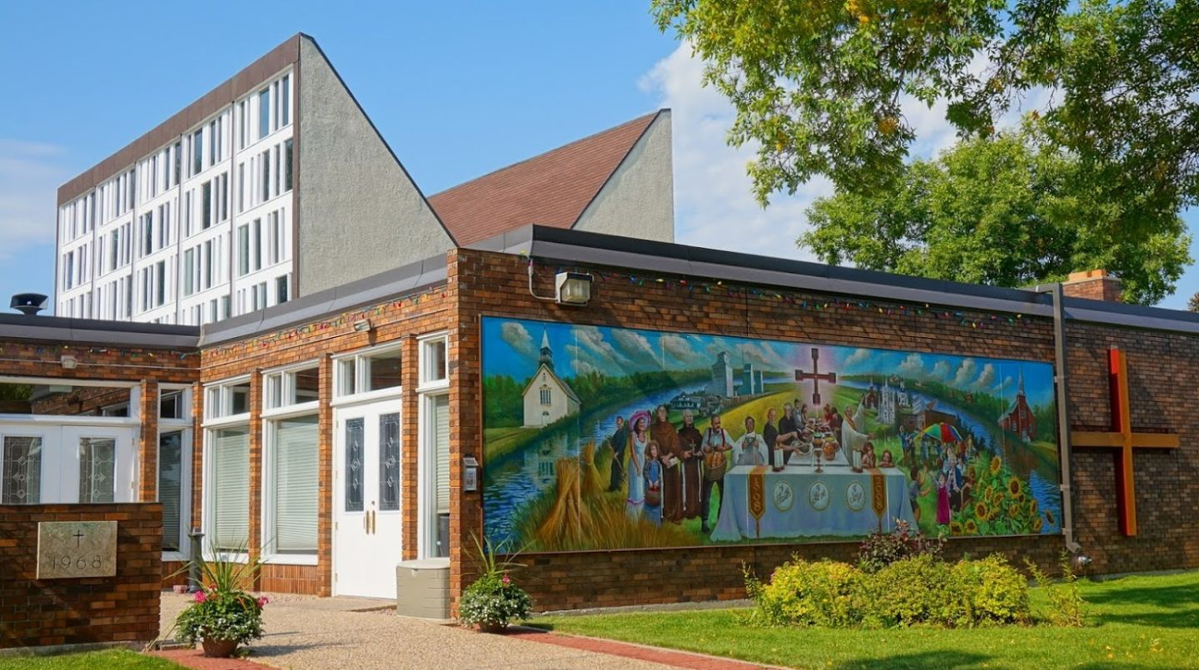

Hotel/Motel Suggestions:

Hampton Inn by Hilton 8709 – 101 Street Fort Saskatchewan (780-997-1001)
($101.00 per night & GST 2 Queen Beds or 1 King Bed) includes complimentary breakfast

Southfort Inn 140 Town Crest Road Fort Saskatchewan (780-589-2000)
($89.00 per night & GST 2 Queen Beds or 1 King Bed) includes hot breakfast

Comfort Inn 120 Town Crest Road Fort Saskatchewan (780-998-4000)
($99.00 per night & GST 2 Queen Beds or 1 King Bed) includes hot breakfast

If you would like to share accommodations and do not have a roommate, please indicate here.
Yes _______

Area Restaurant information will be available at the Convention.

